**MINISTRY OF EDUCATION AND TRAINING**

FPT UNIVERSITY

Capstone Project Document

**Insurance Card**

|  |  |
| --- | --- |
| **Group 2** | |
| **Group members** | Đinh Quang Trung – SE60994  Nguyễn Hữu Phúc – SE60749  Phùng Quang Minh Trí – SE60746  Nguyễn Chí Kha – 60351 |
| **Supervisor** | Kiều Trọng Khánh |
| **Ext. Supervisor** | N/A |
| **Capstone Project Code** | MIC |

- Ho Chi Minh City, 12 May 2015 -

This page is intentionally left blank

Table of Contents

Table of Contents 3

List of Tables 6

List of Figures 10

Definitions, Acronyms, and Abbreviations 13

A. Introduction 14

1. Project Information 14

2. Introduction 14

3. Current Situation 14

4. Problem Definition 14

5. Proposed Solution 15

5.1. Feature functions 15

5.2. Advantages and disadvantages 16

6. Functional Requirements 16

7. Roles and Responsibility 17

B. Software Project Management Plan 18

1. Problem Definition 18

1.1. Name of this Capstone Project 18

1.2. Problem Abstract 18

1.3. Project Overview 18

2. Project organization 21

2.1. Software Process Model 21

2.2. Roles and responsibilities 22

2.3. Tools and Techniques 23

3. Project Management Plan 23

3.1. Software development life cycle 23

3.2. Phase Detail 26

3.3. Task sheet 27

3.4. All Meeting Minutes 27

4. Coding Convention 27

C. Software Requirement Specification 29

1. User Requirement Specification 29

1.1. Customer requirement 29

1.2. Staff requirement 29

1.3. Police requirement 30

1.4. Admin requirement 30

2. System Requirement Specification 30

2.1. External Interface Requirement 30

2.2. System Overview Use Case 30

2.3. List of Use Case 33

3. Software System Attribute 95

3.1. Usability 95

3.2. Reliability 95

3.3. Availability 95

3.4. Security 96

3.5. Maintainability 96

3.6. Portability 96

3.7. Performance 96

4. Conceptual Diagram 96

D. Software Design Description 98

1. Design Overview 98

2. System Architecture Design 98

2.1. Web Application architecture description 98

2.2. Mobile Application architecture description 99

3. Component Diagram 100

4. Detailed Description 101

4.1. Class Diagram 101

4.2. Class Diagram Explanation 102

4.3. Interactive Diagram 110

5. Interface 119

5.1. Component Interface 119

5.2. Web application Design 122

5.3. Checker Mobile Application Design 136

5.4. Printer Mobile Application Design 139

6. Database Design 141

6.1. Entity relationship diagram 141

6.2. Entity Dictionary 143

7. Algorithms 143

7.1. Contract State 143

7.2. Concurrency Control 144

7.3. Notification 147

7.4. System Scheduler Process 148

7.5. NFC Card Data Format 149

7.6. Strategy for future expand plan 152

E. System Implementation & Test 157

1. Introduction 157

1.1. Overview 157

1.2. Test Approach 157

2. Database Relationship Diagram 157

2.1. Physical Diagram 157

2.2. Data Dictionary 159

3. Performance Measures 164

3.1. Web application page load speed 164

3.2. Mobile application API load speed 167

4. Test Plan 169

4.1. Features to be tested 169

4.2. Features not to be tested 169

5. System Testing Test Case 169

F. Software User’s Manual 194

1. Installation Guide 194

1.1. Setting up environment at server side 194

1.2. Web Application Deployment Process 194

1.3. Mobile Application Deployment Process 196

2. User Guide 198

2.1. Web Application 198

2.2. Checker Application 198

2.3. Printer Application 200

List of Tables

Table 1: Definitions, Acronyms, and Abbreviations 13

Table 2 Roles and Responsibility 17

Table 3 Hardware requirement for continuous integrating server 20

Table 4 Hardware requirement for web development 21

Table 5 Hardware requirement for mobile development 21

Table 6 Software requirement 21

Table 7 Roles and responsibilities 23

Table 8 Tools and Techniques 23

Table 9 Software development life cycle 25

Table 10 Use case WG01 - <Guest> Login 34

Table 11 Use case WG02 - <Guest> Create new contract request 37

Table 12 Use case WC01 - <Customer> Logout 38

Table 13 Use case WC02 - <Customer> Renew contract by user 40

Table 14 Use case WC03 - <Customer> Cancel contract 41

Table 15 Use case WC04 - <Customer> View payment history 43

Table 16 Use case WC05 - <Customer> View accident history 44

Table 17 Use case WC06 - <Customer> View punishment history 45

Table 18 Use case WC07 - <Customer> Request compensation 47

Table 19 Use case WC08 - <Customer> View compensation history 49

Table 20 Use case WC09 - <Customer> New card request 50

Table 21 Use case WC10 - <Customer> View card information 52

Table 22 Use case WC11 - <Customer> View personal information 53

Table 23 Use case WC12 - <Customer> Change password 54

Table 24 Use case WS01 - <Staff> View profile 57

Table 25 Use case WS02 - <Staff> Change password 58

Table 26 Use case WS03 - <Staff> Resolve new card request 60

Table 27 Use case WS04 - <Staff> Resolve compensation request 62

Table 28 Use case WS05 - <Staff> View customer information 63

Table 29 Use case WS06 - <Staff> Edit customer information 65

Table 30 Use case WS07 - <Staff> Create new customer 67

Table 31 Use case WS08 - <Staff> Create new contract 69

Table 32 Use case WS09 - <Staff> Renew contract 71

Table 33 Use case WS10 - <Staff> Cancel contract 72

Table 34 Use case WS11 - <Staff> Update contract information 73

Table 35 Use case WS12 - <Staff> Update compensation history 75

Table 36 Use case WS13 - <Staff> Update punishment history 77

Table 37 Use case WS14 - <Staff> Update accident history 78

Table 38 Use case WS15 - <Staff> View cards information 79

Table 39 Use case WS16 - <Staff> Update contract type information 80

Table 40 Use case WA01 - <Admin> Remove staff 82

Table 41 Use case WA02 - <Admin> Add staff 83

Table 42 Use case WY01 - <System> Notify schedule 85

Table 43 Use case WP01 - <Payment> Payment 87

Table 44 Use case CP01 - <Police> Verify card information 90

Table 45 Use case CP02 - <Police> Add punishment information 91

Table 46 Use case PS01 - <Staff> Search / filter contract 92

Table 47 Use case PS02 - <Staff> View contract information 94

Table 48 Use case PS03 - <Staff> Print information to NFC card 95

Table 49 Conceptual Diagram Data Dictionary 97

Table 50 Component Dictionary 100

Table 51 Class dictionary 102

Table 52 PaymentEntity Attribute 102

Table 53 PaymentEntity Method 102

Table 54 CardEntity Attribute 103

Table 55 CardEntity Method 103

Table 56 CardInstanceEntity Attribute 103

Table 57 CardInstanceEntity Method 103

Table 58 CustomerEntity Attribute 103

Table 59 CustomerEntity Method 104

Table 60 ContractEntity Attribute 104

Table 61 Contract Method 105

Table 62 StaffEntity Attribute 105

Table 63 StaffEntity Method 105

Table 64 CompensationEntity Attribute 106

Table 65 CompensationEntity Method 106

Table 66 PunishmentEntity Attribute 106

Table 67 PunishmentEntity Method 106

Table 68 AccidentEntity Attribute 107

Table 69 AccidentEntity Method 107

Table 70 ContractTypeEntity Attribute 107

Table 71 ContractTypeEntity Method 107

Table 72 NewCardRequestEntity Attribute 107

Table 73 NewCardRequestEntity Method 108

Table 74 CardAccessLogEntity Attribute 108

Table 75 CardAccessLogEntity Method 108

Table 76 NotificationEntity Attribute 108

Table 77 NotificationEntity Method 109

Table 78 NotificationReadEntity Attribute 109

Table 79 NotificationReadEntity Method 109

Table 80 Web Services Interfaces 120

Table 81 Entity description 121

Table 82 Exception description 121

Table 83 Staff home page fields 122

Table 84 Staff home page buttons/hyperlinks 123

Table 85 <Staff> Manage customer fields 124

Table 86 <Staff> Manage customer buttons/hyperlinks 124

Table 87 <Staff> Create customer fields 125

Table 88 <Staff> Create customer buttons/hyperlinks 125

Table 89 <Staff> Manage contracts fields 126

Table 90 <Staff> Manage contracts buttons/hyperlinks 126

Table 91 <Staff> Create contract fields 128

Table 92 <Staff> Create contract buttons/hyperlinks 129

Table 93 <Staff> Renew contract fields 130

Table 94 <Staff> Renew contract buttons/hyperlinks 130

Table 95 <Staff> Cancel contract fields 131

Table 96 <Staff> Cancel contract buttons/hyperlinks 131

Table 97 <Customer> Manage contract fields 132

Table 98 <Customer> Manage contract buttons/hyperlinks 132

Table 99 <Customer> Contract detail fields 133

Table 100 <Customer> Contract detail buttons/hyperlinks 133

Table 101 <Customer> Cancel contract fields 134

Table 102 <Customer> Cancel contract button/hyperlinks 134

Table 103 <Customer> Renew contract fields 134

Table 104 <Customer> Renew contract button/hyperlinks 135

Table 105 <Customer> Select payment method fields 135

Table 106 <Customer> Select payment method buttons/hyperlinks 136

Table 107 Scan NFC card screen - Fields 136

Table 108 Scan NFC card screen - Buttons 137

Table 109 View card information screen - Buttons 138

Table 110 Search contract screen - Fields 139

Table 111 Search contract screen - Buttons 140

Table 112 View contract screen - Buttons 141

Table 113 Entity dictionary 143

Table 114 Contract State Dictionary 144

Table 115 Contract State Flow 144

Table 116 Notification use cases 147

Table 117 NDEF Message Types 151

Table 118 Data table dictionary 160

Table 119 Data attribute dictionary 164

Table 120 Web application page load speed test result 167

Table 121 Mobile app API load speed client specification 167

Table 122 Mobile app API load speed test cases 168

Table 123 Mobile application API load speed test result 169

Table 124 Test case - <Guest> Register new contract 173

Table 125 Test case - <Guest> Register new contract payment 174

Table 126 Test case - <Staff> View contract 175

Table 127 Test case - <Staff> Create contract 177

Table 128 Test case - <Staff> Renew contract 179

Table 129 Test case - <Staff> Cancel contract 180

Table 130 Test case - <Staff> View compensation list 181

Table 131 Test case - <Staff> View compensation detail 182

Table 132 Test case - <Staff> Resolve compensation 182

Table 133 Test case - <Staff> View new card requests 183

Table 134 Test case - <Staff> Resolve new card request 183

Table 135 Test case - <Customer> Create contract 185

Table 136 Test case - <Customer> Renew contract 186

Table 137 Test case - <Customer> Cancel contract 188

Table 138 Test case - <Customer> Send compensation request 190

Table 139 Test case - <Customer> Send new card request 193

Table 140 Hardware requirements 194

Table 141 Software requirements 194

List of Figures

Figure 1: Waterfall model 22

Figure 2: Web Application Overview Use Case 31

Figure 3: Checker Mobile Application 32

Figure 4: Printer Mobile Application 32

Figure 5 <Guest> Overview Use Case 33

Figure 6 <Guest> Login 33

Figure 7 <Guest> Create new contract request 34

Figure 8 <Customer> Overview Use Case 37

Figure 9 <Customer> Renew contract 38

Figure 10 <Customer> Cancel contract 40

Figure 11 <Customer> View payment history 42

Figure 12 <Customer> View accident history 43

Figure 13 <Customer> View punishment history 44

Figure 14 <Customer> Request compensation 45

Figure 15 <Customer> View compensation history 47

Figure 16 <Customer> New card request 49

Figure 17 <Customer> View card information 51

Figure 18 <Customer> View personal information 52

Figure 19 <Customer> Change password 53

Figure 20 <Staff> Overview Use Case 55

Figure 21 <Staff> View profile 56

Figure 22 <Staff> Change password 57

Figure 23 <Staff> Resolve new card request 58

Figure 24 <Staff> Resolve compensation request 60

Figure 25 <Staff> View customer information 62

Figure 26 <Staff> Edit customer information 64

Figure 27 <Staff> Create new customer 65

Figure 28 <Staff> Create contract 67

Figure 29 <Staff> Renew contract 69

Figure 30 <Staff> Cancel contract 71

Figure 31 <Staff> Update contract information 72

Figure 32 <Staff> Update compensation history 74

Figure 33 <Staff> Update punishment history 76

Figure 34 <Staff> Update accident history 77

Figure 35 <Staff> View card information 78

Figure 36 <Staff> Update contract type information 79

Figure 37 <Admin> Overview Use Case 81

Figure 38 <Admin> Remove staff 81

Figure 39 <Admin> Add staff 82

Figure 40 <System> Overview Use Case 83

Figure 41 <System> Notify schedule 83

Figure 42 <Payment> Payment 85

Figure 43 <Payment> Payment 86

Figure 44 <Police> Overview Use Case 88

Figure 45 <Police> Verify card information 88

Figure 46 <Police> Add punishment information 90

Figure 47 <Staff> Overview Use Case 91

Figure 48 <Staff> Search / filter contract 91

Figure 49 <Staff> View contract information 93

Figure 50 <Staff> Print information to NFC card 94

Figure 51 Conceptual diagram 96

Figure 52 System architecture design 98

Figure 53 Component Diagram 100

Figure 54 Class Diagram 101

Figure 55 Sequence diagram - <Staff> Create new contract 110

Figure 56 Sequence diagram - <Staff> Renew contract 111

 Figure 57 Sequence diagram - <Staff> Cancel contract 111

Figure 58 Sequence diagram - <Customer> Cancel contract 112

Figure 59 Sequence diagram - <Customer> Renew contract 113

Figure 60 Sequence diagram - <Guest> Register new contract 113

Figure 61 Sequence diagram - <Guest> Paypal payment 114

Figure 62 <Police> Verify card validation 115

Figure 63 <Police> Add punishment information 116

Figure 64 <Staff> Search contract 117

Figure 65 <Staff> View contract information 118

Figure 66 <Staff> Print information to NFC card 119

Figure 67 Interface - <Staff> Home page 122

Figure 68 Interface - <Staff> Manage customer 123

Figure 69 Interface - <Staff> Create customer 124

Figure 70 Interface - <Staff> Manage contract 125

Figure 71 Interface - <Staff> Create contract 127

Figure 72 Interface - <Staff> Renew contract 129

Figure 73 Interface - <Staff> Cancel contract 130

Figure 74 Interface - <Customer> Manage contract 131

Figure 75 Interface - <Customer> Contract detail 133

Figure 76 Interface - <Customer> Cancel contract 133

Figure 77 Interface - <Customer> Renew contract 134

Figure 78 Interface - <Customer> Select payment method 135

Figure 67 Scan NFC card screen 136

Figure 68 View card information screen 137

Figure 69 Search contract screen 139

Figure 70 View contract screen 140

Figure 71 Print card screen 141

Figure 72 Entity relationship diagram 142

Figure 73 Contract State Chart 143

Figure 74 Concurrency control flow 146

Figure 75 System Scheduler Process 149

Figure 76 NDEF message structure 150

Figure 77 Isolated Single Service Deployment Model 152

Figure 78 Entities group by components (Isolated Single Service) 153

Figure 79 Isolated Multiple Service Deployment Model 153

Figure 80 Entities group by components (Isolated Multiple Service) 154

Figure 81 Distributed Multiple Service Deployment Model 155

Figure 82 Components group by container (Distributed Multiple Service) 156

Figure 83 Physical diagram 158

Figure 84 Web application page load speed test result 166

Figure 85 Mobile application API load speed test result 168

Definitions, Acronyms, and Abbreviations

|  |  |
| --- | --- |
| Name | Definition |
| MIC | Motor Insurance Card |
| NFC | Near field communication |
|  |  |

Table : Definitions, Acronyms, and Abbreviations

# Introduction

## Project Information

* Project name: **Insurance Card**
* Project Code: **MIC**
* Product Type: **Website & Android Application**
* Start Date: **May 11th, 2015**
* End Date: **September 5­th,2015**

## Introduction

In this document, we introduce a solution for motorbike insurance company. Current insurance company systems have some problems like delayed in renew contracts for customer or inconvenient in checking insurance card validation process. Based on our researches and analysis, we proposed a solution for insurance company in Vietnam and other developed countries.

We build a system, which help the insurance companies to solve current problems. In the process of analysis, we believe the NFC cards is capable to resolve the problem by using NFC card to save information about insurance contract. NFC cards are convenient to manage the contract information and checking, validating process. Beside of that we also provide an information system to manage NFC cards so that insurance companies will manage the contracts easier.

This document also describes our working process in 4 months includes our perspective in the system, component designs and detailed core workflows. We hope the system and our solution will help resolve the problems from insurance companies in Vietnam and other developed countries.

## Current Situation

When participating in traffic, vehicle owners is required to have compulsory insurance. Therefore, vehicle owners buy insurance from insurance companies or its agents. They pay insurance premium by cash or in online website and receive an insurance certificate with a term of one year, the term can be shorter in some specific situation. When their insurance out of date, they must buy a new insurance, old certificate will be useless. Traffic police will read insurance certificate to check traffic participants.

## Problem Definition

Below are disadvantages of current situation:

* **Forget insurance’s expired date**: Vehicle owners usually keeps their insurance certificate in wallet or somewhere on their vehicle. However, except in cases of necessity, people are not often check their insurance so they could forget its expired date. An expired insurance is not good while it be revealed by traffic officers and could get worse in case of traffic accident.
* **Hard for traffic officers to check and verify insurance**: Traffic officers must read insurance certificate to check and verify vehicle owner’s information. It can be difficult and hinder their work in some cases as at dark or handwriting illegible on insurance certificate.
* **No mechanism to renew old contract**:customers have to handy register new contract when the old one is expired, this is inconvenient for customers.
* **Insurance certificate made of paper:** It could be torn, wet, smudged and especially is counterfeited.
* **Claim/compensation process is ineffective** between customer and insurance company.
* **Difficult to track and manage number of traffic violations and collisions:** In current scenario, insurance companies almost impossible knows vehicle owner’s history to adjust their insurance policy.

## Proposed Solution

The proposed solution is to build an insurance NFC card system, include a web application and two mobile applications with following functions:

### Feature functions

* Web application:
  + **Register insurance**: user can register a new insurance card with on website using online payment. A staff will contact the user to create contract and sends an insurance NFC card to him/her. If users already have a NFC card, they can use the website to renew current contract.
  + **Check card information**: user can login into the website and check for their card’s information.
  + **Request compensation**: user can fill data into the sample fields and sends compensation request to the company.
  + **Make/manage contracts**: staff can make and manage contracts.
  + **Resolve compensation**: staff can receive and resolve compensation requests.
  + **Notify contract state**: system will send an email to notify the insured one when their insurance is expired.
  + **Notify compensation state**: system will send an email to info the insured one when their compensation were accepted or rejected.
* Insurance card printer (mobile app):
  + **Simulating NFC card printer**: staff can print NFC card.
* Insurance card checker (mobile app):
  + **Check card:** traffic police and Police Department can check specified motor insurance card expired or not.
  + **Update the punishment of violator:** traffic police and Police Department can update the punishment of violator to the card information.

### Advantages and disadvantages

* Advantages:
  + The interaction between the insured one and the insurance company: the insured one and the company now are easier to communicate through the website when each person has an account.
  + Reduce risk of insurance card made of paper: the NFC insurance card will not be torn, wet or smudged. Moreover, it is difficult to be counterfeit than insurance card made of paper.
  + Support police to check valid insurance card easier.
* Disadvantages:
  + Currently not consistent with the law of Vietnam about insurance card issues.
  + Checking the valid of card can take a long time when the internet is slow.

## Functional Requirements

Function requirements of the system are listed as below:

* **User component:**
  + New contract request
  + Check card information.
  + Renew contract.
  + Request compensation.
  + New card request
  + Cancel contract
* **Staff component**
  + Create new contracts
  + Manage contracts.
  + Resolve compensation requests.
  + Resolve new card request
* **System component** 
  + Manage contract states
* **Payment system**
  + Process payments
* **Notify component**
  + Notify contract expiration.
  + Notify compensation states (approved / rejected).
* **Checker mobile application**
  + Check card validation.
  + Update punishment information.
  + Retrieve card information.
* **Printer mobile application**
  + Get contract information from server.
  + Print NFC insurance card.

## Roles and Responsibility

|  |  |  |  |  |
| --- | --- | --- | --- | --- |
| No | Full Name | Role | Position | Contact |
| 1 | Kiều Trọng Khánh | Project Manager | Supervisor | khanhkt@fpt.edu.vn |
| 2 | Đinh Quang Trung | Developer | Leader | trungdqse60994@fpt.edu.vn |
| 3 | Nguyễn Hữu Phúc | Developer | Member | phucnhse60749@fpt.edu.vn |
| 4 | Phùng Quang Minh Trí | Developer | Member | tripqmse60746@fpt.edu.vn |
| 5 | Nguyễn Chí Kha | Developer | Member | khanc60351@fpt.edu.vn |

Table Roles and Responsibility

# Software Project Management Plan

## Problem Definition

### Name of this Capstone Project

* **Official name**: Insurance Card
* **Vietnamese name**: Thẻ bảo hiểm
* **Abbreviation**: MIC

### Problem Abstract

As current in Viet Nam customer use Motor Insurance Certificate Paper when they get problems with their motor. Using the Motor Insurance Certificate Paper is inconvenient, for example, it can be wet or to insert or update the information in to insurance certificate paper is complicate. So we use the NFC card we call it is insurance card to handle it. Insurance company supplies the NFC card when the customer buy insurance. The card contains the information of customer, if the customer join with many insurance service they just use only one card.

We provide a software to check the validation of card, the deadline of card and some insurance services that customer joined. We also provide some other advantage that can help save time and costs in some process of company. For example, the software can automatic extend the insurance service, update the information about accidents of motor. In addition, we also provide a system software to manage the information of customer via some insurance card we bought, this software will deploy at insurance company.

### Project Overview

#### Current Situation

Below are the problems encountered in this project:

* **Security**: currently, there is few possible problems encountered with NFC tags, as NFC tags can be counterfeited, attacked during data transmission caused data loss, data corruption.
* **Server crash**: all the needed data is stored in the server. So if server crash, all the devices cannot get card information.
* **Absence of team members**: team members can get sick or unexpected problems.
* **Currently not consistent with the law** of Vietnam about insurance card issues.

#### The Proposed System

According to the technology researches, we found out that the NFC technology is very capable of resolve the current situations in insurance companies. We can use a feature of NFC tag to resolve the security problem from NFC card. The basic idea is to use a NFC tag (or NFC “card”) which contains a unique card ID as an insurance card instead of paper card currently.

We also build a high available webserver to maintain the main system to work 24/7 to make sure that if mobile applications need access to the information there will be always available.

We assign responsibility in vertical to make sure if any member in this problem cannot continue to work in our team there will be the least harmful to the project processes.

To resolve problem from Vietnam laws of insurance for motorbike, we support the insurance companies to propose new law sections about using technology devices to work with insurance certificate paper to make our system work legally in current situation.

Our system includes three main subsystems: an online website for company’s staffs, a mobile application for police officers and a mobile application to simulate the card printer.

##### Website

Website is a common communication portal for insurance company’s staffs and users (customers). Website provide following features:

* For users (customers):
  + Users can register new insurance card with online payment.
  + Users can look up information about their insurance card: compensation history, punishment history, expired date…
  + Users can renew current insurance contract with online payment.
  + Users can request compensations to insurance company when an accident occurs.
  + Users will be notified by emails when insurance card is nearly expired or a compensation request is approved/rejected.
* For staffs:
  + Staffs can create new contract for customer.
  + Staffs can manage contracts, see all insurance cards published and see statistics
  + Staffs can update compensation requests, resolve a compensation request when the case is done.

Beside above, website system also provides an API interface for two mobile applications to retrieve, update data from mobile applications.

##### Checker Mobile Application

Traffic officer uses this mobile application. This application does followings:

* Check if an insurance card (NFC card) is valid or not.
* Send punishment if the customer has law violations. Punishment information will be updated in server.

##### Printer Mobile Application

This is a simulating application to simulate the work of Card Printer. In reality, the company who deploy this system need to have a NFC Card Printer to write information about the insurance company and customer information into an NFC card. However, our system currently only support this as a simulating application. This application is used by company’s staffs and do followings:

* Retrieves insurance contract information and write data to a physical NFC card.

#### Boundaries of the System

This section supposes that the government law in local area supports the method of using NFC cards as insurance cards, and accept NFC insurance cards are legal.

* Every company who has Information System infrastructure can deploy this system.
* Companies who deployed this system has to equip enough devices for the system to run, includes:
  + Computer system with internet connection.
  + Smartphone devices with built-in NFC technology.
* The language of this system is Vietnamese
* The complete product includes:
  + Website application for staffs and users
  + Printer mobile application for staffs.
  + Checker mobile application for traffic police officers

#### Development Environment

##### Hardware requirement

* For continuous integrating server:

|  |  |  |
| --- | --- | --- |
| Hardware | Minimum Requirements | Recommended |
| Internet Connection | 512Kbps | 8 Mbps |
| Operating System | Ubuntu Server 12 LTS | Ubuntu Server 14.04.2 LTS |
| Computer Processor | Intel® Pentium II | Intel® Core(TM) i5 CPU , M 460 @ 2.53GHz |
| Computer Memory | 128MB of RAM | 3GB of RAM or more |

Table Hardware requirement for continuous integrating server

* For web development:

|  |  |  |
| --- | --- | --- |
| Hardware | Minimum Requirements | Recommended |
| Internet Connection | 512Kbps | 8 Mbps |
| Operating System | Windows Vista, 7, 8 | Windows 7, 8 |
| Computer Processor | 1 GHz | Intel® Core(TM) i5 CPU , M 460 @ 2.53GHz |
| Computer Memory | 1GB of RAM | 3GB of RAM or more |

Table Hardware requirement for web development

* For mobile development:

|  |  |  |
| --- | --- | --- |
| Hardware | Minimum Requirements | Recommended |
| Internet Connection | 512Kbps | Wi-Fi Connection 12MB |
| Operating System | Android 4.0 | Android 4.0 |
| Hardware | NFC supported | NFC supported |
| Memory | 128MB of RAM | 1GB of RAM or more |

Table Hardware requirement for mobile development

##### Software requirement

|  |  |
| --- | --- |
| Software | Name / Version |
| Operating system | Windows 7 or above |
| Environment | Java EE 6 |
| Modeling tool | Microsoft Visio 2013 |
| IDE | Netbeans 7.2.1, Intellij IDEA 14.1 |
| DBMS | MySQL 5.6 |
| Source control | TortoiseSVN 1.8.11 |
| Web browser | Chrome 42 or above |

Table Software requirement

## Project organization

### Software Process Model

This project is developed under waterfall model. We apply waterfall model with customizes to capable with current situation in our team. We choose this model because the following reasons:

* This project is 4 months long due to the FPT University Capstone Project timeline, which can be consider a short project.
* Based on researches and clarify Vietnam laws of insurance for motorbike and current system in insurance companies, the requirements of this project are stable, clear, fixed and well understood by all team members.
* This project use NFC technology, which we have strong background knowledge and well practice skills. We also have experience in designing, building web and mobile application system.



Figure : Waterfall model

Reference: SOFTWARE ENGINEERING 9th Edition, by Ian Sommerville.

We customize the waterfall model from the reference to make the process more capable with current situation of our team.

### Roles and responsibilities

|  |  |  |  |
| --- | --- | --- | --- |
| No | Full name | Role in Group | Responsibilities |
| 1 | Kiều Trọng Khánh | Supervisor / Project Manager | - Clarify user requirement.  - Technical support and business analysis.  - Tracking development process.  - Review document and product. |
| 2 | Đinh Quang Trung | Team leader, BA, Developer, Tester | - Tracking process.  - Planning project, distribute tasks.  - Requirement analysis.  - Database design.  - Documentation.  - GUI Design.  - Coding.  - Testing.  - Deploy product. |
| 3 | Nguyễn Hữu Phúc | BA, Developer, Tester | - Requirement analysis.  - Database design.  - Documentation.  - GUI Design.  - Coding.  - Testing. |
| 4 | Phùng Quang Minh Trí | BA, Developer, Tester | - Requirement analysis.  - Database design.  - Documentation.  - GUI Design.  - Coding.  - Testing. |
| 5 | Nguyễn Chí Kha | BA, Developer, Tester | - Requirement analysis.  - Database design.  - Documentation.  - GUI Design.  - Coding.  - Testing. |

Table Roles and responsibilities

### Tools and Techniques

|  |  |
| --- | --- |
| Tool / Technique | Name / version |
| Frontend | HTML, CSS, JavaScript, jQuery, Bootstrap |
| Backend | JavaEE, Servlet, JSP, Hibernate |
| Web server | Apache Tomcat 7 |
| Development tool | NetBeans 7.2.1, IntelliJ IDEA 14 |
| DBMS | MySQL 5.6 |
| Source control | TortoiseSVN 1.8.11 |
| Modeling tool | StarUML 5.0, Lucid Chart |
| Document tool | Microsoft Word 2013 |

Table Tools and Techniques

## Project Management Plan

### Software development life cycle

Below are all the major tasks that need to be performed sequentially during the development of the system.

|  |  |  |  |  |  |
| --- | --- | --- | --- | --- | --- |
| Phase | Description | Deliverables | Resource needed | Dependencies and Constrains | Risk |
| Requirements Definition | Identify and clarify system requirements. | Report No.1 Introduction. | 20 man-days | N/A | - Missing requirement.  - Project’s scope can be unclear.  - Lack of member share and understand. |
| System and Software Design | - Identify hardware and software requirements.  - Decide software architect and clarify software detail design.  - Design database. | Report No.2 Software Project Management Plan, Report No. 3 Software Requirement Specification and  Report No. 4 Software Design Description. | 50 man-days | Depend on Requirements Definition. | - Misunderstood or unclear system’s requirement.  - Lack of practical experience leading to unreasonable design. |
| Implementation and Unit Testing | - Implements all functions of system.  - Create test plan.  - Perform Unit testing. | Software package. | 120 man-days | - Base on Software Requirement Specification and Software Design Description.  - Coding try to follow coding convention. | - Member does not performs unit test.  - Lack of practical experience. |
| Integration and System Testing | - Perform integration test and system test. | Report No. 5 System Implementation & Test | 35 man-days | Implementation and Unit Testing are finished. | - Lack of testing experience leading to lack of test cases.  - Not enough time for performing test. |
| Operation and Maintenance | - Deploy the system  - Create the user’s manuals.  - Do routine maintenance activities. | Report No.6 Software User’s Manual | 15 man-days | Integration and System Testing are finished. | User’s manual may be difficult for user to understand and confuse. |

Table Software development life cycle

### Phase Detail

#### Phase 1: Requirements Definition

|  |  |  |
| --- | --- | --- |
| Task | Description | Author |
| Identify and clarify system requirements. | Research current systems to collect requirements.  Define main and needed functions the system must include. | Đinh Quang Trung  Nguyễn Hữu Phúc  Phùng Quang Minh Trí  Nguyễn Chí Kha |

#### Phase 2: System and Software Design

|  |  |  |
| --- | --- | --- |
| Task | Description | Author |
| Identify hardware and software requirements. | Find out the suitable hardware and software for the system, as well as its minimum and recommended requirements. | Đinh Quang Trung  Nguyễn Hữu Phúc  Phùng Quang Minh Trí  Nguyễn Chí Kha |
| Decide software architect and clarify software detail design. | - Define the major software components and interfaces.  - Draw core flow diagram, use case diagram, prototype …  - Group meeting to review and modify. | Đinh Quang Trung  Nguyễn Hữu Phúc  Phùng Quang Minh Trí  Nguyễn Chí Kha |
| Design database. | - Design database for the system. | Đinh Quang Trung  Nguyễn Hữu Phúc  Phùng Quang Minh Trí  Nguyễn Chí Kha |

#### Phase 3: Implementation and Unit Testing

|  |  |  |
| --- | --- | --- |
| Task | Description | Author |
| Implements all functions of system. | Coding all the components. | Đinh Quang Trung  Nguyễn Hữu Phúc  Phùng Quang Minh Trí  Nguyễn Chí Kha |
| Create test plan. | Planning for testing. | Đinh Quang Trung  Nguyễn Hữu Phúc  Phùng Quang Minh Trí  Nguyễn Chí Kha |
| Perform Unit testing. | - Write Unit test cases.  - Implement Unit tests. | Đinh Quang Trung  Nguyễn Hữu Phúc  Phùng Quang Minh Trí  Nguyễn Chí Kha |

#### Phase 4: Integration and System Testing

|  |  |  |
| --- | --- | --- |
| Task | Description | Author |
| Perform integration test and system test. | - Test groups of modules and test whole the system. | Đinh Quang Trung  Nguyễn Hữu Phúc  Phùng Quang Minh Trí  Nguyễn Chí Kha |

#### Phase 5: Operation and Maintenance

|  |  |  |
| --- | --- | --- |
| Task | Description | Author |
| Deploy the system | Deploy the system in client environment. | Đinh Quang Trung  Nguyễn Hữu Phúc  Phùng Quang Minh Trí  Nguyễn Chí Kha |
| Create the user’s manuals. | Create a guideline to instruct users using system. | Đinh Quang Trung  Nguyễn Hữu Phúc  Phùng Quang Minh Trí  Nguyễn Chí Kha |
| Do routine maintenance activities. | Do routine maintenance activities for client system. | Đinh Quang Trung  Nguyễn Hữu Phúc  Phùng Quang Minh Trí  Nguyễn Chí Kha |

### Task sheet

Refer to “Task sheet” folder.

### All Meeting Minutes

Refer to “Meeting minutes” folder.

## Coding Convention

This project follows “Code Conventions for the Java TM Programming Language, by Sun Microsystems, rev April 20, 1999”.

<http://www.oracle.com/technetwork/java/codeconventions-150003.pdf>

We use followings naming convention from the reference to capable with current situation in our team:

* Naming:
  + Class names must be in Pascal case.
  + Variable names must be in Camel case.
  + Each Java class belongs to a single file.
* Intentions:
  + Use four spaces intentions.
  + Avoid lines with more than 80 characters
* Declaration:
  + One declaration per line is recommended since it encourages commenting.
  + In absolutely no case should variables and functions be declared on the same line.
  + Do not put different types on the same line.

# Software Requirement Specification

## User Requirement Specification

### Customer requirement

Customer is user who uses service of system. The customer can use some following functions:

* View history information include:
  + View payment history
  + View accident history
  + View punishment history
* View compensation history
* View contract information
* View personal information
* Create new contract
* New card request
* Renew contract
* Cancel contract
* Request compensation

### Staff requirement

Staff is people who works directly with system to track the information of customer or manages customer, staff can handle directly some problems if it happens from customer. Staff can use some following functions:

* View profile: they can change password of customer
* View customer information
* View card information
* Resolve new card request
* Resolve compensation requests
* Update contract type information
* Manage customer includes:
* View customer information
* Edit customer information
* Create new customer
* Manage contracts includes:
* Create new contract
* Update contract information
* Renew contract
* Cancel contract
* Update compensation history
* Update punishment history
* Update accident history

### Police requirement

Police is people who is interactive with system for checking information about customer’s NFC card and handling in case the customer violates the traffic rule or make accident. Police can use some following functions:

* Verify card validation
* Get contract information
* Update punishment information

### Admin requirement

Admin is people who manages staff. Administrator can use some following functions:

* Manage staff includes:
* Remove staff
* Add staff

## System Requirement Specification

### External Interface Requirement

#### User interface

* The user interface uses Vietnamese language.
* Use consistent palette of colors between the text and the background.
* The user interface displays best on 1024x768-screen size.

#### Hardware Interface

* N/A

#### Software Interface

* Web application: work with Firefox (v30 or above), Chromes (v14 or above), Internet Explorer (v10 or above) browse.
* Mobile application: Android operating system (v 4.0 or above).

#### Communication Protocol

* Use HTTP protocol 1.1 for communication between the web browser and the web server.
* Use HTTP protocol 1.1 for communication between the mobile application and the web service.

### System Overview Use Case

#### Web Application



Figure : Web Application Overview Use Case

#### Checker Mobile Application



Figure : Checker Mobile Application

#### Printer Mobile Application



Figure : Printer Mobile Application

### List of Use Case

#### Web Application

##### <Guest> Overview Use Case



Figure <Guest> Overview Use Case

###### <Guest> Login



Figure <Guest> Login

|  |  |  |  |
| --- | --- | --- | --- |
| USE CASE – WG01 | | | |
| Use Case No. | WG01 | **Use Case Version** | 2.0 |
| Use Case Name | Login | | |
| Author | TrungDQ | | |
| Date | 27/05/2015 | **Priority** | Normal |
| Actor:   * Guest   Summary:   * This use case allows guest to log in the system.   Goal:   * Guest can log in the system.   Triggers:   * Guest sends the login command.   Preconditions:   * N/A   Post Conditions:   * Success: Guest login the system. * Fail: Show error message.   Main Success Scenario:   |  |  |  | | --- | --- | --- | | Step | Actor Action | System Response | | 1 | Guest goes to login view. | System requires identity information from Guest:   * Email or customer code: free text input, required, length 3 – 250 * Password: free text input, required, length 6 – 32 | | 2 | Guest inputs information. |  | | 3 | Guest sends command to login to system | Guest will login system with their specific role  [Alternative 1]  [Exception 1] |   Alternative Scenario:   |  |  |  | | --- | --- | --- | | Step | Actor Action | System Response | | 1 | Guest enter wrong identity information. | Wrong identity information, System shows error message. |   Exceptions:   |  |  |  | | --- | --- | --- | | Step | Actor Action | System Response | | 1 | Missing of required fields | System notify guest to enter their identity information |   Relationships: N/A  Business Rules:   * After login to system, guest will be redirected to specific view based on their role on the system: staff or customer. * If role is “Customer”, the system will display to Customer view. * If role is “Staff”, the system will display to Staff Dashboard view. | | | |

Table Use case WG01 - <Guest> Login

###### <Guest> Create new contract request



Figure <Guest> Create new contract request

|  |  |  |  |
| --- | --- | --- | --- |
| USE CASE – WG02 | | | |
| Use Case No. | WG02 | **Use Case Version** | 2.0 |
| Use Case Name | Create new contract request | | |
| Author | TrungDQ | | |
| Date | 27/05/2015 | **Priority** | Normal |
| Actor:   * Guest   Summary:   * This use case allows guest to create new contract request.   Goal:   * Guest can create new contract request.   Triggers:   * Guest sends command to create contract request.   Preconditions:   * N/A   Post Conditions:   * Success: New account and new contract will be created for guest. * Fail: Show error message.   Main Success Scenario:   |  |  |  | | --- | --- | --- | | Step | Actor Action | System Response | | 1 | Guest goes to new contract view. | System requires information from guest:  **Personal information**   * Name: free text input, required, length 3 – 80. * Address: free text input, required, length 3 – 250. * Email: free text input, required, length 3 – 250. * Phone number: free text input, required, length 8 – 15. * Personal ID: free text input, length 8 – 15.   **Contract information** (all information below are required)   * Contract’s type: select one of the options. * Start date: date time input, required. * Contract term: text * Contract’s fee: text   **Vehicle information**   * Plate: free text input, required, length 4 – 15. * Brand: free text input, required, length 2 – 20. * Model code: free text input, length 2 – 20. * Vehicle type: free text input, length 2 – 20. * Color: free text input, length 2 – 20. * Engine: free text input, required, length 2 – 20. * Chassis: free text input, required, length 2 – 20. * Capacity: free text input, required, length 2 – 20. * Year of manufacture: number text input, value from 1900 to current year. * Weight: free text input, value from 1 – 1000, unit: kilogram * Seat capacity: free text input, value from 1 – 100. | | 2 | Guest inputs information. |  | | 3 | Guest sends command to create new contract request. | System validate information, display contract details and request for confirmation.  [Exception 1, 2, 3] | | 4 | Guest sends command to create new contract request. | Add new account and new contract information to the system. Show successful message and ask user to process payment. | | 5 | Guest sends command to process payment | Display new view let user select one of following payment gateways:  - PayPal payment gateway.  - Direct payment.  And show guest the fee:  Contract’s fee: text. | | 6 | If user chooses PayPal gateway and sends confirm command.  [Alternative 1] | Forward to PayPal payment view to process the payment. | | 7 | User process the PayPal payment | If payment succeed:  Show message created successful.  [Exception 4] |   Alternative Scenario:   |  |  |  | | --- | --- | --- | | No | Actor Action | System Response | | 1 | If user chooses direct payment method | Show company address map. |   Exceptions:   |  |  |  | | --- | --- | --- | | No | Actor Action | System Response | | 1 | Guest sends command to create new contract request | System shows error message to ask user input missing required fields. | | 2 | Guest’s email is existed in the system | Show message to notify guest that their email is existed in the system. | | 3 | Guest’s vehicle plate is existed in the system | Show message to notify guest that their vehicle is existed in the system. | | 4 | If payment failed | Show message to notify user that payment failed and the renew request has been aborted. |   Relationships: Payment  Business Rules:   * New customer account and new contract will be created in the system with inputted information. * The initial status of contract will be set to “Pending”. * When customer completed payment process:   + if the contract’s start date has come, contract’s status would change from “Pending” to “No Card”.  + If start date is not come yet, the contract status is not changed.   * Staff will receive a notification about new contract request, they verify contract’s information and issue a card for this contract, in this case, contract’s status would change from “No Card” to “Ready”. * System must ensure has no duplicate customer or vehicle. * An email contains customer code and password will be sent to user, user can use this information to login to the system later. * Start date must not be earlier than the current date. * Contract term is specified by the system. * Contract price would be calculated from contract type and contract term. | | | |

Table Use case WG02 - <Guest> Create new contract request

##### <Customer> Overview Use Case



Figure <Customer> Overview Use Case

###### <Customer> Logout

|  |  |  |  |
| --- | --- | --- | --- |
| USE CASE – WC01 | | | |
| Use Case No. | WC01 | **Use Case Version** | 2.0 |
| Use Case Name | Logout | | |
| Author | TriPQM | | |
| Date | 27/05/2015 | **Priority** | Medium |
| Actor:   * Customer, staff.   Summary:   * This use case allows user to log out the system.   Goal:   * User can log out the system.   Triggers:   * User sends the logout command.   Preconditions:   * User logged in the system.   Post Conditions:   * Success: User logs out the system. * Fail: Show error message.   Main Success Scenario:   |  |  |  | | --- | --- | --- | | Step | Actor Action | System Response | | 1 | User sends logout command. | User exits from the system. |   Alternative Scenario: N/A  Exceptions: N/A  Relationships: N/A  Business Rules:   * After user logged out, return to the home. | | | |

Table Use case WC01 - <Customer> Logout

###### <Customer> Renew contract



Figure <Customer> Renew contract

|  |  |  |  |
| --- | --- | --- | --- |
| USE CASE – WC02 | | | |
| Use Case No. | WC02 | **Use Case Version** | 2.0 |
| Use Case Name | Renew contract by user | | |
| Author | TriPQM | | |
| Date | 27/05/2015 | **Priority** | High |
| Actor:   * Customer.   Summary:   * This use case helps user to renew their contract.   Goal:   * User can renew their insurance contract.   Triggers:   * User sends renew contract command.   Preconditions:   * User must login into the system with role Customer. * Contract’s status must be “No Card”, “Ready” or “Expired”. * The contract type belongs to this contract is NOT deactivated yet. * Contract remaining days must NOT exceed the limit in administrator’s configuration.   Post Conditions:   * Success: Customer's contract is renewed or a renew contract request would be sent to the Staff. * Fail: Show error message.   Main Success Scenario:   |  |  |  | | --- | --- | --- | | Step | Actor Action | System Response | | 1 | User goes to renew contract view. | Display renew contract information:  - Type of contract: text  - Start date: text  - New expired date: text  - Renewal fee: text. | | 2 | User sends renew contract command. | Display new view with following information:  - Payment content: text  - Renewal fee: text  And let user select one of following payment gateways:  - PayPal payment gateway.  - Direct payment. | | 3 | If user chooses PayPal gateway and sends confirm command.  [Alternative 1] | Forward to PayPal payment view to process the payment. | | 4 | User process the PayPal payment | If payment succeed:  Update information to the system. Renew user insurance contract.  Show message renew successful.  [Exception 1] |   Alternative Scenario:   |  |  |  | | --- | --- | --- | | No | Actor Action | System Response | | 1 | If user chooses direct payment method and sends the confirm command. | Show list of company brands address. |   Exceptions:   |  |  |  | | --- | --- | --- | | No | Actor Action | System Response | | 1 | If payment failed | Show message to notify user that payment failed and the renew request has been aborted. |   Relationships: Extend “Payment”.  Business Rules:   * If contract status is “Expired” and user paid the renew fee through PayPal, system automatically change the contract status to “Ready”. * If user paid the renew fee directly, contract’s status is “Pending” and Staff will update the payment for that contract and change contract status to “Ready”. * If contract status as “No Card”, it will remain in despite of renew process is completed successfully. * If contract type of contract is not active the customer will not be able renew contract. * A notification will be sent to staff after the process is completed. | | | |

Table Use case WC02 - <Customer> Renew contract by user

###### <Customer> Cancel contract



Figure <Customer> Cancel contract

|  |  |  |  |
| --- | --- | --- | --- |
| USE CASE – WC03 | | | |
| Use Case No. | WC03 | **Use Case Version** | 2.0 |
| Use Case Name | Cancel contract | | |
| Author | TriPQM | | |
| Date | 27/05/2015 | **Priority** | High |
| Actor:   * Customer.   Summary:   * This use case helps user cancel their contract.   Goal:   * Customer can cancel the contract.   Triggers:   * Customer sends cancel contract request.   Preconditions:   * User must login into the system with role Customer. * User’s contract has not expired. * Customer's contract status must not be “Expired”, "Cancelled" or “Request cancel”.   Post Conditions:   * Success: Send to the staff the cancel contract request. * Fail: Show error message.   Main Success Scenario:   |  |  |  | | --- | --- | --- | | Step | Actor Action | System Response | | 1 | User goes to cancel contract view. | Display new view require user input some information:   * Reason to cancel the contract: can be optional selected from these values:   + “Xe cơ giới bị thu hồi đăng ký và biển số theo quy định của pháp luật”   + “Xe cơ giới hết niên hạn sử dụng theo quy định của pháp luật”   + “Xe cơ giới bị mất được cơ quan công an xác nhận”   + “Xe cơ giới hỏng không sử dụng được hoặc bị phá huỷ do tai nạn giao thông được cơ quan công an xác nhận”   + Other reason: free text input, required, length 1-250. | | 2 | User inputs information |  | | 3 | User sends cancel contract request command. | * Change contract status. * Send request to the Staff.   [Exception 1] |   Alternative Scenario: N/A  Exceptions:   |  |  |  | | --- | --- | --- | | No | Actor Action | System Response | | 1 | If user didn't check any reason to cancel contract | Show message to notify user that they have to choose the reason for cancel contract. |   Relationships: N/A  Business Rules:   * Cancel contract request will be sent to the system with inputted information. * System update status of the contract from “Pending”, “No Card” or “Ready” to “Request cancel”. * A notification will be sent to staff after the process is completed. | | | |

Table Use case WC03 - <Customer> Cancel contract

###### <Customer> View payment history



Figure <Customer> View payment history

|  |  |  |  |
| --- | --- | --- | --- |
| USE CASE – WC04 | | | |
| Use Case No. | WC04 | **Use Case Version** | 2.0 |
| Use Case Name | View payment history | | |
| Author | TriPQM | | |
| Date | 27/05/2015 | **Priority** | Medium |
| Actor:   * Customer.   Summary:   * This use case shows user the history of customer’s transactions.   Goal:   * User can view list of transactions were made.   Triggers:   * User sends view payment history command.   Preconditions:   * User must login into the system with role Customer. * There is at least 01 transaction belongs to customer in the system.   Post Conditions:   * Success: Show the customer’s transactions history to the user. * Fail: Show error message.   Main Success Scenario:   |  |  |  | | --- | --- | --- | | Step | Actor Action | System Response | | 1 | User sends view payment history command. | Display new view that show user list of transaction history information includes:   * Transaction code: text * Date of transaction: text * Payment method: text * Service: text * Amount: text * View detail transaction: button   [Alternative 1] |   Alternative Scenario:   |  |  |  | | --- | --- | --- | | No | Actor Action | System Response | | 1 | If there are no transaction was made. | Show message to notify that there are no transaction was made. |   Exceptions: N/A  Relationships: N/A  Business Rules:   * The information is loaded from the system. * List of transactions will be sorted by date in descending order. * Pagination must be displayed if number of transactions larger than 10. * Search bar on the top help user finding transactions faster. | | | |

Table Use case WC04 - <Customer> View payment history

###### <Customer> View accident history



Figure <Customer> View accident history

|  |  |  |  |
| --- | --- | --- | --- |
| USE CASE – WC05 | | | |
| Use Case No. | WC05 | **Use Case Version** | 2.0 |
| Use Case Name | View accident history | | |
| Author | TriPQM | | |
| Date | 27/05/2015 | **Priority** | Medium |
| Actor:   * Customer.   Summary:   * This use case shows user the history of customer’s accidents.   Goal:   * User can view list of their accidents history.   Triggers:   * User sends view accident history command.   Preconditions:   * User must login into the system with role Customer. * There is at least 01 accident belongs to customer in the system.   Post Conditions:   * Success: Show the customer’s accidents history to the user. * Fail: Show error message.   Main Success Scenario:   |  |  |  | | --- | --- | --- | | Step | Actor Action | System Response | | 1 | User sends view accident history command | Display new view show list of accidents information includes:   * Accident code: text * Contant of accident: text * Date of accident: text * Attachment file: link to file.   [Alternative 1] |   Alternative Scenario:   |  |  |  | | --- | --- | --- | | No | Actor Action | System Response | | 1 | There are no accident. | Show message to notify that there are no accident. |   Exceptions: N/A  Relationships: N/A  Business Rules:   * The information is loaded from the system. * List of accidents will be sorted by date in descending order. * Pagination must be displayed if number of accidents larger than 10. * Search bar on the top help user to search accident by title. | | | |

Table Use case WC05 - <Customer> View accident history

###### <Customer> View punishment history



Figure <Customer> View punishment history

|  |  |  |  |
| --- | --- | --- | --- |
| USE CASE – WC06 | | | |
| Use Case No. | WC06 | **Use Case Version** | 2.0 |
| Use Case Name | View punishment history | | |
| Author | TriPQM | | |
| Date | 27/05/2015 | **Priority** | Medium |
| Actor:   * Customer.   Summary:   * This use case shows user the history of the punishment.   Goal:   * User can view list of their punishment history.   Triggers:   * User sends view punishment history command.   Preconditions:   * User must login into the system with role Customer. * There is at least 01 punishment belongs to customer in the system.   Post Conditions:   * Success: Show the punishment history to the user. * Fail: Show error message.   Main Success Scenario:   |  |  |  | | --- | --- | --- | | Step | Actor Action | System Response | | 1 | User sends view punishment history command | Display a table shows list of punishments information includes:   * Punishment code: text * Contant of punishment: text * Date sent punishment: text * Attachment file: link to file.   [Alternative 1] |   Alternative Scenario:   |  |  |  | | --- | --- | --- | | No | Actor Action | System Response | | 1 | There are no punishment | Show message to notify that there are no punishment. |   Exceptions: N/A  Relationships: N/A  Business Rules:   * The information is loaded from the system. * Punishments list is sorted by date order. * Search bar on the top help user finding punishment information faster. * Pagination must be displayed if number of punishments larger than 10. | | | |

Table Use case WC06 - <Customer> View punishment history

###### <Customer> Request compensation



Figure <Customer> Request compensation

|  |  |  |  |
| --- | --- | --- | --- |
| USE CASE – WC07 | | | |
| Use Case No. | WC07 | **Use Case Version** | 2.0 |
| Use Case Name | Request compensation | | |
| Author | TriPQM | | |
| Date | 27/05/2015 | **Priority** | High |
| Actor:   * Customer.   Summary:   * This use case helps user to request compensation.   Goal:   * User can request compensation.   Triggers:   * User sends request compensation command.   Preconditions:   * User must login into the system with role Customer. * Contract’s status must not be “Pending”. * Contract’s status must not be “Canelled” or “Expired” has expired date is more than 30 days with current date.   Post Conditions:   * Success: Store the compensation request to into the system. * Fail: Show error message.   Main Success Scenario:   |  |  |  | | --- | --- | --- | | Step | Actor Action | System Response | | 1 | User goes to request compensation view. | Display new view ask user to input required information includes:   * Driver name: free text input, required, length 3-80. * License number: free text input, required, length 10-15. * License type: free text input, required, length 1-10. * Driver phone: free text input, required, length 8-15. * Vehicle capacity: free text input, required, length 1-20. * Driver address: free text input, required, length 3-250. * Plate number of accident motor: free text input, required, length 4-15. * Date of accident: date time input, required. * Place of accident: free text input, required, length 3-250. * Control Police Department: free text input, required, length 3-250. * Description: free text input, required, length 1-2000. * Human damage: free text input, required, length 1-2000. * Asset damage: free text input, required, length 1-2000. * Observer: free text input, required, length 3-80. * Compensation note: free text input, required, length 1-2000. * Attachment file: file upload input. | | 2 | User fill required information and attach the minutes of the accident (if any). |  | | 3 | User sends request compensation command | Show message to notify that request punishment succeed.  [Exception 1, 2] |   Alternative Scenario: N/A  Exceptions:   |  |  |  | | --- | --- | --- | | No | Actor Action | System Response | | 1 | User input missed one of requirement information. | Show message to notify user what required information is missing. | | 2 | The inputted information length is out of range. | Show message to notify user what information is out of range. |   Relationships: N/A  Business Rules:   * Compensation request will be sent to the system with inputted information. * Only permit user chooses the accident date before or at the request date. * New compensation request status will be set to “Đang xử lý”. * Compensation decision will be set to “Chưa quyết định”. * A notification will be sent to staff after the process is completed. | | | |

Table Use case WC07 - <Customer> Request compensation

###### <Customer> View compensation history



Figure <Customer> View compensation history

|  |  |  |  |
| --- | --- | --- | --- |
| USE CASE – WC08 | | | |
| Use Case No. | WC08 | **Use Case Version** | 2.0 |
| Use Case Name | View compensation history. | | |
| Author | TriPQM | | |
| Date | 27/05/2015 | **Priority** | Medium |
| Actor:   * Customer.   Summary:   * This use case helps user to view compensation history.   Goal:   * User can view compensation history.   Triggers:   * User sends view compensation history command.   Preconditions:   * User must login into the system with role Customer. * There is at least 01 compensation belongs to customer in the system.   Post Conditions:   * Success: Show the compensation history to the user. * Fail: Show error message.   Main Success Scenario:   |  |  |  | | --- | --- | --- | | Step | Actor Action | System Response | | 1 | User sends view compensation history command. | Display new view show a table of compensations includes:   * Compensation code: text. * Contract code: text. * Request date: text. * Resolve date: text. | | 2 | User selects a compensation to view its details. | Display new view that show the detail of the selected compensation includes:   * Contract code: text. * Customer name: text. * Driver name: text. * License number: text. * License type: text. * Driver phone: text. * Vehicle capacity: text. * Driver address: text. * Plate number of accident motor: text. * Date of accident: text. * Place of accident: text. * Control Police Department: text. * Description: text. * Human damage: text. * Asset damage: text. * Observer: text. * Compensation note: text. * Attachment file: link to file. * Created date: text. * Resolve date: text. * Decision: text. * Resolve note: text.   [Alternative 1] |   Alternative Scenario:   |  |  |  | | --- | --- | --- | | No | Actor Action | System Response | | 1 | There are no compensation | Show message to notify that there are no compensation. |   Exceptions: N/A  Relationships: N/A  Business Rules:   * The information is loaded from the system. * List of compensation is sorted by resolve date in decreasing order. The unsolved compensations will be the top rows. * Pagination must be displayed if number of compensations larger than 10. * Search bar on the top help user to finding compensation faster. | | | |

Table Use case WC08 - <Customer> View compensation history

###### <Customer> New card request



Figure <Customer> New card request

|  |  |  |  |
| --- | --- | --- | --- |
| USE CASE – WC09 | | | |
| Use Case No. | WC09 | **Use Case Version** | 2.0 |
| Use Case Name | New card request | | |
| Author | TriPQM | | |
| Date | 27/05/2015 | **Priority** | High |
| Actor:   * Customer.   Summary:   * This use case helps user to request a new card.   Goal:   * User can request a new card.   Triggers:   * User sends new card request command.   Preconditions:   * User must login into the system with role Customer. * User must has a card in the system. * Contract status must be “Ready”   Post Conditions:   * Success: New card request will be sent to the system. * Fail: Show error message.   Main Success Scenario:   |  |  |  | | --- | --- | --- | | Step | Actor Action | System Response | | 1 | User sends new card request command. | Display a new view shows to user:   * A text box to confirm by password: free text input, required, length 6-32. * A text box to enter note: : free text input, length 0-2000. * Payment gateways: can be optional selected from these selections:   + PayPal payment gateway.   + Direct payment. * Check boxes for customer to choose deactivate the old card immediately and delivery card request. * The new card fee: text. * The delivery fee: text. * The total fee: text. | | 2 | User enter password and choose the PayPal payment gateway. Then sends confirm command.  [Alternative 1] | Forward to PayPal payment process view.  [Alternative 2] | | 3 | User process the PayPal payment. | If payment succeed,  Show message to notify that the new card request and payment is succeed.  [Exception 1] |   Alternative Scenario:   |  |  |  | | --- | --- | --- | | No | Actor Action | System Response | | 1 | User choose the direct payment method. | Show message to notify that the new card is sent.  [Alternative 2] | | 2 | If user enter wrong password | Show message to notify that user has entered wrong password. |   Exceptions:   |  |  |  | | --- | --- | --- | | No | Actor Action | System Response | | 1 | If payment failed | Show message to notify that the payment failed. The request is aborted. |   Relationships: N/A  Business Rules:   * The new card fee and delivery fee is specified by the system. * At a time, user can only has one new card request for each contract. * A notification will be sent to staff after the process is completed. | | | |

Table Use case WC09 - <Customer> New card request

###### <Customer> View card information



Figure <Customer> View card information

|  |  |  |  |
| --- | --- | --- | --- |
| USE CASE – WC10 | | | |
| Use Case No. | WC10 | **Use Case Version** | 2.0 |
| Use Case Name | View card information | | |
| Author | TriPQM | | |
| Date | 27/05/2015 | **Priority** | Medium |
| Actor:   * Customer.   Summary:   * This use case shows user their card information.   Goal:   * User can view their card information.   Triggers:   * User sends view card information command.   Preconditions:   * User must login into the system with role Customer. * There is at least 01 card belongs to customer in the system.   Post Conditions:   * Success: Show the user’s card information and the access history. * Fail: Show error message.   Main Success Scenario:   |  |  |  | | --- | --- | --- | | Step | Actor Action | System Response | | 1 | User sends view card information command | Display new view shows the card information includes:   * Card ID: text * User name: text * Card status: text * Activated date: text   And a table shows list of access history information includes:   * Access date: text * Access device: text * Request: text * Response: text |   Alternative Scenario:   |  |  |  | | --- | --- | --- | | No | Actor Action | System Response | | 1 | There are no card | Show message to notify that there are no card. |   Exceptions: N/A  Relationships: N/A  Business Rules:   * The information is loaded from the system. * List of access history is sorted by access date in descending order. * Pagination must be displayed if number of access logs larger than 10. * Filter bar on the top help user to finding access logs faster. | | | |

Table Use case WC10 - <Customer> View card information

###### <Customer> View personal information



Figure <Customer> View personal information

|  |  |  |  |
| --- | --- | --- | --- |
| USE CASE – WC11 | | | |
| Use Case No. | WC11 | **Use Case Version** | 2.0 |
| Use Case Name | View personal information | | |
| Author | TriPQM | | |
| Date | 27/05/2015 | **Priority** | Medium |
| Actor:   * Customer.   Summary:   * This use case shows user their personal information.   Goal:   * User can review their card information.   Triggers:   * User sends view personal information command.   Preconditions:   * User must login into the system with role Customer.   Post Conditions:   * Success: Show the user’s personal information. * Fail: Show error message.   Main Success Scenario:   |  |  |  | | --- | --- | --- | | Step | Actor Action | System Response | | 1 | User sends view personal information command | Display new view shows the user information includes:   * User code: text * User name: text * Address: text * Email: text * Phone number: text * Personal ID: text |   Alternative Scenario: N/A  Exceptions: N/A  Relationships: N/A  Business Rules: N/A   * The information is loaded from the system. | | | |

Table Use case WC11 - <Customer> View personal information

###### <Customer> Change password



Figure <Customer> Change password

|  |  |  |  |
| --- | --- | --- | --- |
| USE CASE – WC12 | | | |
| Use Case No. | WC12 | **Use Case Version** | 2.0 |
| Use Case Name | Change password. | | |
| Author | TriPQM | | |
| Date | 27/05/2015 | **Priority** | High |
| Actor:   * Customer.   Summary:   * This use case helps user to change their password.   Goal:   * User can change the password.   Triggers:   * User sends change password command.   Preconditions:   * User must login into the system.   Post Conditions:   * Success: Update new user’s password to the system. * Fail: Show error message.   Main Success Scenario:   |  |  |  | | --- | --- | --- | | Step | Actor Action | System Response | | 1 | User goes to change password view. | Display new view contains textboxes for user to input their current and new password:   * Current password: free text input, required, length 6-32 * New password: free text input, required, length 6-32 * Confirm new password: free text input, required, length 6-32 | | 2 | User input their current password, new password and confirm new password. |  | | 3 | User sends change password command. | Show message to notify that the password has been changed successfully.  [Alternative 1, 2] |   Alternative Scenario:   |  |  |  | | --- | --- | --- | | No | Actor Action | System Response | | 1 | If user inputs the wrong current password | Show message to notify that the current password is wrong. | | 2 | If the new password and the confirm password not matched. | Show message to notify that the confirm password is not matched with the new password. |   Exceptions: N/A  Relationships: N/A  Business Rules:   * The new password will be saved into the system if the provided information is correct. | | | |

Table Use case WC12 - <Customer> Change password

##### <Staff> Overview Use Case



Figure <Staff> Overview Use Case

###### <Staff> View profile



Figure <Staff> View profile

|  |  |  |  |
| --- | --- | --- | --- |
| USE CASE – WS01 | | | |
| Use Case No. | WS01 | **Use Case Version** | 2.0 |
| Use Case Name | View profile | | |
| Author | KhaNC | | |
| Date | 27/05/2015 | **Priority** | Normal |
| Actor:   * Staff   Summary:   * This use case allows staff view their profile.   Goal:   * Staff can view their detailed profile.   Triggers:   * Staff goes to view their profile.   Preconditions:   * Staff must login into the system with roles Staff.   Post Conditions:   * Success: Staff profile information is shown. * Fail: Show error message.   Main Success Scenario:   |  |  |  | | --- | --- | --- | | Step | Actor Action | System Response | | 1 | Staff goes to view theirprofile. | Staff’s detail profile will be shown with following information:   * Staff’s code: text * Staff’s full name: text * Staff’s email: text * Staff’s phone: text |   Alternative Scenario: N/A  Exceptions: N/A  Relationships: N/A  Business Rules:   * Staff’s profile information is always loaded from the system. | | | |

Table Use case WS01 - <Staff> View profile

###### <Staff> Change password



Figure <Staff> Change password

|  |  |  |  |
| --- | --- | --- | --- |
| USE CASE – WS02 | | | |
| Use Case No. | WS02 | **Use Case Version** | 2.0 |
| Use Case Name | Change password | | |
| Author | KhaNC | | |
| Date | 27/05/2015 | **Priority** | Normal |
| Actor:   * Staff   Summary:   * This use case allows staff change their password.   Goal:   * Staff can change their account password.   Triggers:   * Staff sends change password command.   Preconditions:   * Staff must login into the system with roles Staff.   Post Conditions:   * Success: Staff’s new password is updated to the system. * Fail: Show error message.   Main Success Scenario:   |  |  |  | | --- | --- | --- | | Step | Actor Action | System Response | | 1 | User goes to change password view. | Change password view will be shown with following information:   * Current password: free text input, required, length 6 – 32 * New password: free text input, required, length 6 – 32 * Confirm new password: free text input, required, length 6 – 32 | | 2 | User enters required information |  | | 3 | User sends change password command. | * Validate data   [Alternative 1, 2]  [Exception 1, 2]   * Update staff’s new password into the system. * Display message notify user their password has changed successfully. |   Alternative Scenario:   |  |  |  | | --- | --- | --- | | No | Actor Action | System Response | | 1 | Current password does not match with staff’s password in the system | Show message notify staff entered current password does not match with staff’s password in the system | | 2 | Confirm new password does not match with new password | Show message notify staff entered confirm password is not match with their new password |   Exceptions:   |  |  |  | | --- | --- | --- | | No | Actor Action | System Response | | 1 | Missing of required fields | Show message to notify staff input missed fields | | 2 | Length of new password not in range | Show message notify staff’s new password is out of range |   Relationships: N/A  Business Rules:   * In case of successful scenario, staff’s new password would be updated to the system. * The user should be able to know how strong their password is when they input their new password. * Passwords could be rated in one of three ways: “Weak”, “Moderate” and “Strong”. | | | |

Table Use case WS02 - <Staff> Change password

###### <Staff> Resolve new card request



Figure <Staff> Resolve new card request

|  |  |  |  |
| --- | --- | --- | --- |
| USE CASE – WS03 | | | |
| Use Case No. | WS03 | **Use Case Version** | 2.1 |
| Use Case Name | Resolve new card request | | |
| Author | KhaNC | | |
| Date | 27/05/2015 | **Priority** | Medium |
| Actor:   * Staff.   Summary:   * This use case allows staff view and solve new card request.   Goal:   * Staff can view and solve request for new card from customers.   Triggers:   * Staff sends view and solve new card request command.   Preconditions:   * User must login into the system with role Staff. * There is at least 1 unsolved request for new card from customer.   Post Conditions:   * Success: A customer’s new card request is solved, a new card issued and the date request solved updated. * Fail: Request is unsolved.   Main Success Scenario:   |  |  |  | | --- | --- | --- | | Step | Actor Action | System Response | | 1 | Staff goes to view all new card request view. | New card request view will be shown with following information:   * Date of request: text * Note of customer: text * ID of old card: link to card details. * Name of card owner: link to detailed information of the customer who own this card. * Date a new card be issued for this customer: text * ID of new card: link to card details. | | 2 | Staff add new card for this customer | Update new card information to customer’s request and sends notification.   * Date new card issued. * ID of new card |   Alternative Scenario:   |  |  |  | | --- | --- | --- | | No | Actor Action | System Response | | 1 | There are no unsolved new card request | Show message to notify staff there are no unsolved new card request. |   Exceptions: N/A  Relationships: N/A  Business Rules:   * List of new card request is always loaded from the system. * List of new card request is sorted by resolved date in ascending order. * The old card will change status from “Ready” to “Deactivated”. * The new card will has status is “Ready”. * Search bar on the top help user finding card faster by its id. * Pagination must be display if number of requests larger than 10. * A solved request must have code of new card and the date this card issued. | | | |

Table Use case WS03 - <Staff> Resolve new card request

###### <Staff> Resolve compensation request



Figure <Staff> Resolve compensation request

|  |  |  |  |
| --- | --- | --- | --- |
| USE CASE – WS04 | | | |
| Use Case No. | WS04 | **Use Case Version** | 2.0 |
| Use Case Name | Resolve compensation request | | |
| Author | KhaNC | | |
| Date | 27/05/2015 | **Priority** | High |
| Actor:   * Staff.   Summary:   * This use case allows staff view and solves compensation requests.   Goal:   * Staff can view and solve request for compensation from customers.   Triggers:   * Staff sends view and solve compensation request command.   Preconditions:   * User must login into the system with role Staff. * There is at least 1 unsolved request for compensation from customer. * The compensation’s decision must be negotiated with the customer, approved by the insurance company.   Post Conditions:   * Success: A customer’s compensation request solved, decision for this compensation has been made and the date request solved is updated. * Fail: Request is unsolved.   Main Success Scenario:   |  |  |  | | --- | --- | --- | | Step | Actor Action | System Response | | 1 | Staff goes to view list of request for compensation. | List of compensation request will be shown with following information:   * Compensation code: link to request detail * Request created date: text * Contract’s code: link to contract detail * Contract’s owner full name: link to customer detail * Request status: text | | 2 | Staff select an unsolved request to view. | Compensation request detail will be shown with following information:   * Contract’s code: link to contract details. * Contract’s owner full name: link to customer details. * Compensation created date: text * Compensation status: text * Driver’s full name: text * Driver’s phone number: text * Driver’s address: text * Driver’s license number: text * Driver’s license type: text * Accident vehicle plate number: text * Vehicle’s capacity or seat capacity: text * Time of the accident: text * Place of the accident: text * Police department solved accident: text * Description of the accident: text * Human damaged in the accident: text * Asset damaged in the accident: text * Name of the observer: text * Address of the observer: text * Detail of compensation request from customer: text * Compensation attachment: link to attachment detail | | 3 | Staff send resolve this compensation request command. | Resolve compensation request view is shown with following labels and fields   * Resolve date: date time input, required * Note for compensation: free text input, length 1 – 2000 | | 4 | Staff input resolve compensation request information and select one from two decision |  | | 5 | Staff sends save changes command | Update compensation status and notify to customer |   Alternative Scenario:   |  |  |  | | --- | --- | --- | | No | Actor Action | System Response | | 1 | There are no compensation request | Show message to notify staff there are no compensation request. |   Exceptions: N/A  Relationships: N/A  Business Rules:   * List of compensation request is always loaded from the system. * List of compensation request is sorted by compensation request resolved date and created date in ascending order. * With unsolved request, its solved date does not exist. * Compensation resolved date must be restricted in the limit by configuration of the administrator. * A compensation request could have one of following decision: * “Chấp nhận bồi thường” * “Từ chối bồi thường” * A compensation request could have one of following status: * “Đã giải quyết” * “Chưa giải quyết” * Search bar on the top help user finding contract or customer faster. * Pagination must be display if number of requests larger than 10. * A notification will be sent to request customer after the process is completed. | | | |

Table Use case WS04 - <Staff> Resolve compensation request

###### <Staff> View customer information



Figure <Staff> View customer information

|  |  |  |  |
| --- | --- | --- | --- |
| USE CASE – WS05 | | | |
| Use Case No. | WS05 | **Use Case Version** | 2.0 |
| Use Case Name | View customer information | | |
| Author | KhaNC | | |
| Date | 20/05/2015 | **Priority** | Medium |
| Actor:   * Staff.   Summary:   * This use case allows staff view customer details.   Goal:   * Staff can view customer’s detail information.   Triggers:   * Staff sends view customer information command.   Preconditions:   * User must login into the system with role Staff.   Post Conditions:   * Success: Customer’s detail information is shown. * Fail: Show error message.   Main Success Scenario:   |  |  |  | | --- | --- | --- | | Step | Actor Action | System Response | | 1 | Staff goes to list of customer. | List of customer will be shown with following information:   * Customer’s code: link to customer detail * Customer’s full name: text * Customer’s phone: text * Customer’s email address: text | | 2 | Staff selects customer to view their detail information. | Customer detail will be shown with following information:   * Customer’s code: text * Customer’s full name: link to customer detail * Customer’s address: text * Customer’s email address: text * Customer’s phone: text * Customer’s personal ID: text   List of customer’s contract:   * Customer’s contract code: link to contract detail. * Customer’s contract type: text * Contract’s status: text |   Alternative Scenario: N/A  Exceptions: N/A  Relationships: N/A  Business Rules:   * List of customer and their detail information is always loaded from the system. * Search bar on the top help user find customer faster. * Pagination must be display if number of requests larger than 10. * Contract’s status is one of 6 below: * Pending * No card * Ready * Expired * Request cancel * Cancelled | | | |

Table Use case WS05 - <Staff> View customer information

###### <Staff> Edit customer information



Figure <Staff> Edit customer information

|  |  |  |  |
| --- | --- | --- | --- |
| USE CASE – WS06 | | | |
| Use Case No. | WS06 | **Use Case Version** | 2.0 |
| Use Case Name | Edit customer information | | |
| Author | KhaNC | | |
| Date | 20/05/2015 | **Priority** | Medium |
| Actor:   * Staff.   Summary:   * This use case allows staff edit customer’s information.   Goal:   * Customer’s information is updated to the system.   Triggers:   * Staff sends update customer’s information command.   Preconditions:   * User must login into the system with role Staff.   Post Conditions:   * Success: Customer’s information is updated. * Fail: Show error message.   Main Success Scenario:   |  |  |  | | --- | --- | --- | | Step | Actor Action | System Response | | 1 | Staff goes to edit customer information. | Edit customer view is shown with following labels and fields:   * Customer’s full name: free text input, required, length 3 – 80 * Customer’s address: free text input, required, length 3 – 250 * Customer’s email address: free text input, required, length 3 – 250 * Customer’s phone number: free text input, required, length 8 – 15 * Customer’s personal ID: free text input, length 8 – 15 | | 2 | Staff fills out the form. |  | | 3 | Staff sends update customer’s information command. | * Validate data   [Exception 1, 2, 3]   * Update customer’s new information to the system. * Reload customer detail. |   Alternative Scenario: N/A  Exceptions:   |  |  |  | | --- | --- | --- | | No | Actor Action | System Response | | 1 | Missing of required fields | Show message notify staff input missed fields | | 2 | Length of field’s value is out of range | Show message notify staff which field’s value is out of range | | 3 | Entered email address is not a valid email | Show message notify entered email is not valid |   Relationships: N/A.  Business Rules:   * Customer’s detail information is always loaded from the system. * In case of success scenarios, customer new information would be updated to the system. * Reloaded customer detail will display customer updated information. * An email address must be validated by this regular expression:   /^([a-z0-9_\.-]+)@([\da-z\.-]+)\.([a-z\.]{2,6})$/   * Customer’s current information must be shown in its respective fields. | | | |

Table Use case WS06 - <Staff> Edit customer information

###### <Staff> Create new customer



Figure <Staff> Create new customer

|  |  |  |  |
| --- | --- | --- | --- |
| USE CASE – WS07 | | | |
| Use Case No. | WS07 | **Use Case Version** | 2.0 |
| Use Case Name | Create new customer | | |
| Author | KhaNC | | |
| Date | 20/05/2015 | **Priority** | Medium |
| Actor:   * Staff.   Summary:   * This use case allows staff create new customer.   Goal:   * A new customer is added to the system.   Triggers:   * Staff sends create new customer command.   Preconditions:   * User must login into the system with role Staff. * This customer is not existed in the system yet.   Post Conditions:   * Success: New customer is added to the system. * Fail: Show error message.   Main Success Scenario:   |  |  |  | | --- | --- | --- | | Step | Actor Action | System Response | | 1 | Staff goes to create customer view. | Create customer view is shown with following labels and fields:   * Customer’s full name: free text input, required, length 3 – 80 * Customer’s address: free text input, required, length 3 – 250 * Customer’s email address: free text input, required, length 3 – 250 * Customer’s phone number: free text input, required, length 8 – 15 * Customer’s personal ID: free text input, length 8 – 15 | | 2 | Staff fills out the form. |  | | 3 | Staff sends create new customer command. | * Validate data   [Exception 1, 2, 3, 4]   * Add new customer to the system. * Display create customer success message. |   Alternative Scenario: N/A  Exceptions:   |  |  |  | | --- | --- | --- | | No | Actor Action | System Response | | 1 | Missing of required fields | Show message notify staff input missed fields | | 2 | Length of field’s value is out of range | Show message notify staff which field’s value is out of range | | 3 | Entered email address is not a valid email | Show message notify entered email is not valid | | 4 | Entered email is existed in the system | Show message notify entered email is existed |   Relationships: N/A  Business Rules:   * In case of success scenarios, a new customer would be added to the system. * An email address must be validated by this regular expression:   /^([a-z0-9_\.-]+)@([\da-z\.-]+)\.([a-z\.]{2,6})$/   * System will suggest staff create new contract for the customer has just created. | | | |

Table Use case WS07 - <Staff> Create new customer

###### <Staff> Create contract



Figure <Staff> Create contract

|  |  |  |  |
| --- | --- | --- | --- |
| USE CASE – WS08 | | | |
| Use Case No. | WS08 | **Use Case Version** | 2.0 |
| Use Case Name | Create new contract | | |
| Author | KhaNC | | |
| Date | 20/05/2015 | **Priority** | Medium |
| Actor:   * Staff.   Summary:   * This use case allows staff create new contract.   Goal:   * A new contract is added to the system.   Triggers:   * Staff sends create new contract command.   Preconditions:   * User must login into the system with role Staff. * There is at least 1 customer in the system.   Post Conditions:   * Success: New contract is added to the system * Fail: Show error message.   Main Success Scenario:   |  |  |  | | --- | --- | --- | | Step | Actor Action | System Response | | 1 | Staff goes to create new contract view. | Contract detail is shown with following label and fields:   * Customer code: free text input, required, length 6 – 10   Contract’s information   * Contract’ type: select one of the options. * Start date: date time input, required * Expired date: date time input, required * Contract’s fee: text   Vehicle’s information:   * Vehicle’s plate number: free text input, required, length 4 – 15 * Vehicle’s brand: free text input, required, length 2 – 20 * Vehicle’s model code: free text input, length 2 – 20 * Vehicle’s type: free text input, length 2 – 20 * Vehicle’s color: free text input, length 2 – 20 * Vehicle’s engine: free text input, required, length 2 – 20 * Vehicle’s chassis: free text input, required, length 2 – 20 * Vehicle’s capacity: free text input, required, length 2 – 20 * Vehicle’s year of manufacture: free text input, length: 4 * Vehicle’s empty weight: free text input, length 1 – 4 * Vehicle’s seat capacity: free text input, length 1 – 3   Payment information:   * Paid date: date time input, required | | 2 | Staff fills out the form. |  | | 3 | Staff sends create new contract command. | Display contract’s information to review and request for confirmation | | 4 | Staff confirms create new contract command. | * Validate data   [Exception 1, 2, 3]   * Add new contract’s information to the system. * Notify to staff created contract successfully. |   Alternative Scenario: N/A  Exceptions:   |  |  |  | | --- | --- | --- | | No | Actor Action | System Response | | 1 | Missing of required fields | Show message notify staff input missed fields | | 2 | Length of field’s value is out of range | Show message notify staff which field’s value is out of range | | 3 | Entered vehicle is existed in the system | Show message notify staff this vehicle is existed. |   Relationships: N/A  Business Rules:   * In case of success scenarios, a new contract would be added to the system. * Staff can search and select a contract owner from available customers. * List of contract’s type must be loaded from the system. * A new contract created successfully will has the initial status is “No card”. * Contract’s start date, expired date, paid date must be restricted in the limit by configuration of the administrator. * Default contract’s term is set up by configuration of the administrator. * Contract’s term must not exceed contract's default term. * Contract’s expired date must not be earlier than contract’s start date. * Contract’s fee is calculated by the following formula, with price per year is loaded from the system belongs to selected contract type: $$contract fee= \frac{price per year}{12} × contract term$$* Contract’s term will be rounded up to nearest month, for example: 2 months 18 days is 3 months | | | |

Table Use case WS08 - <Staff> Create new contract

###### <Staff> Renew contract



Figure <Staff> Renew contract

|  |  |  |  |
| --- | --- | --- | --- |
| USE CASE – WS09 | | | |
| Use Case No. | WS09 | **Use Case Version** | 2.0 |
| Use Case Name | Renew contract | | |
| Author | KhaNC | | |
| Date | 27/05/2015 | **Priority** | Medium |
| Actor:   * Staff.   Summary:   * This use case allows staff renew contract.   Goal:   * Contract’s new expired date will be updated to the system.   Triggers:   * Staff sends renew contract command.   Preconditions:   * User must login into the system with role Staff. * The contract type belongs to this contract is NOT deactivated yet. * Contract remaining days must NOT exceed the limit in administrator’s configuration. * Contract’s status must be “No card”, “Ready” or “Expired”.   Post Conditions:   * Success: Contract is renewed * Fail: Show error message.   Main Success Scenario:   |  |  |  | | --- | --- | --- | | Step | Actor Action | System Response | | 1 | Staff goes to renew contract view. | Renew contract detail is shown with following renew contract information:   * Contract’s code: text * Contract’s status: text * Contract’s type: text * Contract’s status: text * Contract’s start date: text * Contract’s expired date: text * Contract’s new expired date: date time input, required * Renew contract fee: text * Request for new card: free text input * New card fee: text * Delivery new card: free text input * Delivery new card fee: text * Paid date: date time input, required | | 2 | Staff fills out the form. |  | | 3 | Staff sends renew this contract command | Display confirm renew contract view. | | 4 | Staff confirms renew this contract command. | * Validate data   [Exception 1, 2]   * Update contract’s information to the system. * Reload contract detail. |   Alternative Scenario: N/A  Exceptions:   |  |  |  | | --- | --- | --- | | No | Actor Action | System Response | | 1 | Missing of required fields | Show message notify staff input missed fields | | 2 | Length of field’s value is out of range | Show message notify staff which field’s value is out of range |   Relationships: N/A  Business Rules:   * In case of success scenarios, a new expired date of contract would be updated to the system. * A contract renewed successfully will has status is “Ready”: * If contract’s status is “No card” or “Ready”, there are no change. * In case of the contract has status is “Expired”, its will be changed to “Ready”. * Contract’s new expired date, paid date must be restricted in the limit by configuration of the administrator. * Default contract’s term is set up by configuration of the administrator. * Contract’s term must not exceed contract's default term. * Contract’s expired date must not be earlier than contract’s start date. * Contract’s fee is calculated by the following formula, with price per year is loaded from the system belongs to current contract type: $$contract fee= \frac{price per year}{12} × contract term$$* Contract’s term will be rounded up to nearest month, for example: 2 months 18 days is 3 months. | | | |

Table Use case WS09 - <Staff> Renew contract

###### <Staff> Cancel contract



Figure <Staff> Cancel contract

|  |  |  |  |
| --- | --- | --- | --- |
| USE CASE – WS10 | | | |
| Use Case No. | WS10 | **Use Case Version** | 2.0 |
| Use Case Name | Cancel contract | | |
| Author | KhaNC | | |
| Date | 27/05/2015 | **Priority** | Medium |
| Actor:   * Staff.   Summary:   * This use case allows staff cancel a contract.   Goal:   * Contract’s new status is updated to the system.   Triggers:   * Staff sends cancel contract command.   Preconditions:   * User must login into the system with role Staff. * Contract’s status must be “Pending”, “No card” or “Ready”.   Post Conditions:   * Success: Contract is cancelled. * Fail: Show error message.   Main Success Scenario:   |  |  |  | | --- | --- | --- | | Step | Actor Action | System Response | | 1 | Staff goes to cancel contract view. | Cancel contract detail is shown with following information:   * Cancel date: date time input, required * Cancel reason: free text input, required, length 1 – 250 * Description: free text input, length 1 – 2000 | | 2 | Staff fills out the form. |  | | 3 | Staff sends cancel contract command. | Display confirm cancel contract view. | | 4 | Staff confirms cancel contract command. | * Validate data   [Exception 1, 2]   * Update contract’s information to the system. * Reload contract detail. |   Alternative Scenario: N/A  Exceptions:   |  |  |  | | --- | --- | --- | | No | Actor Action | System Response | | 1 | Missing of required fields | Show message notify staff input missed fields | | 2 | Length of field’s value is out of range | Show message notify staff which field’s value is out of range |   Relationships: N/A  Business Rules:   * When contract cancelled successfully, there are no notification would be sent to the customer who own this contract. * A contract cancelled successfully will change status from “No card”, “Ready” or “Pending” to “Cancelled”. * Contract’s cancel date must be restricted in the limit by configuration of the administrator. | | | |

Table Use case WS10 - <Staff> Cancel contract

###### <Staff> Update contract information



Figure <Staff> Update contract information

|  |  |  |  |
| --- | --- | --- | --- |
| USE CASE – WS11 | | | |
| Use Case No. | WS11 | **Use Case Version** | 2.0 |
| Use Case Name | Update contract information | | |
| Author | TrungDQ | | |
| Date | 27/05/2015 | **Priority** | High |
| Actor:   * Staff   Summary:   * This use case allows staff to update contract information.   Goal:   * Staff can update contract information.   Triggers:   * Staff sends command to update contract information.   Preconditions:   * User has to logged in to the system as Staff role * Contract is existed in the system * Contract status must not be “Cancelled”   Post Conditions:   * Success: Contract information will be updated * Fail: Show error message.   Main Success Scenario:   |  |  |  | | --- | --- | --- | | Step | Actor Action | System Response | | 1 | Staff goes to update contract information. | System list out information of contract:  Contract general information   * Contract’s code: text * Contract’s status: text * Contract’s type: text * Contract’s start date: text * Contract’s expired date: text   Vehicle information   * Plate: free text input, required, length 4 – 15. * Brand: free text input, required, length 2 – 20. * Model code: free text input, length 2 – 20. * Vehicle type: free text input, length 2 – 20. * Color: free text input, length 2 – 20. * Engine: free text input, required, length 2 – 20. * Chassis: free text input, required, length 2 – 20. * Capacity: free text input, required, length 2 – 20. * Year of manufacture: free text input, value from 1900 to 2200. * Weight: free text input, value from 1 – 1000, unit: kilogram * Seat capacity: free text input, value from 1 – 100. | | 2 | Staff inputs required information. |  | | 3 | Staff sends command to save new information. | System shows message notify contract information is updated successfully.  [Exception 1, 2] |   Alternative Scenario: N/A  Exceptions:   |  |  |  | | --- | --- | --- | | Step | Actor Action | System Response | | 1 | Staff sends command to save new information. | System shows error message to ask staff input missing required fields. | | 2 | Entered vehicle plate is existed in the system | System shows error message to ask staff input another plate number. |   Relationships: N/A  Business Rules:   * Contract information will be updated to system. * Current contract information will be filled to corresponding input fields. | | | |

Table Use case WS11 - <Staff> Update contract information

###### <Staff> Update compensation history



Figure <Staff> Update compensation history

|  |  |  |  |
| --- | --- | --- | --- |
| USE CASE – WS12 | | | |
| Use Case No. | WS12 | **Use Case Version** | 2.0 |
| Use Case Name | Update compensation history | | |
| Author | TrungDQ | | |
| Date | 27/05/2015 | **Priority** | High |
| Actor:   * Staff   Summary:   * This use case allows staff to update compensation information.   Goal:   * Staff can update compensation information.   Triggers:   * Staff sends command to update compensation information.   Preconditions:   * User has to logged in to the system as Staff role * Compensation is existed in the system * If contract status is “Expired” or “Cancelled”, must not exceed update contract due date has been set up in the administrator’s configuration.   Post Conditions:   * Success: Compensation information will be updated * Fail: Show error message.   Main Success Scenario:   |  |  |  | | --- | --- | --- | | Step | Actor Action | System Response | | 1 | Staff goes to update compensation information. | System list out information of compensation:   * Contract code: free text input, required, length 6 – 10 * Created date: date time input, required. * Driver name: free text input, required, length 3 – 80. * Driver phone: free text input, required, length 8 – 15. * Driver address: free text input, required, length 3 – 250. * License number: free text input, required, length 10 – 15. * License type: free text input, required, length 1 – 10. * Plate: free text input, required, length 4 – 15. * Vehicle capacity: free text input, required, length 1 – 20. * Date: date time input, required. * Place: free text input, required, length 4 – 15. * Control department: free text input, required, length 3 – 250. * Description: free text input, required, length 1 – 2000. * Human damage: free text input, required, length 1 – 2000. * Asset damage: free text input, required, length 1 – 2000. * Observer: free text input, required, length 3 – 80. * Compensation note: free text input, required, length 1 – 2000. * Attachment: file upload input * Resolve date: date time input, required. * Decision: free text input, required, length 1 – 250. * Resolve note: free text input, required, length 1 – 2000. | | 2 | Staff inputs information |  | | 3 | Staff sends command to save new information. | System shows message notify compensation information is updated successfully.  [Exception 1] |   Alternative Scenario: N/A  Exceptions:   |  |  |  | | --- | --- | --- | | Step | Actor Action | System Response | | 1 | Staff sends command to save new information. | System shows error message to ask staff input missing required fields. |   Relationships: N/A  Business Rules:   * Compensation information will be updated to system. * Staff can search and select a contract from available contract in the system. * Created date must not exceed current date. * Accident date must not exceed created date. * If the compensation request has not been resolved yet, it would not have resolve date, decision and resolve note. | | | |

Table Use case WS12 - <Staff> Update compensation history

###### <Staff> Update punishment history



Figure <Staff> Update punishment history

|  |  |  |  |
| --- | --- | --- | --- |
| USE CASE – WS13 | | | |
| Use Case No. | WS13 | **Use Case Version** | 2.0 |
| Use Case Name | Update punishment history | | |
| Author | TrungDQ | | |
| Date | 27/05/2015 | **Priority** | High |
| Actor:   * Staff   Summary:   * This use case allows staff to update punishment information.   Goal:   * Staff can update punishment information.   Triggers:   * Staff sends command to update punishment information.   Preconditions:   * User has to logged in to the system as Staff role * Punishment is existed in the system * If contract status is “Expired” or “Cancelled”, must not exceed update contract due date has been set up in the administrator’s configuration.   Post Conditions:   * Success: Punishment information will be updated * Fail: Show error message.   Main Success Scenario:   |  |  |  | | --- | --- | --- | | Step | Actor Action | System Response | | 1 | Staff goes to update punishment information. | System list out information of punishment:   * Date: date time input, required. * Title: free text input, required, length 1 – 250. * Attachment: file upload input, required. | | 2 | Staff inputs information |  | | 3 | Staff sends command to save new information. | System shows message notify punishment information is updated successfully.  [Exception 1] |   Alternative Scenario: N/A  Exceptions:   |  |  |  | | --- | --- | --- | | Step | Actor Action | System Response | | 1 | Staff sends command to save new information. | System shows error message to ask staff input missing required fields. |   Relationships: N/A  Business Rules:   * Punishment information will be updated to system. * Punishment date must not exceed current date. | | | |

Table Use case WS13 - <Staff> Update punishment history

###### <Staff> Update accident history



Figure <Staff> Update accident history

|  |  |  |  |
| --- | --- | --- | --- |
| USE CASE – WS14 | | | |
| Use Case No. | WS14 | **Use Case Version** | 2.0 |
| Use Case Name | Update accident history | | |
| Author | TrungDQ | | |
| Date | 27/05/2015 | **Priority** | High |
| Actor:   * Staff   Summary:   * This use case allows staff to update accident information.   Goal:   * Staff can update accident information.   Triggers:   * Staff sends command to update accident information.   Preconditions:   * User has to logged in to the system as Staff role * Accident is existed in the system * If contract status is “Expired” or “Cancelled”, must not exceed update contract due date has been set up in the administrator’s configuration.   Post Conditions:   * Success: Punishment information will be updated * Fail: Show error message.   Main Success Scenario:   |  |  |  | | --- | --- | --- | | Step | Actor Action | System Response | | 1 | Staff goes to accident information. | System list out information of accident:   * Date: date time input, required. * Title: free text input, required, length 1 – 250. * Attachment: file upload input, required. | | 2 | Staff inputs information. |  | | 3 | Staff sends command to save new information. | System shows message notify compensation information is updated successfully.  [Exception 1] |   Alternative Scenario: N/A  Exceptions:   |  |  |  | | --- | --- | --- | | Step | Actor Action | System Response | | 1 | Staff sends command to save new information. | System shows error message to ask staff input missing required fields. |   Relationships: N/A  Business Rules:   * Accident information will be updated to the system. * Accident date must not exceed current date. | | | |

Table Use case WS14 - <Staff> Update accident history

###### <Staff> View cards information



Figure <Staff> View card information

|  |  |  |  |
| --- | --- | --- | --- |
| USE CASE – WS15 | | | |
| Use Case No. | WS15 | **Use Case Version** | 2.0 |
| Use Case Name | View cards information | | |
| Author | TrungDQ | | |
| Date | 27/05/2015 | **Priority** | High |
| Actor:   * Staff   Summary:   * This use case allows staff to view published cards information.   Goal:   * Staff can view cards information.   Triggers:   * Staff goes to view cards information.   Preconditions:   * User has to logged in to the system as Staff role * Cards information is existed in the system   Post Conditions:   * Success: Cards information is shown * Fail: Show error message.   Main Success Scenario:   |  |  |  | | --- | --- | --- | | Step | Actor Action | System Response | | 1 | Staff goes to view cards information | System list out information of published cards:   * Card ID: link to card detail * Card owner: link to customer detail * Contract code: link to contract detail * Activated date: text * Status: text   [Exception 1] | | 2 | Staff sends command to view card detail information | System shows card detail information:   * Card ID: text * Status: text * Card owner: link to customer detail * Contract code: link to contract detail * Activated date: text   Access history:   * Access date: text * Device: text * Request service: text * Responde result: text   Published history   * Contract code: link to contract detail * Activated date: text * Deactivated date: text   [Exception 2] |   Alternative Scenario: N/A  Exceptions:   |  |  |  | | --- | --- | --- | | Step | Actor Action | System Response | | 1 | Staff goes to view cards information | System shows no connection error message. | | 2 | Staff sends command to view card detail information | System shows no connection error message. |   Relationships:  Business Rules:   * Cards information will be loaded from the system. * History of access will show 10 results at a time, with pagination links at the bottom. | | | |

Table Use case WS15 - <Staff> View cards information

###### <Staff> Update contract type information



Figure <Staff> Update contract type information

|  |  |  |  |
| --- | --- | --- | --- |
| USE CASE – WS16 | | | |
| Use Case No. | WS16 | **Use Case Version** | 2.0 |
| Use Case Name | Update contract type information | | |
| Author | TrungDQ | | |
| Date | 27/05/2015 | **Priority** | High |
| Actor:   * Admin   Summary:   * This use case allows admin to update contract type.   Goal:   * Admin can update contract type.   Triggers:   * Admin sends command to update contract type.   Preconditions:   * User has to logged in to the system as Admin role * Contract type is existed in the system   Post Conditions:   * Success: Contract type information will be updated * Fail: Show error message.   Main Success Scenario:   |  |  |  | | --- | --- | --- | | Step | Actor Action | System Response | | 1 | Admin goes to view contract type information. | System list out information of contract type:   * Name: free text input, required, length 1 – 250. * Description: free text input, required, length 1 – 2000. * Price per year: free number input, required, value from 0 to 1 billion, unit: VNĐ. | | 2 | Admin inputs information |  | | 3 | Admin sends command to save new information. | System shows message notify contract type information is updated successfully.  [Exception 1,2] |   Alternative Scenario: N/A  Exceptions:   |  |  |  | | --- | --- | --- | | Step | Actor Action | System Response | | 1 | Admin sends command to save new information. | System shows message notify missing required fields. |   Relationships: N/A  Business Rules:   * Contract type information will be updated to system. * Contract type price per year must be greater than 0 and less than 1 billion. | | | |

Table Use case WS16 - <Staff> Update contract type information

##### <Admin> Overview Use Case



Figure <Admin> Overview Use Case

###### < Admin> Remove staff



Figure <Admin> Remove staff

|  |  |  |  |
| --- | --- | --- | --- |
| USE CASE – WA01 | | | |
| Use Case No. | WA01 | **Use Case Version** | 2.0 |
| Use Case Name | Remove staff | | |
| Author | TrungDQ | | |
| Date | 27/05/2015 | **Priority** | High |
| Actor:   * Admin   Summary:   * This use case allows admin to remove other staff from the system.   Goal:   * Admin can remove staff from the system.   Triggers:   * Admin sends command to remove staff from the system.   Preconditions:   * User has to logged in to the system as Admin role   Post Conditions:   * Success: Admin be able to remove staff from the system * Fail: Show error message.   Main Success Scenario:   |  |  |  | | --- | --- | --- | | Step | Actor Action | System Response | | 1 | Admin goes to manage members | System list out information of staffs in system:   * Staff code: text * Name: text * Email: text * Phone number: text | | 2 | Admin select the staff to delete |  | | 3 | Admin sends command to delete staff. | System shows message staff has been removed successfully.  [Exception 1] |   Alternative Scenario: N/A  Exceptions:   |  |  |  | | --- | --- | --- | | Step | Actor Action | System Response | | 1 | Admin sends command to delete staff. | System shows error message user cannot remove themselves from the system. |   Relationships: N/A  Business Rules:   * Their must be at least 01 staff in the system. | | | |

Table Use case WA01 - <Admin> Remove staff

###### < Admin> Add staff



Figure <Admin> Add staff

|  |  |  |  |
| --- | --- | --- | --- |
| USE CASE – WA02 | | | |
| Use Case No. | WA02 | **Use Case Version** | 2.0 |
| Use Case Name | Add staff | | |
| Author | TrungDQ | | |
| Date | 27/05/2015 | **Priority** | High |
| Actor:   * Admin   Summary:   * This use case allows admin to add new staff to the system.   Goal:   * Admin can add new staff to the system.   Triggers:   * Admin sends command to add new staff to the system.   Preconditions:   * User has to logged in to the system as Admin role   Post Conditions:   * Success: New staff is added into the system * Fail: Show error message.   Main Success Scenario:   |  |  |  | | --- | --- | --- | | Step | Actor Action | System Response | | 1 | Admin goes to add staff page. | System require information of staff:   * Email: text, required, length 3 – 250. * Name: text, required, length 3 – 80. * Phone number: text, required, length 8 – 15. | | 2 | Admin inputs information |  | | 3 | Admin sends command to add new staff. | System shows message staff has been added successfully.  [Exception 1] |   Alternative Scenario: N/A  Exceptions:   |  |  |  | | --- | --- | --- | | Step | Actor Action | System Response | | 1 | Admin sends command to add other staff. | System shows error message to ask user to enter missing required field. |   Relationships: N/A  Business Rules:   * Staff code is automatic initialized by the system. * Staff email must not be duplicated. | | | |

Table Use case WA02 - <Admin> Add staff

##### <System> Overview Use Case



Figure <System> Overview Use Case

###### <System> Notify schedule



Figure <System> Notify schedule

|  |  |  |  |
| --- | --- | --- | --- |
| USE CASE – WY01 | | | |
| Use Case No. | WY01 | **Use Case Version** | 2.0 |
| Use Case Name | Notify schedule | | |
| Author | TrungDQ | | |
| Date | 26/05/2015 | **Priority** | Medium |
| Actor:   * System   Summary:   * This use case describes how the system run a schedule task to notify to users when necessary.   Goal:   * System will able to update status of contract, compensation and send notification to users.   Triggers:   * System run a timer task that trigger check event.   Preconditions:   * System time is at 00:00 AM. * Their must be at least one contract in the system.   Post Conditions:   * Success: Show the status of contract and notify to user. * Fail: System display error message.   Main Success Scenario:   |  |  |  | | --- | --- | --- | | Step | Actor Action | System Response | | 1 | System run timer task to check contract state and sends notify | System response:   * List of contract status that need to be change. * List of compensation status that need to be change. * Notifications that need to be sent to users.   [Exception 1] |   Exceptions:   |  |  |  | | --- | --- | --- | | No | Actor Action | System Response | | 1 | System timer task is interrupted | No notification will be sent. Error detail will be tracked in a log file. |   Relationships: N/A  Business rules:   * System timer will send check event at 00:00 AM everyday. * If a contract has expired date remaining is less than a number of days specified by admin, system will send notification to users to ask users to renew their contract. This notification will repeat 2 more times in the specified days if the user do not renew the contract. * If a contract exceeded expired date, the contract status will be set to “Expired”. * If a contract is not paid within a number of days specified by the system, the contract status will be set to “Cancelled”. * If a pending contract’s start date arrived, the contract will be started. And the contract status will be set to “No Card” or “Ready”. * If there is new contract, cancel contract request, new card request or new compensation, notifications will be sent to staffs. And if staff resolved the requests, notifications will be sent to customers. | | | |

Table Use case WY01 - <System> Notify schedule

##### <Payment system> Overview Use Case



Figure <Payment> Payment

###### <Payment system> Payment



Figure <Payment> Payment

|  |  |  |  |
| --- | --- | --- | --- |
| USE CASE – WP01 | | | |
| Use Case No. | WP01 | **Use Case Version** | 2.0 |
| Use Case Name | Payment | | |
| Author | KhaNC | | |
| Date | 03/06/2015 | **Priority** | High |
| Actor:   * Payment system.   Summary:   * This use case allows payment system process the payment transaction.   Goal:   * Payment process is completed.   Triggers:   * Customer sends pay for charge by payment system command.   Preconditions:   * User must login into the system with role Customer.   Post Conditions:   * Success: Payment is completed successfully. * Fail: Show error message.   Main Success Scenario:   |  |  |  | | --- | --- | --- | | Step | Actor Action | System Response | | 1 | Customer select payment via PayPal. | Summary of customer payment:   * Description: text. * Amount: text. * Total: text.   Payment view is shown with following labels and fields:   * Customer’s PayPal account: free text input, required, length 3 – 250 * Customer’s PayPal password: free text input, required, length 6 – 32 | | 2 | Staff fills out the form. |  | | 3 | Staff sends pay command. | * Validate data   [Alternative 1]  [Exception 1, 2, 3]   * Process payment in PayPal |   Alternative Scenario:   |  |  |  | | --- | --- | --- | | No | Actor Action | System Response | | 1 | Identity information is not match. | Show message notify customer input wrong email or password. |   Exceptions:   |  |  |  | | --- | --- | --- | | No | Actor Action | System Response | | 1 | Missing of required fields | Show message notify staff input missed fields | | 2 | Length of field’s value is out of range | Show message notify staff which field’s value is out of range | | 3 | Entered email address is not a valid email | Show message notify entered email is not valid |   Relationships: N/A.  Business Rules:   * Use PayPal API to validate customer email and password. * PayPal will send notification to alert transaction is failed or succeeded. * An email address must be validated by this regular expression:   /^([a-z0-9_\.-]+)@([\da-z\.-]+)\.([a-z\.]{2,6})$/ | | | |

Table Use case WP01 - <Payment> Payment

#### Checker Mobile Application

##### <Police> Overview Use Case



Figure <Police> Overview Use Case

###### <Police> Verify card information



Figure <Police> Verify card information

|  |  |  |  |
| --- | --- | --- | --- |
| USE CASE – CP01 | | | |
| Use Case No. | CP01 | **Use Case Version** | 2.0 |
| Use Case Name | Verify card information | | |
| Author | PhucNH | | |
| Date | 20/06/2015 | **Priority** | High |
| Actor:   * Police   Summary:   * Traffic Police and Police Department can use the device to view card’s information and check if the card is valid or not.   Goal:   * Check if the insurance card is valid or not.   Triggers:   * Police put the NFC card near the device to read card information.   Preconditions:   * The application in home screen.   Post Conditions:   * Success: Show the insurance card information. * Fail: Show error message.   Main Success Scenario:   |  |  |  | | --- | --- | --- | | Step | Actor Action | System Response | | 1 | Police put the NFC card close to the device. | Show the insurance contract and the motor information:   * Motor owner: text. * Owner address: text. * Phone number: text. * Plate number: text. * Engine: text. * Chassis: text. * Brand: text. * Model Code: text. * Type: text. * Color: text. * Capacity: text. * Year of manufacture: text. * Weight: text. * Seat capacity: text. * Contract fee: text. * Start date: text * Expired date: text * Card Status: text.   [Alternative 1]  [Exception 1, 2] |   Alternative Scenario:   |  |  |  | | --- | --- | --- | | No | Actor Action | System Response | | 1 | If unable to read the card or the card is invalid | Mobile app shows error to notify police that mobile cannot read this card |   Exceptions:   |  |  |  | | --- | --- | --- | | No | Actor Action | System Response | | 1 | Cannot read card | Mobile app notifies that cannot read card | | 2 | Cannot connect to server. | Mobile app shows error connect to server is fail |   Relationships:  Business Rules:   * Mobile application sends request about card information to server and receives information about contract. * A card is “Valid” if all of the following conditions are true:   + The card ID is in activated status.   + Contract has status “Ready” or “Request cancel” * A card is “Nearly expired” if the card is “Valid” and the contract expired day remaining is less than a number of days specified by the system. * Highlight the status of the card include:   + Valid card   + Expired card   + Card is nearly expired, show remaining days | | | |

Table Use case CP01 - <Police> Verify card information

###### <Police> Add punishment information



Figure <Police> Add punishment information

|  |  |  |  |
| --- | --- | --- | --- |
| USE CASE – CP02 | | | |
| Use Case No. | CP02 | **Use Case Version** | 2.0 |
| Use Case Name | Add punishment information | | |
| Author | PhucNH | | |
| Date | 26/05/2015 | **Priority** | High |
| Actor:   * Police   Summary:   * Traffic Police and Police Department can use the device to add punishment information of the driver.   Goal:   * Add punishment information of the driver.   Triggers:   * Device reads NFC card successful.   Preconditions:   * The card is verified.   Post Conditions:   * Success: Add punishment information of the driver. * Fail: Show error message.   Main Success Scenario:   |  |  |  | | --- | --- | --- | | Step | Actor Action | System Response | | 1 | Police chooses new punishment | Mobile required police input description about punishment and picture about it.   * Description: free text input, required, length 1 - 200   Picture: file upload input, required | | 2 | Police fill the punishment information and sends add punishment command | Mobile sends punishment from police and notify this action is success  [Exception 1, 2] |   Exceptions:   |  |  |  | | --- | --- | --- | | No | Actor Action | System Response | | 1 | Police input missed one of punishment description and picture of punishment record. | Mobile reminds input required information. | | 2 | Cannot connect to server. | Show error message to notify that can not connect to server. |   Relationships: Verify card information  Business Rules:   * Information about punishment will be sent in server and update in contract of user. | | | |

Table Use case CP02 - <Police> Add punishment information

#### Printer Mobile Application

##### <Staff> Overview Use Case



Figure <Staff> Overview Use Case

###### <Staff> Search / filter contract



Figure <Staff> Search / filter contract

|  |  |  |  |
| --- | --- | --- | --- |
| USE CASE – PS01 | | | |
| Use Case No. | PS01 | **Use Case Version** | 2.0 |
| Use Case Name | Search / filter contract | | |
| Author | PhucNH | | |
| Date | 26/05/2015 | **Priority** | Medium |
| Actor:   * Staff   Summary:   * This use case helps staff can search or filter the information of contract by contract code or customer name.   Goal:   * The information of contract is shown following the request search of staff.   Triggers:   * Staff sends command to search/ filter contract.   Preconditions:   * Staff must log in the system.   Post Conditions:   * Success: The information of request search is shown. * Fail: System display error message.   Main Success Scenario:   |  |  |  | | --- | --- | --- | | Step | Actor Action | System Response | | 1 | Staff sends command to search/ filter contract  Staff chooses contract | System shows:  Information about request search.  System shows information about contract:   * Contract code: text * Customer name: text * Date start: text * Time of contract: text * Status: text   [Alternative 1]  [Exception 1] | |  |  |  |   Alternative Scenario:   |  |  |  | | --- | --- | --- | | No | Actor Action | System Response | | 1 | System cannot finds the result from request | System notifies cannot find the request search. |   Exceptions:   |  |  |  | | --- | --- | --- | | No | Actor Action | System Response | | 1 | The request search is not valid. It is include:   * Invalid the value of textbox * Fill some especial character | Website show message to notify. |   Relationships:  Business Rules:  Search/ filter with some criterion:   * By contract code. * By customer name. | | | |

Table Use case PS01 - <Staff> Search / filter contract

###### <Staff> View contract information



Figure <Staff> View contract information

|  |  |  |  |
| --- | --- | --- | --- |
| USE CASE – PS02 | | | |
| Use Case No. | PS02 | **Use Case Version** | 2.0 |
| Use Case Name | View contract information | | |
| Author | PhucNH | | |
| Date | 21/05/2015 | **Priority** | Medium |
| Actor:   * Staff   Summary:   * This use case helps staff view contract’s information.   Goal:   * Staff can view the contract’s information.   Triggers:   * Staff send view contract information command.   Preconditions:   * Staff must log in the system.   Post Conditions:   * Success: Show contract’s information. * Fail: Show error message.   Main Success Scenario:   |  |  |  | | --- | --- | --- | | Step | Actor Action | System Response | | 1 | Staff send view contract information command. | Show information about the contract:   * Motor owner name: text. * Owner address: text. * Phone number: text * Owner ID/passport number. * Contract code: text * Plate number: text. * Engine: text. * Chassis: text. * Brand: text. * Model Code: text. * Type: text. * Color: text. * Capacity: text. * Year of manufacture: text * Weight: text. * Seat capacity: text. * Contract fee: text. * Start date: text * Expired date: text |   Exceptions:   |  |  |  | | --- | --- | --- | | No | Actor Action | System Response | | 1 | Cannot connect to server. | System shows error that cannot connect to server. |   Relationships:  Business Rules:   * The status and the remaining day(if any) of the contract will be highlighted. | | | |

Table Use case PS02 - <Staff> View contract information

###### <Staff> Print information to NFC card



Figure <Staff> Print information to NFC card

|  |  |  |  |
| --- | --- | --- | --- |
| USE CASE – PS03 | | | |
| Use Case No. | PS03 | **Use Case Version** | 2.0 |
| Use Case Name | Print information to NFC card | | |
| Author | PhucNH | | |
| Date | 26/05/2015 | **Priority** | High |
| Actor:   * Staff   Summary:   * This use case helps staff can print information of contract into NFC card.   Goal:   * The information of NFC can be printed from application on mobile   Triggers:   * Staff sends print information into card command.   Preconditions:   * Staff must login successful in mobile application. * View contract information succeed.   Post Conditions:   * Success: Print information to NFC card. * Fail: Show error message.   Main Success Scenario:   |  |  |  | | --- | --- | --- | | Step | Actor Action | System Response | | 1 | Staff put the NFC card nearly the device and sends print information into card command | Show message to notify print successful.  [Alternative 1,2,3]  [Exception 1] |   Alternative Scenario:   |  |  |  | | --- | --- | --- | | No | Actor Action | System Response | | 1 | If the contract is cancelled, expired or not paid. | Show message to notify that can’t print card for that contract. | | 2 | The NFC card is already issued for another contract. | Show message to notify that the NFC card is already issued for another contract. | | 3 | Can’t find NFC card | Show message to notify that can not find NFC card. |   Exceptions:   |  |  |  | | --- | --- | --- | | No | Actor Action | System Response | | 1 | Can not connect to server. | Show error message to notify that can not connect to server. |   Relationships: View contract information.  Business Rules:   * If the contract have no card before, the contract status will be changed from “No card” to “Ready”. * If the contract have a card before, the old card will be deactivated. | | | |

Table Use case PS03 - <Staff> Print information to NFC card

## Software System Attribute

### Usability

#### Graphic User Interface

All the texts, labels and alerts will be written in Vietnamese.

#### Usability

* The system usability are easy to use that will need less than 3 days of training for company staffs to use the system.
* Police officers need less than 1 hours of training to use the mobile app.

#### Installation

* User can follow installation and manual guide for installation. If there are any problems, user cans contacts developer for help.

### Reliability

* N/A

### Availability

* N/A

### Security

* All input data are validated before saving to database.
* All privacy information such as password is encrypted to ensure security.
* Users is authentication/authorization for all users when they login to the system.

### Maintainability

* The system is separated into modules.

### Portability

* Admin, staff and customer can use application on every OS supported web browser.
* Police officers and staffs can use mobile application on every Android smartphone that have version greater than 4.0.

### Performance

* Requests from web application are responded in less than 10 seconds at 8 Mbps bandwidth speed.
* Mobile checker application should return card information in less than 1 minute at 8 Mbps bandwidth speed.
* Mobile printer application should write data to NFC card successfully in less than 1 minute at 8 Mbps bandwidth speed.

## Conceptual Diagram

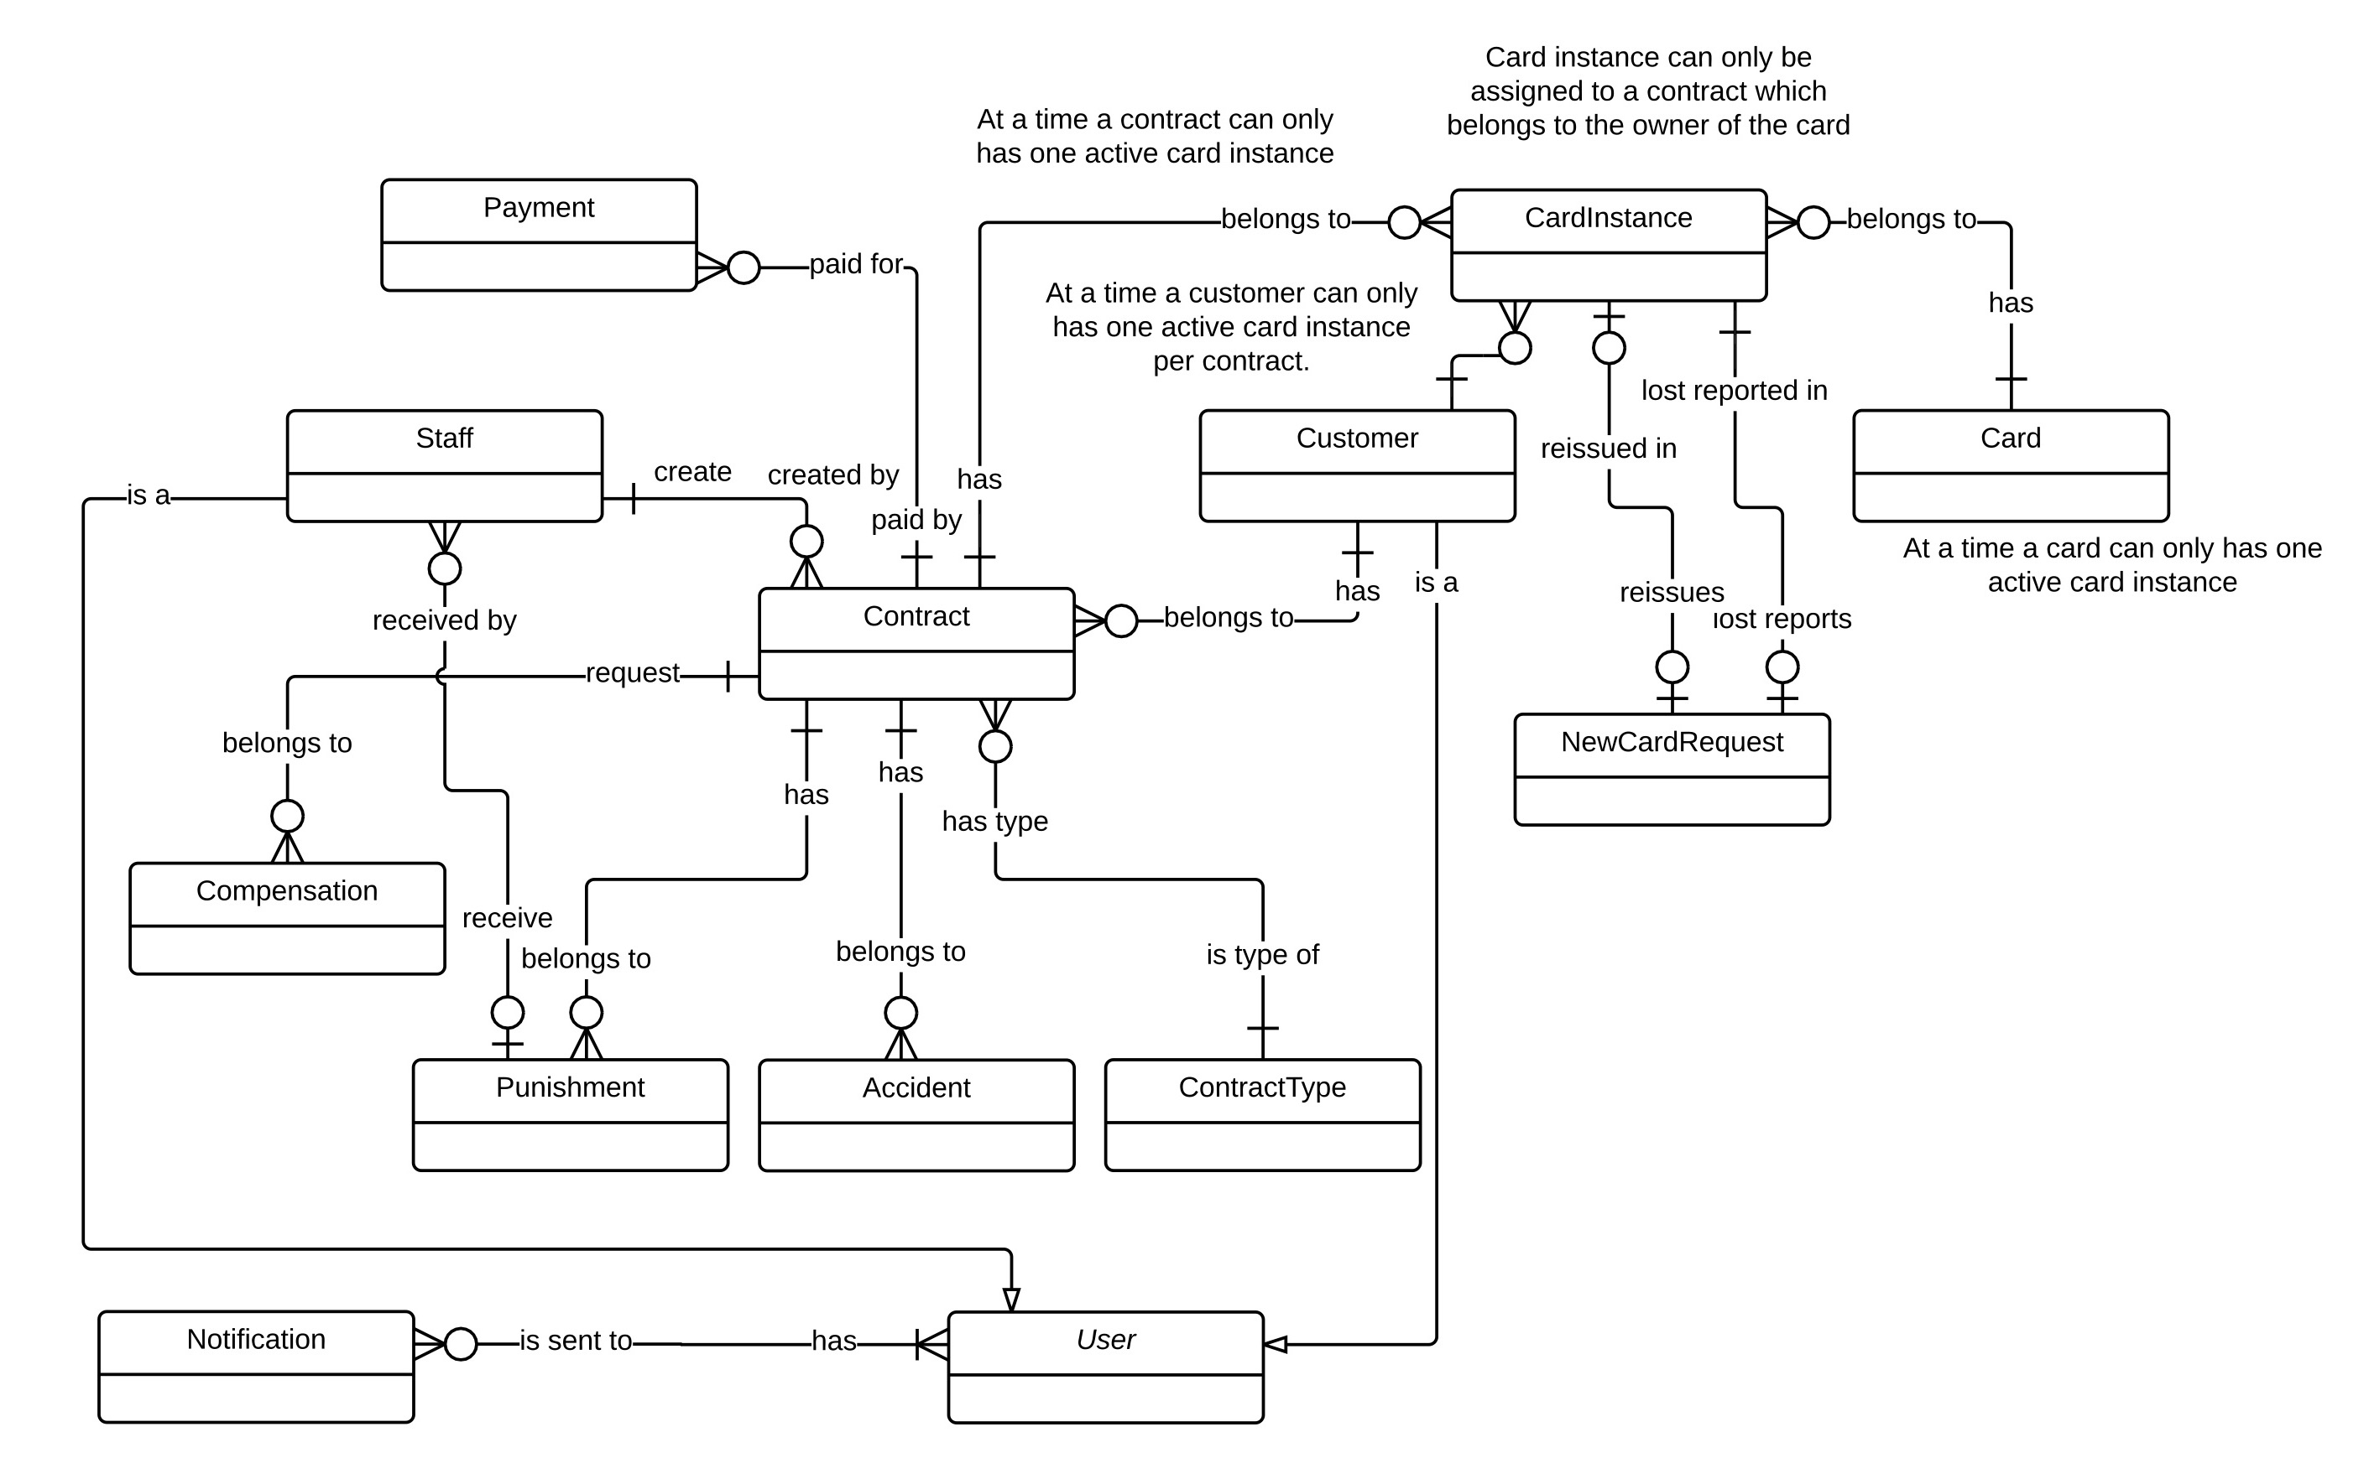

Figure Conceptual diagram

**Data Dictionary**

|  |  |
| --- | --- |
| Entity Data dictionary: describe all content of all entities | |
| Entity Name | **Description** |
| User | Abstract entity describes a user in system |
| Customer | Contain the customer information. |
| Contract | Contain the contract information. |
| Card | Contain the card information |
| CardInstance | Represent a card assigned to a contract |
| Payment | Contain the payment information. |
| Staff | Contain the staff information. |
| Compensation | Contain the compensation information. |
| Punishment | Contain the punishment information. |
| Accident | Contain the accident information. |
| ContractType | Contain the contract type information. |
| NewCardRequest | Contain the new card request information. |
| CardAccessLog | Contain the new card access log. |
| Notification | Contain the notification information |

Table Conceptual Diagram Data Dictionary

# Software Design Description

## Design Overview

* This document describes the technical and user interface design of MIC system. It includes the architectural design, the detailed design of common functions and business functions and the design of database model.
* The architectural design describes the overall architecture of the system and the architecture of each main component and subsystem.
* The detailed design describes static and dynamic structure for each component and functions. It includes class diagrams, class explanations and sequence diagrams for each use cases.
* The database design describes the relationships between entities and details of each entity.
* Document overview:
  + Section 2: gives an overall description of the system architecture design.
  + Section 3: gives component diagrams that describe the connection and integration of the system.
  + Section 4: gives the detail design description, which includes class diagram, class explanation, and sequence diagram to details the application functions.
  + Section 5: describe a fully attributed Entity Relationship Diagram.

## System Architecture Design



Figure System architecture design

### Web Application architecture description

In Web Application, the system is developed under J2EE MVC architecture style. We choose this architecture for Web application because of following advantages:

* Web app contains a Web service (public API for mobile app), with MVC architecture, we can separate business code with Controller and View, so we can use the business code in web service without repeat the code.
* Current system only supports motor insurance card, with MVC architecture, we can organize the code better for maintainability, extensibility, reusability so we can expand the scope to other kind of insurance services such as Heath insurance or Asset insurance…
* In scope of 4-member team, MVC architecture make it easier to split the big project into small modules and make it easier to assign each module for members in our team.

This project follows MVC architecture with following components:

* **Servlet (Controller)** is the parts of the application that acts like event handler to handles user interaction. Typically, controller read data from a request and calls appropriate Business’s method then selects view to return to user.
* **JSP/HTML (View)** is the parts of the application that handles the display of the data. The selection of View is under control of Controller.
* **Business** is the parts of the application that do business processing to solve domain problems.
* **Model** is the parts of the application that acts like a data transfer object between the system and database.
* **Web Service** is the parts of the application that acts like event handler for web and mobile communication via REST method.

### Mobile Application architecture description

The application is developed as an Android native application. In general, the application architecture conforms to Android architecture.



**Reference:** [Android Developer Guide - Application Fundamentals](http://developer.android.com/guide/components/fundamentals.html)

http://developer.android.com/guide/components/fundamentals.html

This project follows Android application architecture with following component:

* **Activity** is the basic core of an android application that handles user input,create thread to run asynchronous tasks, send request and receive data from server via web services ...

## Component Diagram



Figure Component Diagram

|  |  |
| --- | --- |
| Component Dictionary: Describes components | |
| Web Application | Web application package: View, Controller |
| Mobile Application | Mobile application package |
| PayPal | Handle payment process with PayPal API |
| Web Service | operations o handle interaction between the system and database.Provide API for mobile applications to interact with the system. |
| Staff Component | Component to handle staff activities in the system |
| Customer Component | Component to handle customer activities in the system |
| Public Component | Component to handle guest activities in the system |
| Admin Component | Component to handle admin activities in the system |
| Schedule Component | Component to handle scheduler in the system |
| Business Objects | Common objects to handle domain business operations for each components |
| Data Access Objects | Component to handle interaction between the system and database |

Table Component Dictionary

## Detailed Description

### Class Diagram

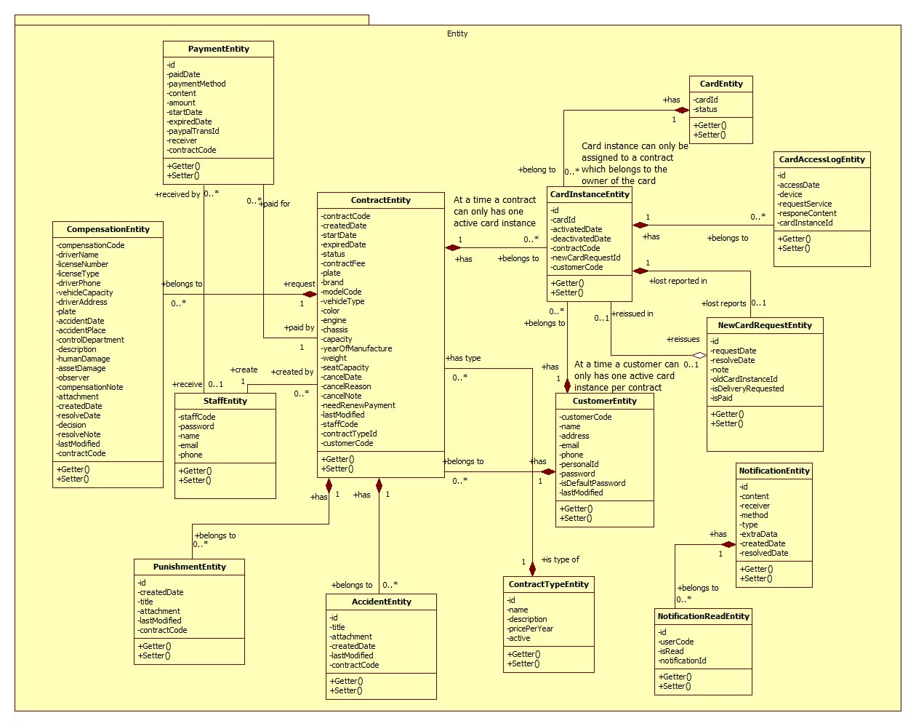

Figure Class Diagram

|  |  |  |
| --- | --- | --- |
| Class dictionary: describe Class | | |
| Class Name | **Mapping column with Conceptual diagram** | **Description** |
| PaymentEntity | Payment | Contain the payment information. |
| CardEntity | Card | Contain the card information. |
| CustomerEntity | Customer | Contain the customer information. |
| ContractEntity | Contract | Contain the contract information. |
| StaffEntity | Staff | Contain the staff information. |
| CompensationEntity | Compensation | Contain the compensation information. |
| PunishmentEntity | Punishment | Contain the punishment information. |
| AccidentEntity | Accident | Contain the accident information. |
| ContractTypeEntity | ContractType | Contain the contract type information. |
| NewCardRequestEntity | NewCardRequest | Contain the new card request information. |
| CardAccessLogEntity | N/A | Not exist in conceptual diagram. But needed in class diagram to contain the card access log information. |
| NotificationEntity | N/A | Not exist in conceptual diagram. But needed in class diagram to contain the notification information. |
| NotificationReadEntity | N/A | Not exist in conceptual diagram. But needed in class diagram to know what notifications is read. |

Table Class dictionary

### Class Diagram Explanation

#### PaymentEntity

|  |  |  |  |
| --- | --- | --- | --- |
| Attribute | Type | Visibility | Description |
| Id | int | Private | Unique identifier of an payment |
| paidDate | Timestamp | Private | The day process the payment |
| paymentMethod | String | Private | The payment method |
| content | String | Private | The content of the payment |
| amount | Double | Private | Total amount of the payment |
| receiver | String | Private | The payment receiver |
| paypalTransId | String | Private | The PayPal transaction ID |
| contractCode | String | Private | The contract code. |

Table PaymentEntity Attribute

|  |  |  |  |
| --- | --- | --- | --- |
| Method | Return Type | Visibility | Description |
| Getter | Attribute type | Public | Get attribute value. |
| Setter | Void | Public | Set value of attribute. |

Table PaymentEntity Method

#### CardEntity

|  |  |  |  |
| --- | --- | --- | --- |
| Attribute | Type | Visibility | Description |
| CardId | String | Private | Unique identifier of a card |
| Status | Integer | Private | Status of the card |

Table CardEntity Attribute

|  |  |  |  |
| --- | --- | --- | --- |
| Method | Return Type | Visibility | Description |
| Getter | Attribute type | Public | Get attribute value. |
| Setter | Void | Public | Set value of attribute. |

Table CardEntity Method

#### CardInstanceEntity

|  |  |  |  |
| --- | --- | --- | --- |
| Attribute | Type | Visibility | Description |
| Id | Integer | Private | Unique identifier of a card instance |
| cardId | String | Private | Card id of the instance |
| activatedDate | Timestamp | Private | The date the card was activated. |
| deactivatedDate | Timestamp | Private | The date the card was deactivated. |
| contractCode | String | Private | The contract code |
| newCardRequestId | String | Private | The new card request ID. |

Table CardInstanceEntity Attribute

|  |  |  |  |
| --- | --- | --- | --- |
| Method | Return Type | Visibility | Description |
| Getter | Attribute type | Public | Get attribute value. |
| Setter | Void | Public | Set value of attribute. |

Table CardInstanceEntity Method

#### CustomerEntity

|  |  |  |  |
| --- | --- | --- | --- |
| Attribute | Type | Visibility | Description |
| customerCode | String | Private | Unique identifier of an customer |
| name | String | Private | Customer’s name. |
| address | String | Private | Customer’s address. |
| email | String | Private | Customer’s email. |
| phone | String | Private | Customer’s phone number. |
| personalId | String | Private | The customer’s personal ID. |
| password | String | Private | Customer’s password. |
| customerCode | String | Private | The customer’s code. |

Table CustomerEntity Attribute

|  |  |  |  |
| --- | --- | --- | --- |
| Method | Return Type | Visibility | Description |
| Getter | Attribute type | Public | Get attribute value. |
| Setter | Void | Public | Set value of attribute. |

Table CustomerEntity Method

#### ContractEntity

|  |  |  |  |
| --- | --- | --- | --- |
| Attribute | Type | Visibility | Description |
| contractCode | String | Private | Unique identifier of a contract |
| startDate | Timestamp | Private | The start date of the contract. |
| expiredDate | Timestamp | Private | The expired date of the contract. |
| status | String | Private | The status of the contract. |
| contactFee | Double | Private | The contract fee. |
| plate | String | Private | The plate number of the motor. |
| brand | String | Private | The brand of the motor. |
| modelCode | String | Private | The model code of the motor. |
| vehicleType | String | Private | The vehicle type. |
| color | String | Private | The motor’s color. |
| engine | String | Private | The motor’s engine. |
| chassis | String | Private | The motor’s chassis. |
| capacity | String | Private | The motor’s capacity. |
| yearOfManufacture | int | Private | The year of manufacture. |
| weight | int | Private | The motor’s weight. |
| seatCapacity | int | Private | The seat capacity. |
| cancelDate | Timestamp | Private | The cancel date of the contract. |
| cancelReason | String | Private | The cancel reason. |
| cancelNote | String | Private | The cancel note. |
| contractTypeId | int | Private | The contract type ID. |
| customerCode | String | Private | The customer code. |

Table ContractEntity Attribute

|  |  |  |  |
| --- | --- | --- | --- |
| Method | Return Type | Visibility | Description |
| Getter | Attribute type | Public | Get attribute value. |
| Setter | Void | Public | Set value of attribute. |

Table Contract Method

#### StaffEntity

|  |  |  |  |
| --- | --- | --- | --- |
| Attribute | Type | Visibility | Description |
| staffCode | String | Private | Unique identifier of a staff |
| password | String | Private | The staff’s password |
| name | String | Private | The staff’s name. |
| email | String | Private | The staff’s email. |
| phone | String | Private | The staff’s phone number. |

Table StaffEntity Attribute

|  |  |  |  |
| --- | --- | --- | --- |
| Method | Return Type | Visibility | Description |
| Getter | Attribute type | Public | Get attribute value. |
| Setter | Void | Public | Set value of attribute. |

Table StaffEntity Method

#### CompensationEntity

|  |  |  |  |
| --- | --- | --- | --- |
| Attribute | Type | Visibility | Description |
| compensationCode | String | Private | Unique identifier of a compensation |
| driverName | String | Private | The driver name. |
| licenseNumber | String | Private | The license number of the motor. |
| licenseType | String | Private | The license type of the motor. |
| driverPhone | String | Private | The driver’s phone number. |
| vehicleCapacity | String | Private | The vehicle capacity. |
| driverAddress | String | Private | The driver’s address. |
| plate | String | Private | The plate number. |
| accidentDate | Timestamp | Private | The accident date. |
| accidentPlace | String | Private | The accident place. |
| controlDepartment | String | Private | The police control department. |
| description | String | Private | The compensation’s description. |
| humanDamage | String | Private | The human damages. |
| assetDamage | String | Private | The asset damages. |
| observer | String | Private | The observer. |
| compensationNote | String | Private | The compensation note. |
| attachment | String | Private | The attachment. |
| createdDate | Timestamp | Private | The created date of the compensation. |
| resolveDate | Timestamp | Private | The resolve date. |
| decision | String | Private | The decision. |
| resolveNote | String | Private | The resolve note. |
| contractCode | String | private | The contract code. |

Table CompensationEntity Attribute

|  |  |  |  |
| --- | --- | --- | --- |
| Method | Return Type | Visibility | Description |
| Getter | Attribute type | Public | Get attribute value. |
| Setter | Void | Public | Set value of attribute. |

Table CompensationEntity Method

#### PunishmentEntity

|  |  |  |  |
| --- | --- | --- | --- |
| Attribute | Type | Visibility | Description |
| id | int | Private | Unique identifier of a punishment |
| createdDate | Timestamp | Private | The created date. |
| title | String | Private | The title of the punishment. |
| attachment | String | Private | The attachment. |
| contractCode | String | Private | The contract code. |

Table PunishmentEntity Attribute

|  |  |  |  |
| --- | --- | --- | --- |
| Method | Return Type | Visibility | Description |
| Getter | Attribute type | Public | Get attribute value. |
| Setter | Void | Public | Set value of attribute. |

Table PunishmentEntity Method

#### AccidentEntity

|  |  |  |  |
| --- | --- | --- | --- |
| Attribute | Type | Visibility | Description |
| id | int | Private | Unique identifier of an accident |
| title | String | Private | The title of the accident. |
| attachment | String | Private | The attachment. |
| createdDate | Timestamp | Private | The created date. |
| contractCode | String | Private | The contract code. |

Table AccidentEntity Attribute

|  |  |  |  |
| --- | --- | --- | --- |
| Method | Return Type | Visibility | Description |
| Getter | Attribute type | Public | Get attribute value. |
| Setter | Void | Public | Set value of attribute. |

Table AccidentEntity Method

#### ContractTypeEntity

|  |  |  |  |
| --- | --- | --- | --- |
| Attribute | Type | Visibility | Description |
| id | int | Private | unique identifier of a contract type |
| name | String | Private | The contract’s name. |
| description | String | Private | The description. |
| pricePerYear | Double | Private | The price per year of the contract. |

Table ContractTypeEntity Attribute

|  |  |  |  |
| --- | --- | --- | --- |
| Method | Return Type | Visibility | Description |
| Getter | Attribute type | Public | Get attribute value. |
| Setter | Void | Public | Set value of attribute. |

Table ContractTypeEntity Method

#### NewCardRequestEntity

|  |  |  |  |
| --- | --- | --- | --- |
| Attribute | Type | Visibility | Description |
| id | int | Private | Unique identifier of a new card request |
| requestDate | Timestamp | Private | The request date. |
| resolveDate | Timestamp | Private | The resolve date. |
| note | String | Private | The new card request note. |
| oldCardId | String | Private | The ID of the old card. |
| customerCode | String | Private | The customer code. |

Table NewCardRequestEntity Attribute

|  |  |  |  |
| --- | --- | --- | --- |
| Method | Return Type | Visibility | Description |
| Getter | Attribute type | Public | Get attribute value. |
| Setter | Void | Public | Set value of attribute. |

Table NewCardRequestEntity Method

#### CardAccessLogEntity

|  |  |  |  |
| --- | --- | --- | --- |
| Attribute | Type | Visibility | Description |
| id | int | Private | Unique identifier of an card access log |
| accessDate | Timestamp | Private | The access date. |
| device | String | Private | The device name. |
| requestService | String | Private | The request service. |
| responseContent | String | Private | The response content. |

Table CardAccessLogEntity Attribute

|  |  |  |  |
| --- | --- | --- | --- |
| Method | Return Type | Visibility | Description |
| Getter | Attribute type | Public | Get attribute value. |
| Setter | Void | Public | Set value of attribute. |

Table CardAccessLogEntity Method

#### NotificationEntity

|  |  |  |  |
| --- | --- | --- | --- |
| Attribute | Type | Visibility | Description |
| id | int | Private | Unique identifier of the notification. |
| content | String | Private | Content of the notification. |
| receiver | String | Private | A regex pattern that match with staffCode or customerCode. |
| method | int | Private | Notification method such as email or web notification. |
| type | int | Private | Type of the action were notified. |
| extraData | String | Private | The extra data such as contractCode, compensationCode,etc. |
| createdDate | Timestamp | Private | The created date. |
| resolvedDate | Timestamp | Private | The resolved date. |

Table NotificationEntity Attribute

|  |  |  |  |
| --- | --- | --- | --- |
| Method | Return Type | Visibility | Description |
| Getter | Attribute type | Public | Get attribute value. |
| Setter | Void | Public | Set value of attribute. |

Table NotificationEntity Method

#### NotificationReadEntity

|  |  |  |  |
| --- | --- | --- | --- |
| Attribute | Type | Visibility | Description |
| id | int | Private | Unique identifier of the notification read. |
| userCode | String | Private | Customer code or staff code. |
| isRead | int | Private | Check if the notification is read. |
| notificationId | int | Private | Notification’s Id. |

Table NotificationReadEntity Attribute

|  |  |  |  |
| --- | --- | --- | --- |
| Method | Return Type | Visibility | Description |
| Getter | Attribute type | Public | Get attribute value. |
| Setter | Void | Public | Set value of attribute. |

Table NotificationReadEntity Method

### Interactive Diagram

#### Web Application

##### Staff

###### Create new contract



Figure Sequence diagram - <Staff> Create new contract

###### Renew contract



Figure Sequence diagram - <Staff> Renew contract

###### Cancel contract

 Figure Sequence diagram - <Staff> Cancel contract

##### Customer

###### Cancel contract



Figure Sequence diagram - <Customer> Cancel contract

###### Renew contract



Figure Sequence diagram - <Customer> Renew contract

##### Guest

###### Register new contract



Figure Sequence diagram - <Guest> Register new contract

###### PayPal payment



Figure Sequence diagram - <Guest> Paypal payment

#### Mobile Application

##### Checker Mobile Application

###### <Police> Verify card validation



Figure <Police> Verify card validation

###### <Police> Add punishment information



Figure <Police> Add punishment information

##### Printer Mobile Application

###### <Staff> Search contract



Figure <Staff> Search contract

###### <Staff> View contract information



Figure <Staff> View contract information

###### <Staff> Print information to NFC Card



Figure <Staff> Print information to NFC card

## Interface

### Component Interface

#### Web Service Interface

|  |  |  |  |  |  |
| --- | --- | --- | --- | --- | --- |
| Signature | Description | Input | Output | Output Format | Exception |
| public ResponseObject getCheckConnection(R r) | Check server status | Request object r | Json Boolean the status of server | Boolean | JsonProcessingException |
| Contractlean if the update is successntractpublic ResponseObject getContracts(R r) | Search contracts by code or customer name | Request object r contains:  Keyword: String | Json string List of ContractSearchResultDto | ContractEntity  CustomerEntity | JsonProcessingException |
| public ResponseObject getUpdateCardID(R r) | Update card ID to a contract | Request object r contains:  cardID: String  contractCode: String | Json CardEntity object | CardEntity | JsonProcessingException  NoResultException |
| public ResponseObject getCheckCard(R r) | Check the validation of the card | Request object r contains:  cardID: String | Json CardEntity object | CardEntity | JsonProcessingException  NoResultException |
| public ResponseObject getUpdatePunishment(R r) | Update punishment information to a contract | Request object r contains:  contractCode: String  punishmentInfo: PunishmentInfoObject | Json Boolean the update result | Boolean | JsonProcessingException |

Table Web Services Interfaces

|  |  |
| --- | --- |
| Entity | Description |
| ContractEntity | contractCode  startDate  expiredDate  status  contractFee  plate  brand  modelCode  vehicleType  color  engine  chassis  capacity  yearOfManufacture  weight  seatCapacity  cancelDate  cancelReason  cancelNote  staffCode  contractTypeId  customerCode  needRenewPayment  lastModified  createdDate |
| CustomerEntity | customerCode  name  address  email  phone  personalId  password  isDefaultPassword  lastModified |
| CardEntity | cardId  activatedDate  deactivatedDate  contractCode  newCardRequestId |

Table Entity description

|  |  |
| --- | --- |
| Exception | Description |
| JsonProcessingException | encountered when processing (parsing, generating) JSON content that are not pure I/O problems |
| NoResultException | Thrown by the persistence provider when getSingleResult() is executed on a query and there is no result to return |

Table Exception description

### Web application Design

#### Staff Interface Design

##### Staff home page



Figure Interface - <Staff> Home page

**Fields**

|  |  |  |  |  |  |  |  |
| --- | --- | --- | --- | --- | --- | --- | --- |
| No | Field Name | Description | Read only | Mandatory | Control Type | Data Type | Length |
| 1 | Menu | Navigation bar | Yes | Yes | Menu bar | N/A | N/A |
| 2 | Title | Title of the page | Yes | Yes | Label | N/A | N/A |

Table Staff home page fields

**Buttons/Hyperlinks**

|  |  |  |  |  |
| --- | --- | --- | --- | --- |
| No | Function | Description | Validation | Outcome |
| 3 | viewContract | List all contract | N/A | Transfer to list contract page |
| 4 | viewCompensation | List all compensation | N/A | Transfer to list compensation page |
| 5 | viewNewCardReq | List all new card request | N/A | Transfer to list new card request page |
| 6 | viewCancelContract | List all cancel contract request | N/A | Transfer to list contract page |

Table Staff home page buttons/hyperlinks

##### Manage customer



Figure Interface - <Staff> Manage customer

**Fields**

|  |  |  |  |  |  |  |  |
| --- | --- | --- | --- | --- | --- | --- | --- |
| No | Field Name | Description | Read only | Mandatory | Control Type | Data Type | Length |
| 1 | Menu | Navigation bar | Yes | Yes | Menu bar | N/A | N/A |
| 2 | Title | Title of the page | Yes | Yes | Label | N/A | N/A |
| 3 | Number | Number of available customer | Yes | No | Label | N/A | N/A |
| 4 | txtSearchValue | Fill search keyword | No | Yes | Textbox | String | N/A |
| 5 | Table | Table of available customer | Yes | Yes | Table | N/A | N/A |

Table <Staff> Manage customer fields

**Buttons/Hyperlinks**

|  |  |  |  |  |
| --- | --- | --- | --- | --- |
| No | Function | Description | Validation | Outcome |
| 6 | btnCreate | Create new customer | N/A | Transfer to create new customer page |
| 7 | btnSearch | Search by input keyword | N/A | Transfer to search result page |
| 8 | customerDetail | View customer detail | N/A | Transfer to customer detail page |

Table <Staff> Manage customer buttons/hyperlinks

##### Create customer



Figure Interface - <Staff> Create customer

**Fields**

|  |  |  |  |  |  |  |  |
| --- | --- | --- | --- | --- | --- | --- | --- |
| No | Field Name | Description | Read only | Mandatory | Control Type | Data Type | Length |
| 1 | Menu | Navigation bar | Yes | Yes | Menu bar | N/A | N/A |
| 2 | Title | Title of the page | Yes | Yes | Label | N/A | N/A |
| 3 | txtName | Fill customer name | No | Yes | Textbox | String | 3 – 80 |
| 4 | txtAddress | Fill address | No | Yes | Textbox | String | 3 – 250 |
| 5 | txtEmail | Fill email | No | Yes | Textbox | String | 3 – 250 |
| 6 | txtPhone | Fill phone | No | Yes | Textbox | Integer | 8 – 15 |
| 7 | txtPersonal ID | Fill personal ID | No | No | Textbox | Integer | 8 – 15 |

Table <Staff> Create customer fields

**Buttons/Hyperlinks**

|  |  |  |  |  |
| --- | --- | --- | --- | --- |
| No | Function | Description | Validation | Outcome |
| 8 | btnCreate | Create new customer | N/A | Transfer to create new customer successful page |

Table <Staff> Create customer buttons/hyperlinks

##### Manage contract



Figure Interface - <Staff> Manage contract

**Fields**

|  |  |  |  |  |  |  |  |
| --- | --- | --- | --- | --- | --- | --- | --- |
| No | Field Name | Description | Read only | Mandatory | Control Type | Data Type | Length |
| 1 | Menu | Navigation bar | Yes | Yes | Menu bar | N/A | N/A |
| 2 | Title | Title of the page | Yes | Yes | Label | N/A | N/A |
| 3 | Number | Number of available contract | Yes | No | Label | N/A | N/A |
| 4 | txtSearchValue | Fill search keyword | No | Yes | Textbox | String | N/A |
| 5 | Table | Table of available customer | Yes | Yes | Table | N/A | N/A |

Table <Staff> Manage contracts fields

**Button/Hyperlinks**

|  |  |  |  |  |
| --- | --- | --- | --- | --- |
| No | Function | Description | Validation | Outcome |
| 6 | btnCreate | Create new contract | N/A | Transfer to create new contract page |
| 7 | btnSearch | Search by input keyword | N/A | Transfer to search result page |
| 8 | contractDetail | View contract detail | N/A | Transfer to contract detail page |
| 9 | customerDetail | View customer detail | N/A | Transfer to customer detail page |

Table <Staff> Manage contracts buttons/hyperlinks

##### Create contract



Figure Interface - <Staff> Create contract

**Fields**

|  |  |  |  |  |  |  |  |
| --- | --- | --- | --- | --- | --- | --- | --- |
| No | Field Name | Description | Read only | Mandatory | Control Type | Data Type | Length |
| 1 | Menu | Navigation bar | Yes | Yes | Menu bar | N/A | N/A |
| 2 | Title | Title of the page | Yes | Yes | Label | N/A | N/A |
| 3 | txtCustomerCode | Fill customer code | No | Yes | Textbox | String | 6 |
| 4 | ddlContractType | Select contract type | No | Yes | Select | N/A | N/A |
| 5 | txtStartDate | Select start date | No | Yes | Date input form | N/A | N/A |
| 6 | txtExpiredDate | Select expired date | No | Yes | Date input form | N/A | N/A |
| 7 | txtContractFee | Contract fee | Yes | Yes | Label | N/A | N/A |
| 8 | txtPlate | Fill vehicle plate | No | Yes | Textbox | String | 4 – 15 |
| 9 | txtBrand | Fill vehicle brand | No | Yes | Textbox | String | 2 – 20 |
| 10 | txtEngine | Fill vehicle engine | No | Yes | Textbox | String | 2 – 20 |
| 11 | txtChassis | Fill vehicle chassis | No | Yes | Textbox | String | 2 – 20 |
| 12 | txtCapacity | Fill vehicle capacity | No | Yes | Textbox | String | 2 – 20 |
| 13 | txtColor | Fill vehicle color | No | No | Textbox | String | 2 – 20 |
| 14 | txtType | Fill vehicle type | No | No | Textbox | String | 2 – 20 |
| 15 | txtModel code | Fill vehicle model code | No | No | Textbox | String | 2 – 20 |
| 16 | txtYearOfMan | Fill vehicle year of manufacture | No | No | Textbox | String | 4 |
| 17 | txtWeight | Fill vehicle empty weight | No | No | Textbox | String | 1 – 4 |
| 18 | txtSeatCapacity | Fill vehicle seat capacity | No | No | Textbox | String | 1 – 3 |
| 19 | txtPaidDate | Select paid contract fee date | No | Yes | Date input form | N/A | N/A |

Table <Staff> Create contract fields

**Buttons/Hyperlinks**

|  |  |  |  |  |
| --- | --- | --- | --- | --- |
| No | Function | Description | Validation | Outcome |
| 20 | btnSelect | Select customer | N/A | Transfer to select customer modal |
| 21 | btnCreate | Create new contract | N/A | Transfer to create new contract successful page |

Table <Staff> Create contract buttons/hyperlinks

##### Renew contract



Figure Interface - <Staff> Renew contract

**Fields**

|  |  |  |  |  |  |  |  |
| --- | --- | --- | --- | --- | --- | --- | --- |
| No | Field Name | Description | Read only | Mandatory | Control Type | Data Type | Length |
| 1 | Title | Title of the modal | Yes | Yes | Label | N/A | N/A |
| 2 | Start date | Contract’s start date | Yes | Yes | Label | N/A | N/A |
| 3 | txtExpiredDate | Select expired date | No | Yes | Date input form | N/A | N/A |
| 4 | txtAmount | Renew contract fee | Yes | Yes | Label | N/A | N/A |
| 5 | txtPaidDate | Select paid contract fee date | No | Yes | Date input form | N/A | N/A |

Table <Staff> Renew contract fields

**Buttons/Hyperlinks**

|  |  |  |  |  |
| --- | --- | --- | --- | --- |
| No | Function | Description | Validation | Outcome |
| 6 | btnRenew | Renew contract | N/A | Transfer to renew contract successful page |
| 7 | btnClose | Close modal | N/A | Transfer to contract detail page |

Table <Staff> Renew contract buttons/hyperlinks

##### Cancel contract



Figure Interface - <Staff> Cancel contract

**Fields**

|  |  |  |  |  |  |  |  |
| --- | --- | --- | --- | --- | --- | --- | --- |
| No | Field Name | Description | Read only | Mandatory | Control Type | Data Type | Length |
| 1 | Title | Title of the modal | Yes | Yes | Label | N/A | N/A |
| 2 | txtCancelDate | Select cancel contract date | No | Yes | Date input form | N/A | N/A |
| 3 | txtCancelReason | Fill cancel contract reason | No | Yes | Textbox | String | 1 – 250 |
| 4 | txtCancelNote | Fill note about cancel contract | No | No | Text area | String | 1 - 2000 |

Table <Staff> Cancel contract fields

**Buttons/Hyperlinks**

|  |  |  |  |  |
| --- | --- | --- | --- | --- |
| No | Function | Description | Validation | Outcome |
| 5 | btnCancel | Cancel contract | N/A | Transfer to cancel contract successful page |
| 6 | btnClose | Close modal | N/A | Transfer to contract detail page |

Table <Staff> Cancel contract buttons/hyperlinks

#### Customer Interface Design

##### Manage contract



Figure Interface - <Customer> Manage contract

**Fields**

|  |  |  |  |  |  |  |  |
| --- | --- | --- | --- | --- | --- | --- | --- |
| No | Field Name | Description | Read only | Mandatory | Control Type | Data Type | Length |
| 1 | lblMenu | Navigation bar | Yes | Yes | Menu bar | N/A | N/A |
| 2 | lblTitle | Title of the page | Yes | Yes | Label | N/A | N/A |
| 3 | lblAmountContract | Number of available customer | Yes | No | Label | N/A | N/A |
| 4 | lblContractStatus | Status of contract | Yes | No | Label | N/A | N/A |
| 5 | txtSearch | Fill search keyword | No | Yes | Textbox | String | N/A |
| 6 | contractTable | Table of available contract | Yes | Yes | Table | N/A | N/A |

Table <Customer> Manage contract fields

**Buttons / Hyperlinks**

|  |  |  |  |  |
| --- | --- | --- | --- | --- |
| No | Function | Description | Validation | Outcome |
| 7 | btnSearch | Search by input keyword | N/A | Transfer to search result page |
| 8 | btnCreate | Create new customer | N/A | Transfer to create new customer page |
| 9 | linkContractDetail | View contract detail | N/A | Transfer to contract detail page |

Table <Customer> Manage contract buttons/hyperlinks

##### Contract detail



Figure Interface - <Customer> Contract detail

**Fields**

|  |  |  |  |  |  |  |  |
| --- | --- | --- | --- | --- | --- | --- | --- |
| No | Field Name | Description | Read only | Mandatory | Control Type | Data Type | Length |
| 1 | lblMenu | Navigation bar | Yes | Yes | Menu bar | N/A | N/A |
| 2 | lblTitle | Contract code | Yes | Yes | Label | N/A | N/A |
| 3 | txtTab | Information about contract | Yes | No | Tab | N/A | N/A |
| 4 | lblContractStatus | Status of contract | Yes | No | Label | N/A | N/A |
| 5 | txtInformation | Information about contract | No | Yes | Textbox | String | N/A |

Table <Customer> Contract detail fields

**Buttons / Hyperlinks**

|  |  |  |  |  |
| --- | --- | --- | --- | --- |
| No | Function | Description | Validation | Outcome |
| 6 | btnRenew | Renew contract | N/A | Show popup to choose the reason cancel |
| 7 | btnCancel | Cancel contract | N/A | Show popup to provide new time for contract and the way to pay for renew contract |

Table <Customer> Contract detail buttons/hyperlinks

##### Cancel contract



Figure Interface - <Customer> Cancel contract

**Fields**

|  |  |  |  |  |  |  |  |
| --- | --- | --- | --- | --- | --- | --- | --- |
| No | Field Name | Description | Read only | Mandatory | Control Type | Data Type | Length |
| 1 | lblTitle | Title | Yes | Yes | Label | N/A | N/A |

Table <Customer> Cancel contract fields

**Buttons / Hyperlinks**

|  |  |  |  |  |
| --- | --- | --- | --- | --- |
| No | Function | Description | Validation | Outcome |
| 2 | chkOptionCancel | Choose reason why customer cancel contract | N/A | N/A |
| 3 | btnConfirm | Confirm to cancel contract | If customer doesn’t input the reason in case they choose another reason, the system will notify. | Reload contract detail with information about contract is canceled |
| 4 | btnLeave | Leave request cancel | N/A | Return to contract detail |

Table <Customer> Cancel contract button/hyperlinks

##### Renew contract



Figure Interface - <Customer> Renew contract

**Select paypment method**

**Fields**

|  |  |  |  |  |  |  |  |
| --- | --- | --- | --- | --- | --- | --- | --- |
| No | Field Name | Description | Read only | Mandatory | Control Type | Data Type | Length |
| 1 | lblTitle | Title | Yes | Yes | Label | N/A | N/A |
| 2 | txtInformation | Information about renew contract | Yes | Yes | Label | N/A | N/A |

Table <Customer> Renew contract fields

**Buttons / Hyperlinks**

|  |  |  |  |  |
| --- | --- | --- | --- | --- |
| No | Function | Description | Validation | Outcome |
| 3 | btnConfirm | Confirm to renew contract | N/A | Transfer to checkout page |
| 4 | btnLeave | Leave request renew | N/A | Return to contract detail |

Table <Customer> Renew contract button/hyperlinks

##### Select payment method



Figure Interface - <Customer> Select payment method

**Fields**

|  |  |  |  |  |  |  |  |
| --- | --- | --- | --- | --- | --- | --- | --- |
| No | Field Name | Description | Read only | Mandatory | Control Type | Data Type | Length |
| 1 | lblTitle | Title | Yes | Yes | Label | N/A | N/A |
| 2 | txtInformation | Information about renew contract | Yes | Yes | Label | N/A | N/A |

Table <Customer> Select payment method fields

**Buttons / Hyperlinks**

|  |  |  |  |  |
| --- | --- | --- | --- | --- |
| No | Function | Description | Validation | Outcome |
| 3 | btnPaypal | Payment by paypal | N/A | Transfer to paypal page |
| 4 | btnDirect | Payment direct at company | N/A | Show address of list company |

Table <Customer> Select payment method buttons/hyperlinks

**Select paypment method**

### Checker Mobile Application Design

#### Scan NFC card screen



Figure Scan NFC card screen

**Fields**

|  |  |  |  |  |  |  |  |
| --- | --- | --- | --- | --- | --- | --- | --- |
| No | Field Name | Description | Read only | Mandatory | Control Type | Data Type | Length |
| 1 | txtCardIDnpen print card screen supporto view detail information of that contractCard | ID of the card | No | No | Textbox | String | 20 |

Table Scan NFC card screen - Fields

**Buttons**

|  |  |  |  |  |
| --- | --- | --- | --- | --- |
| No | Function | Description | Validation | Outcome |
| 2 | btnCheckCard | Verify card validation | N/A | Go to view card information screen |

Table Scan NFC card screen - Buttons

#### View card information screen



Figure View card information screen

**Buttons**

|  |  |  |  |  |
| --- | --- | --- | --- | --- |
| No | Function | Description | Validation | Outcome |
| 1 | btnMenu | Show menu which contains “Add punishment” button and “Exit” button | N/A | Open menu |
| 2 | mnuAddPunishment | Add punishment information | N/A | Open add punishment dialog |
| 3 | mnuExit | Exit the current page | N/A | Return to Scan screen |

Table View card information screen - Buttons

#### Add punishment screen

### Printer Mobile Application Design

#### Search contract screen



Figure Search contract screen

**Fields**

|  |  |  |  |  |  |  |  |
| --- | --- | --- | --- | --- | --- | --- | --- |
| No | Field Name | Description | Read only | Mandatory | Control Type | Data Type | Length |
| 1 | txtSearch | Search box where user input search keyword | No | No | Textbox | String | 0 - 200 |

Table Search contract screen - Fields

**Buttons**

|  |  |  |  |  |
| --- | --- | --- | --- | --- |
| No | Function | Description | Validation | Outcome |
| 2 | btnSearch | Search contract with keyword | N/A | The list will be updated with search results |
| 3 | lstContracts | Click to a row from the list to view detail information of that contract | N/A | Show view contract screen |

Table Search contract screen - Buttons

#### View contract screen



Figure View contract screen

**Buttons**

|  |  |  |  |  |
| --- | --- | --- | --- | --- |
| No | Function | Description | Validation | Outcome |
| 1 | btnPrint | Click to print information to NFC card | Phone have to have NFC support | Open print card screen |

Table View npen print card screen supporto view detail information of that contractcontract screen - Buttons

#### Print card screen



Figure Print card screen

## Database Design

### Entity relationship diagram

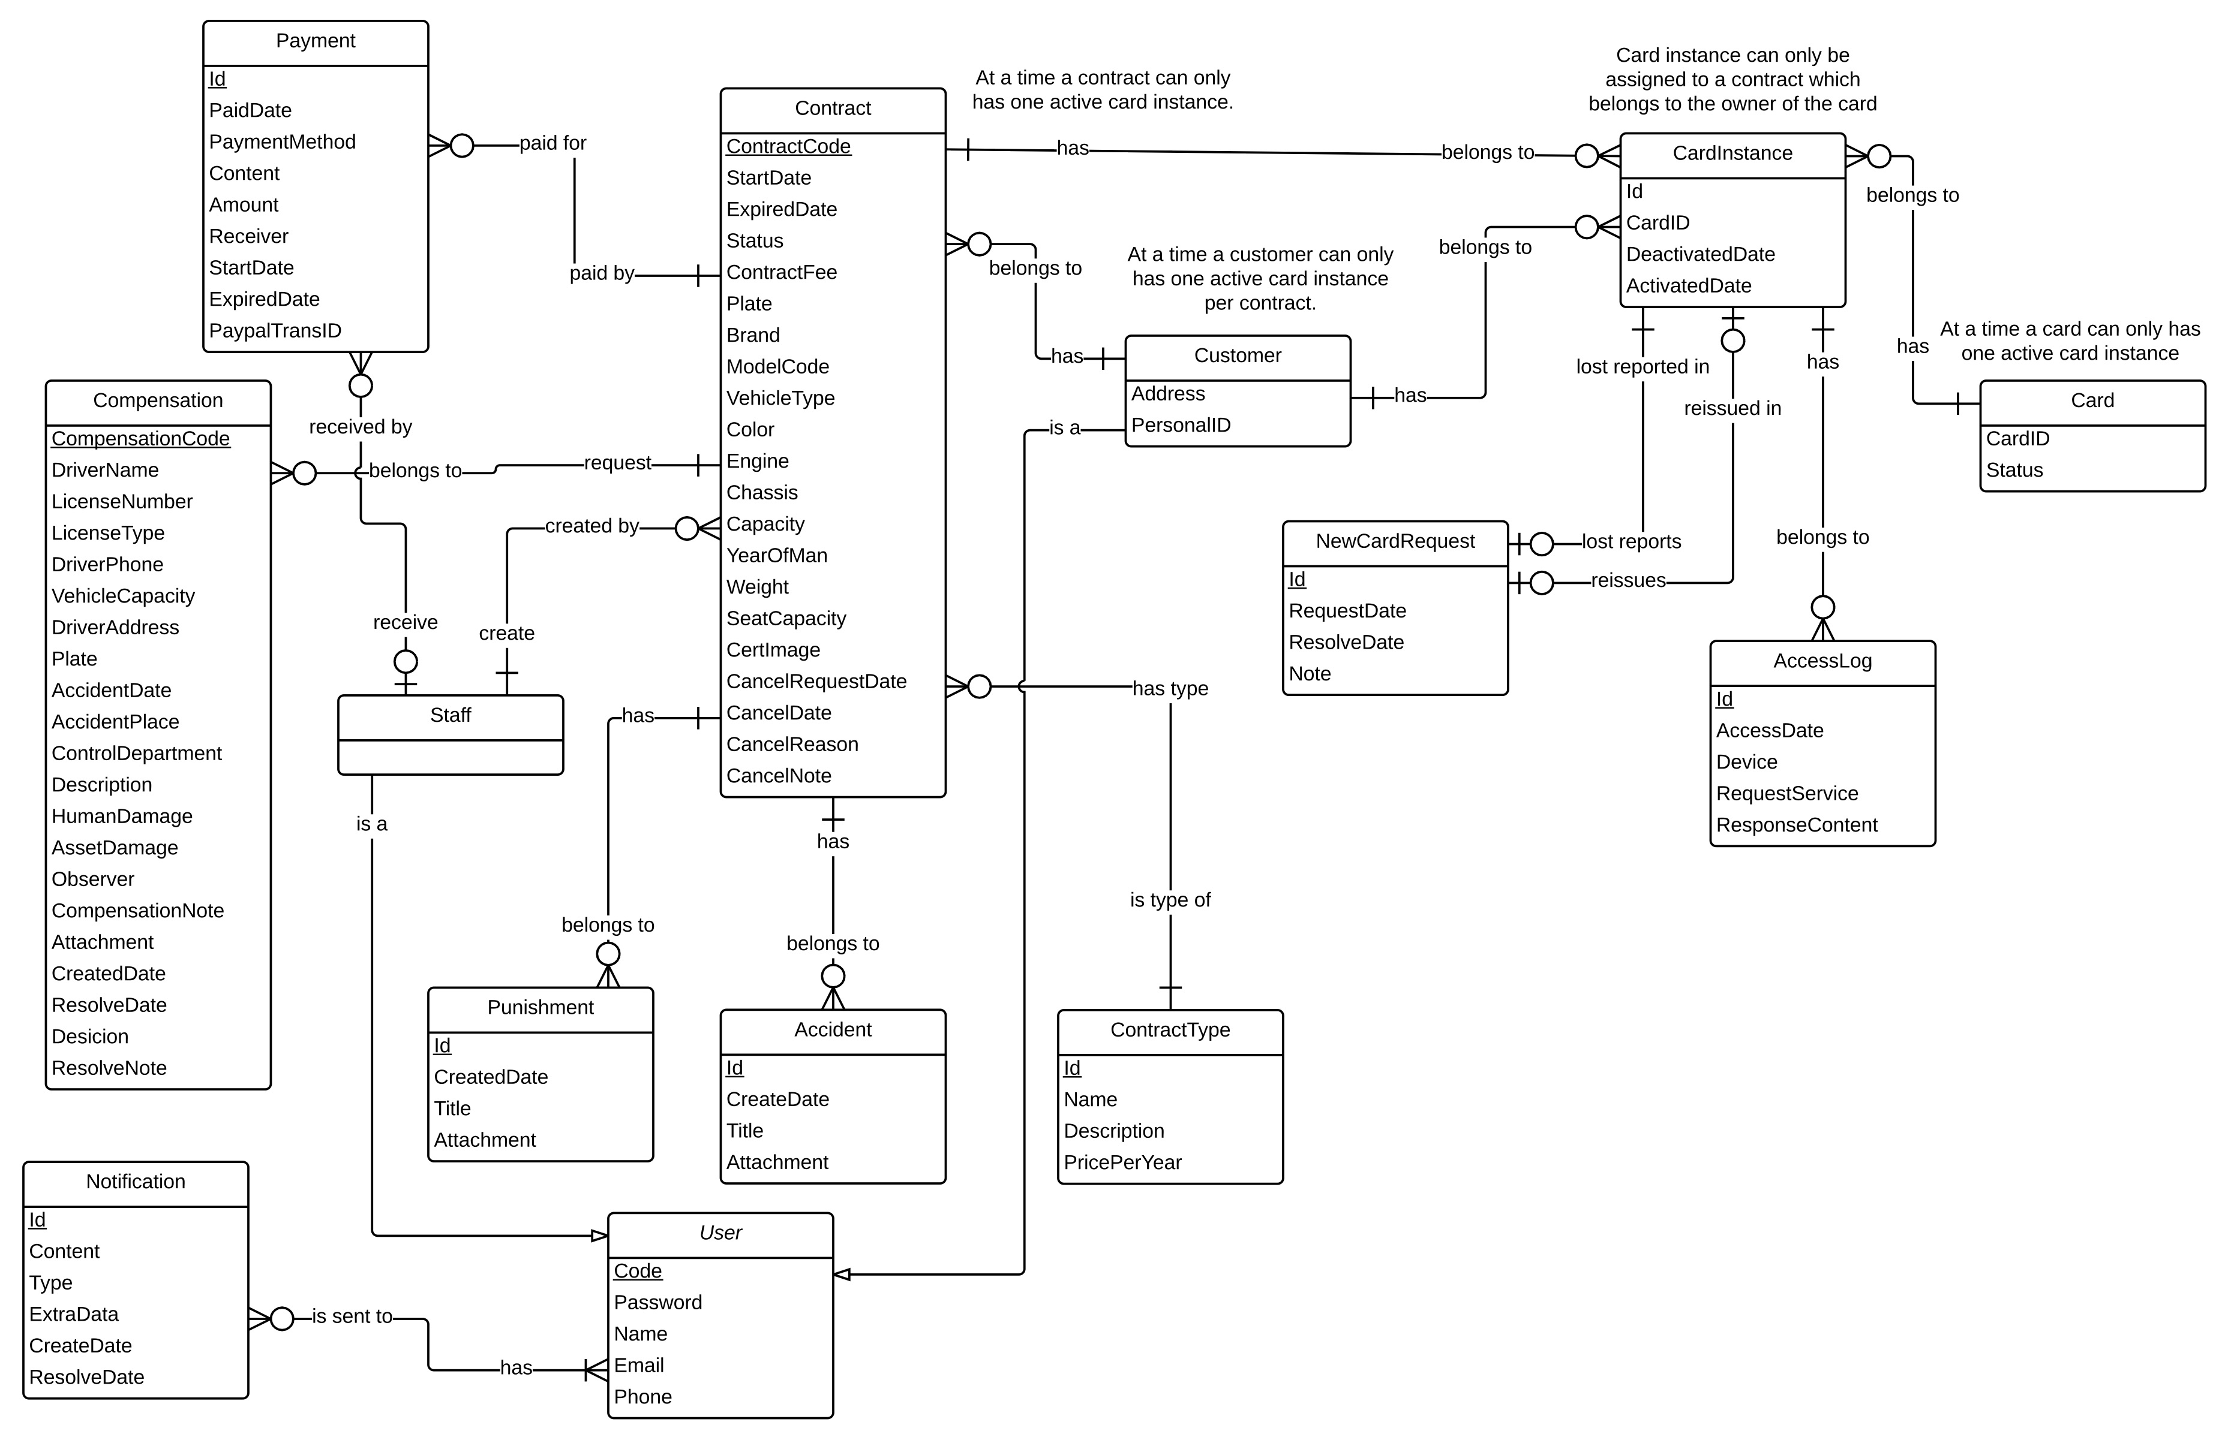

Figure Entity relationship diagram

### Entity Dictionary

|  |  |
| --- | --- |
| Entity Data Dictionary: describe content of all entities | |
| Entity name | **Description** |
| User | Abstract entity describes a user in system |
| Customer | Contain the customer information. |
| Contract | Contain the contract information. |
| Card | Contain the card information |
| CardInstance | Represent a card assigned to a contract |
| Payment | Contain the payment information. |
| Staff | Contain the staff information. |
| Compensation | Contain the compensation information. |
| Punishment | Contain the punishment information. |
| Accident | Contain the accident information. |
| ContractType | Contain the contract type information. |
| NewCardRequest | Contain the new card request information. |
| CardAccessLog | Contain the new card access log. |
| Notification | Contain the notification information |

Table Entity dictionary

## Algorithms

### Contract State

The contracts in MIC system is complex and can be managed differently during the operation. The state chart bellow describes all the state of a contract.



Figure Contract State Chart

|  |  |
| --- | --- |
| SStimulusion﷽﷽﷽﷽﷽> ERDquence numberecution bar em and database.tate | Description |
| Pending | The contract is created and do not have payment or the start date is not come yet |
| No card | The contract had have payment but have not assigned to a card |
| Ready | The contract is assigned with a card and ready to use |
| Expired | The contract due date is exceed and no longer valuable |
| Request cancel | The contract is requested to cancel by customer |
| Cancelled | The contract is cancelled and no longer valuable |

Table Contract State Dictionary

|  |  |  |  |
| --- | --- | --- | --- |
| Stimulus | Description | State before | State after |
| Create | Customer create new contract | N/A | Pending |
| Payment | Customer pay for the contract via PayPal or direct payment | Pending | No card |
| Payment due date exceed | When the payment due date is exceed | Pending | Cancelled |
| Print card | Staff use mobile app to print the card for customer, the card ID is saved to the system | No card | Ready |
| Expire | When the contract due date is exceed, system will change the contract status | Rancelledancelcancel request from customer via web application .eady | Expired |
| Renew | Customer renew contract via web application or direct payment | Expired | Ready |
| Staff cancel contract | Staff cancel contract via web application | No card, Ready | Cancelled |
| Customer cancel contract | Customer cancel contract via web application | No card, Ready | Request cancel |
| Staff approve cancelledancelcancel request from customer via web application .ancel contract | Staff approve cancel request from customer via web application | Request cancel | Cancelled |

Table Contract State Flow

### Concurrency Control

#### Definition

Concurrency control is a method to handle data which can be accessed and modified from many sources at the same time to prevent conflict and data loss.

#### Define problem

In web application, one contract might be edited by stakeholders at the same time, this situation may cause an inconsistent state of the contract. We have to find a solution for this problem.

#### Solution

We defined a list of entity that might be modified by many sources at a same time:

* **Contract**: can be edited/renew by stakeholders at a same time. This includes the information assigned with the contract: Payment, Compensation, Accident and Punishment information.

We use timestamp concurrency control method to solve the concurrency problem. Contract information have a “last modified” value, this value represent the last time the contract is modified. When update the contract information, a validation will run to check if the last modified is changed or not. If it is changed there will be error message to users.

#### Flow chart



Figure Concurrency control flow

### Notification

#### Definition

Notification is a feature of MIC Web application to notify stakeholders when important events occurs.

#### Notification Methods

* Send email to receiver
* Show notification icon on web interface

#### Notification use cases

|  |  |  |  |
| --- | --- | --- | --- |
| Type | Trigger | Receiver | Notify method |
| 1 | Customer creates new contract | All staff | Web |
| 2 | Customer sends compensation request | All staff | Web |
| 3 | Customer sends new card request | All staff | Web |
| 4.1 | Contract is nearly expired (send first) | Customer | Web, Email |
| 4.2 | Contract is nearly expired (send 2nd time) | Customer | Web, Email |
| 4.3 | Contract is nearly expired (send 3rd time) | Customer | Web, Email |
| 5 | Contract is expired | Customer | Web, Email |
| 6 | Customer sends request cancel | All staff | Web |
| 7 | Contract is cancelled because payment due date exceed | Customer | Web, Email |
| 8 | Paid Pending Contract start date come | Customer | Web |
| 9 | Compensation resolved | Customer | Web, Email |

Table Notification use cases

* For staffs, every notification has "status" to show that if the notification not resolved or when the notification is resolved and by whom. Except Type 1 notification has no status.
* All the notification can be handedly turned off by clicking Mark as read button
* When a notification is sent to all the staff, each staff has their own "Read" status. That's mean if staff A mark the status as read but staff B still see it as not read.

### System Scheduler Process

#### Definition

System scheduler is a component of the Web application, this component is responsible for checking the changes from web application and updates information day by day.

#### Define problem

In Web application, the we need a system scheduler that runs every day at 00:00 to check the status of contracts, send notification via web, emails, changes the contract status if the due date is exceed… etc.

#### Solution

We create a scheduler in operating system that run on the same server of the Web application, scheduler will automatically run at specific time that system administrator defines when deploy the system. The scheduler will access to database to check the status and update information to database.

The checking process is described as follow:

1. Get all the contract from the system.
2. With each contract, check following information:
   1. Contract status
   2. Contract expired date
   3. Contract renew due date
   4. Contract payment due date
   5. Compensation requests
   6. New card requests
   7. Cancel request
3. Update the contract state follow the business rules.

#### Flow chart

The following flow chart diagram describes the process of the System scheduler every time it runs.



Figure System Scheduler Process

### NFC Card Data Format

#### Definition

According to Android Developer Forum definition, Near Field Communication (NFC) is a set of short-range wireless technologies, typically requiring a distance of 4cm or less to initiate a connection. NFC allows you to share small payloads of data between an NFC tag and an Android-powered device, or between two Android-powered devices. NFC Card Data format is a type of format to store data in the card’s storage.

#### Define problem

The data stored in the tag can be written in a variety of formats, in Printer application and Checker application we use a NFC Forum standard called NDEF (NFC Data Exchange Format) which is highly recommended from Android developer community.

According to *NFC ForumTM NDEF 1.0 Specification (2006-07-24)*, NDEF Messages is stored in tag in this structure:



Figure NDEF message structure

**Reference:** Brian Jepson, Don Coleman, Tom Igoe. (January 2014). *Beginning NFC, Chapter 4 - Introduction to NDEF, NDEF Structure*. O'Reilly Media, Inc.

NDEF supports followings field types of message:

|  |  |
| --- | --- |
| Type Name Format | Description |
| Empty | Empty record that has no type or payload |
| Well-known | One of several pre-defined types laid out in the NFC Forum RTD specification. |
| MIME media-type | An Internet media type as defined in RFC 2046. |
| Absolute URI | A URI as defined in RFC 3986. |
| External | A user-defined value, based on rules in the NFC Forum Record Type Definition specification. |
| Unknown | Type is unknown. Type length must be 0. |
| Unchanged | Only for middle and terminating records of chunked payloads. Type length must be 0. |
| Reserved | Reserved by the NFC Forum for future use. |

Table NDEF Message Types

**Reference:** NFC Specification, Appendix A. NFC Specification Codes.

To prevent malicious users to override data on the NFC card or using fake card, we need to find a solution to protect data written on the card.

#### Solution

For security reason, we decided to not to write any contract information data to the tag but use only the card low-level ID to verify the card.

Card low-level ID, as known as Manufacture ID (IDm) is an 8-byte number that is used by the NFC Forum Device to address a Type 3 NFC Tag.

**Reference**: *NFC ForumTM Type 3 Tag Operation Specification 1.1, 2011-06-28*.

To make the card ID more friendly to users, we decided to convert the IDm to a series of 2-digit hex number which turn the 8-byte number into a string follow this regex format:

**[0-9A-F]{16}**

Example: 561F3ADF328D9C4B.

To make sure the card can only be read by our Checker application, we write an Android Application Record (AAR) with the package name of the Checker Mobile application.

In this project we have to use NFC card Type 4, which supports IDm and NDEF data format. Other type of NFC card might result different IDm.

**Bellow is the flow to write an NFC tag for customer:**

1. Printer application get contract information
2. Staff confirm the contract information is correct
3. Printer read card ID
4. If the card is not existing in system, update the card ID to the contract
5. Write AAR record to the tag and finish.

**Bellow is the flow to read an NFC tag for police officer:**

1. Checker application read card ID from the card
2. Checker application send card ID to system to verify the card
3. Show result to police officer

### Strategy for future expand plan

MIC system is currently an application to deploy to a single company with single contract type. Our vision for the future plan is to deploy MIC system to multiple companies and with multiple types of contract (motor insurance, health insurance, asset insurance…).

#### Isolated Single Service

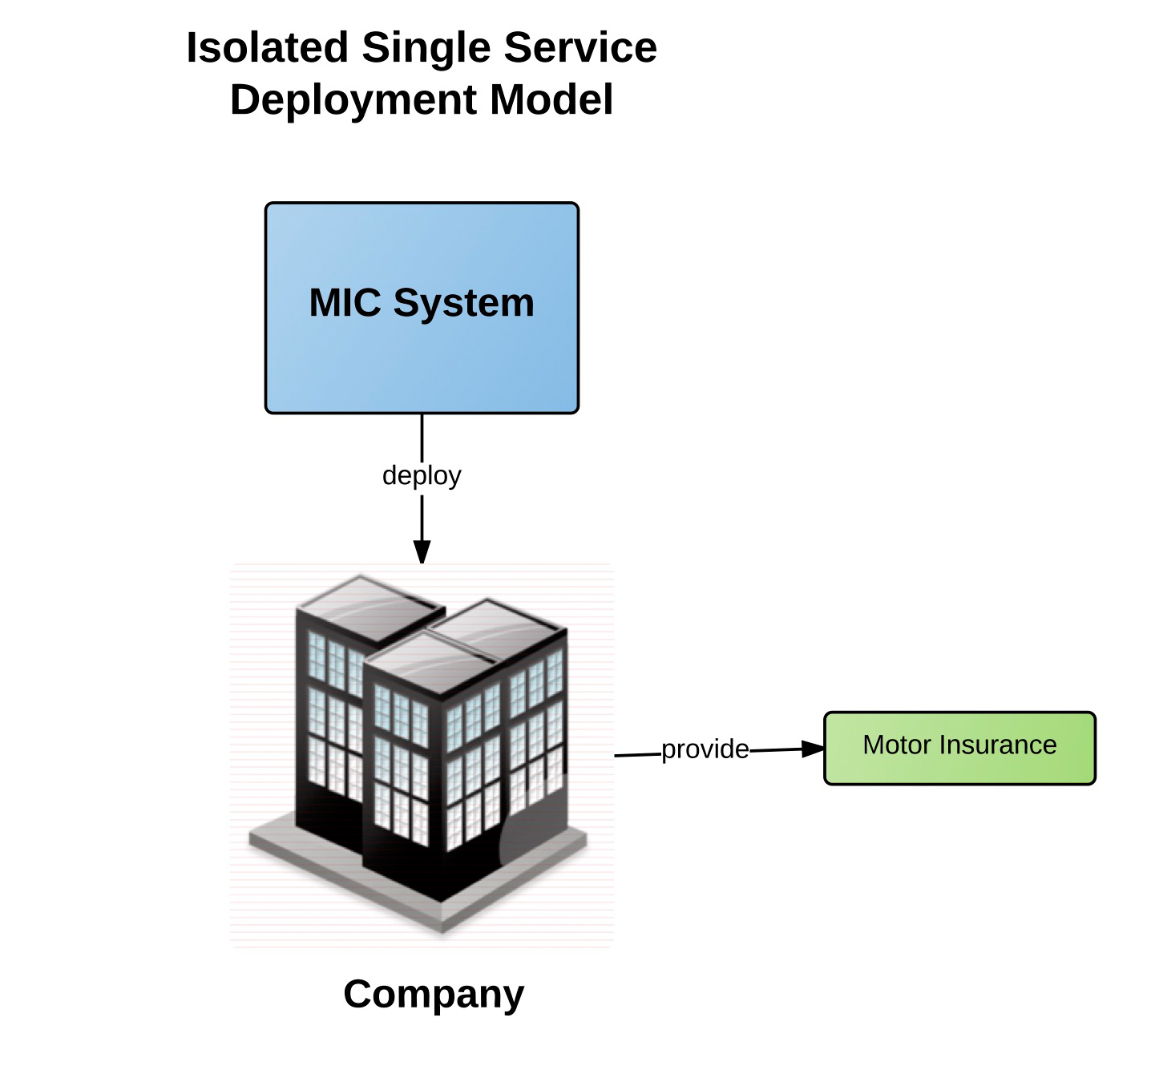

Figure Isolated Single Service Deployment Model

Based on the original requirement, this is the model of MIC system which support manage motor insurance contract. The MIC System will be deployed to a company which provide a single service: motor insurance service.

As a part of the implement process, to obtains the scalability of the system, this is what we designed the components:

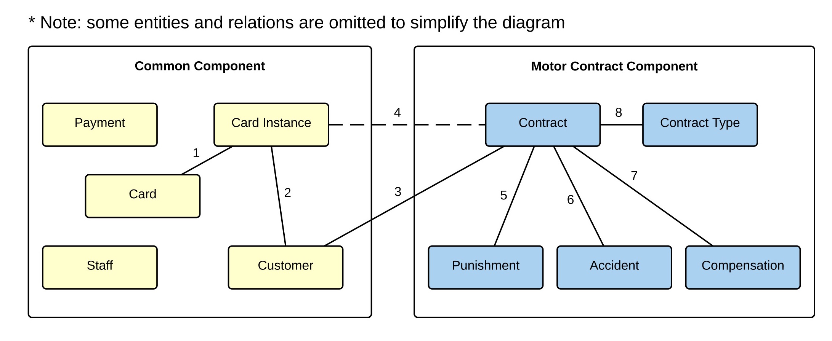

Figure Entities group by components (Isolated Single Service)

From the diagram, we can see the Motor Contract Component is separated with the Common Component which contains common information such as Customer, Card, Payment… This have benefits that if we want to add a new contract type (for example heath insurance contract), the cost of modify the old system is minimize to nearly zero.

Next, we will show the process to expand this system to the new system that supports multiple service.

#### Isolated Multiple Service

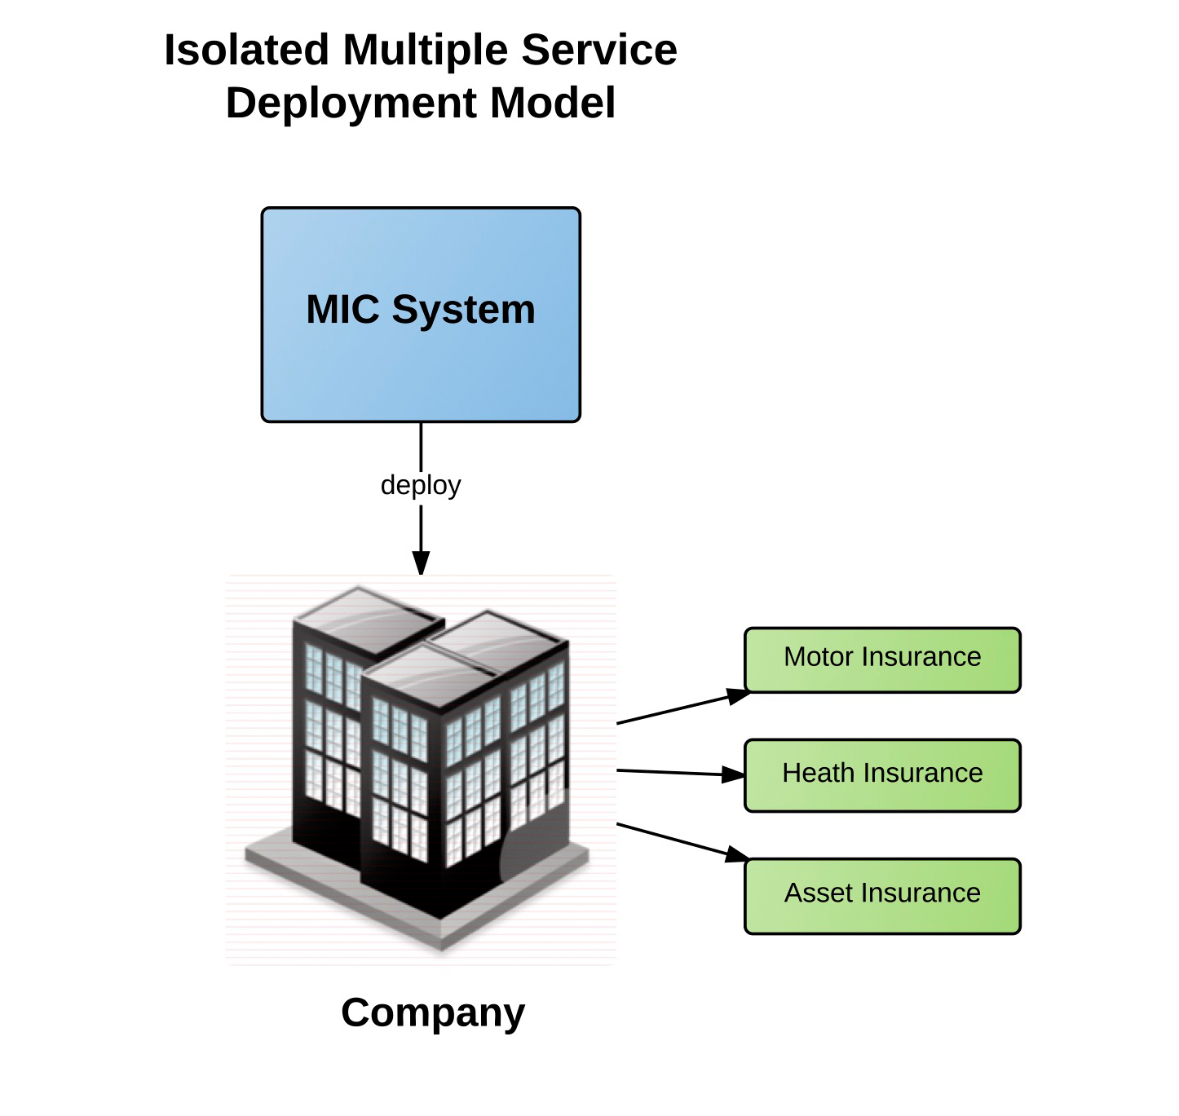

Figure Isolated Multiple Service Deployment Model

This is an expanded MIC system where a company can use MIC System to manage multiple contract type for example motor insurance, health insurance and asset insurance.

Based on the original model, we can implement this model by simply add new component to the current system, this is the planned component and relationships between entities:

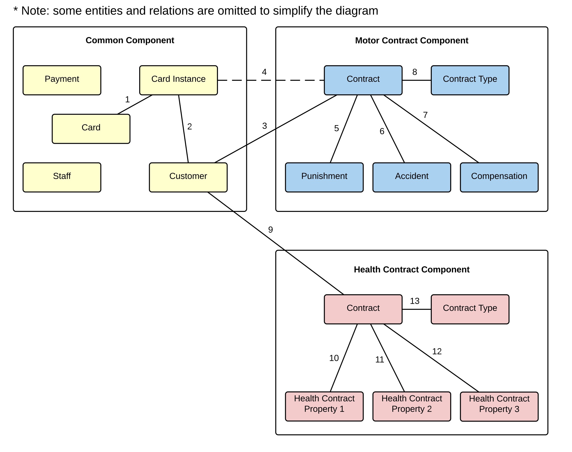

Figure Entities group by components (Isolated Multiple Service)

#### Distributed Multiple Service

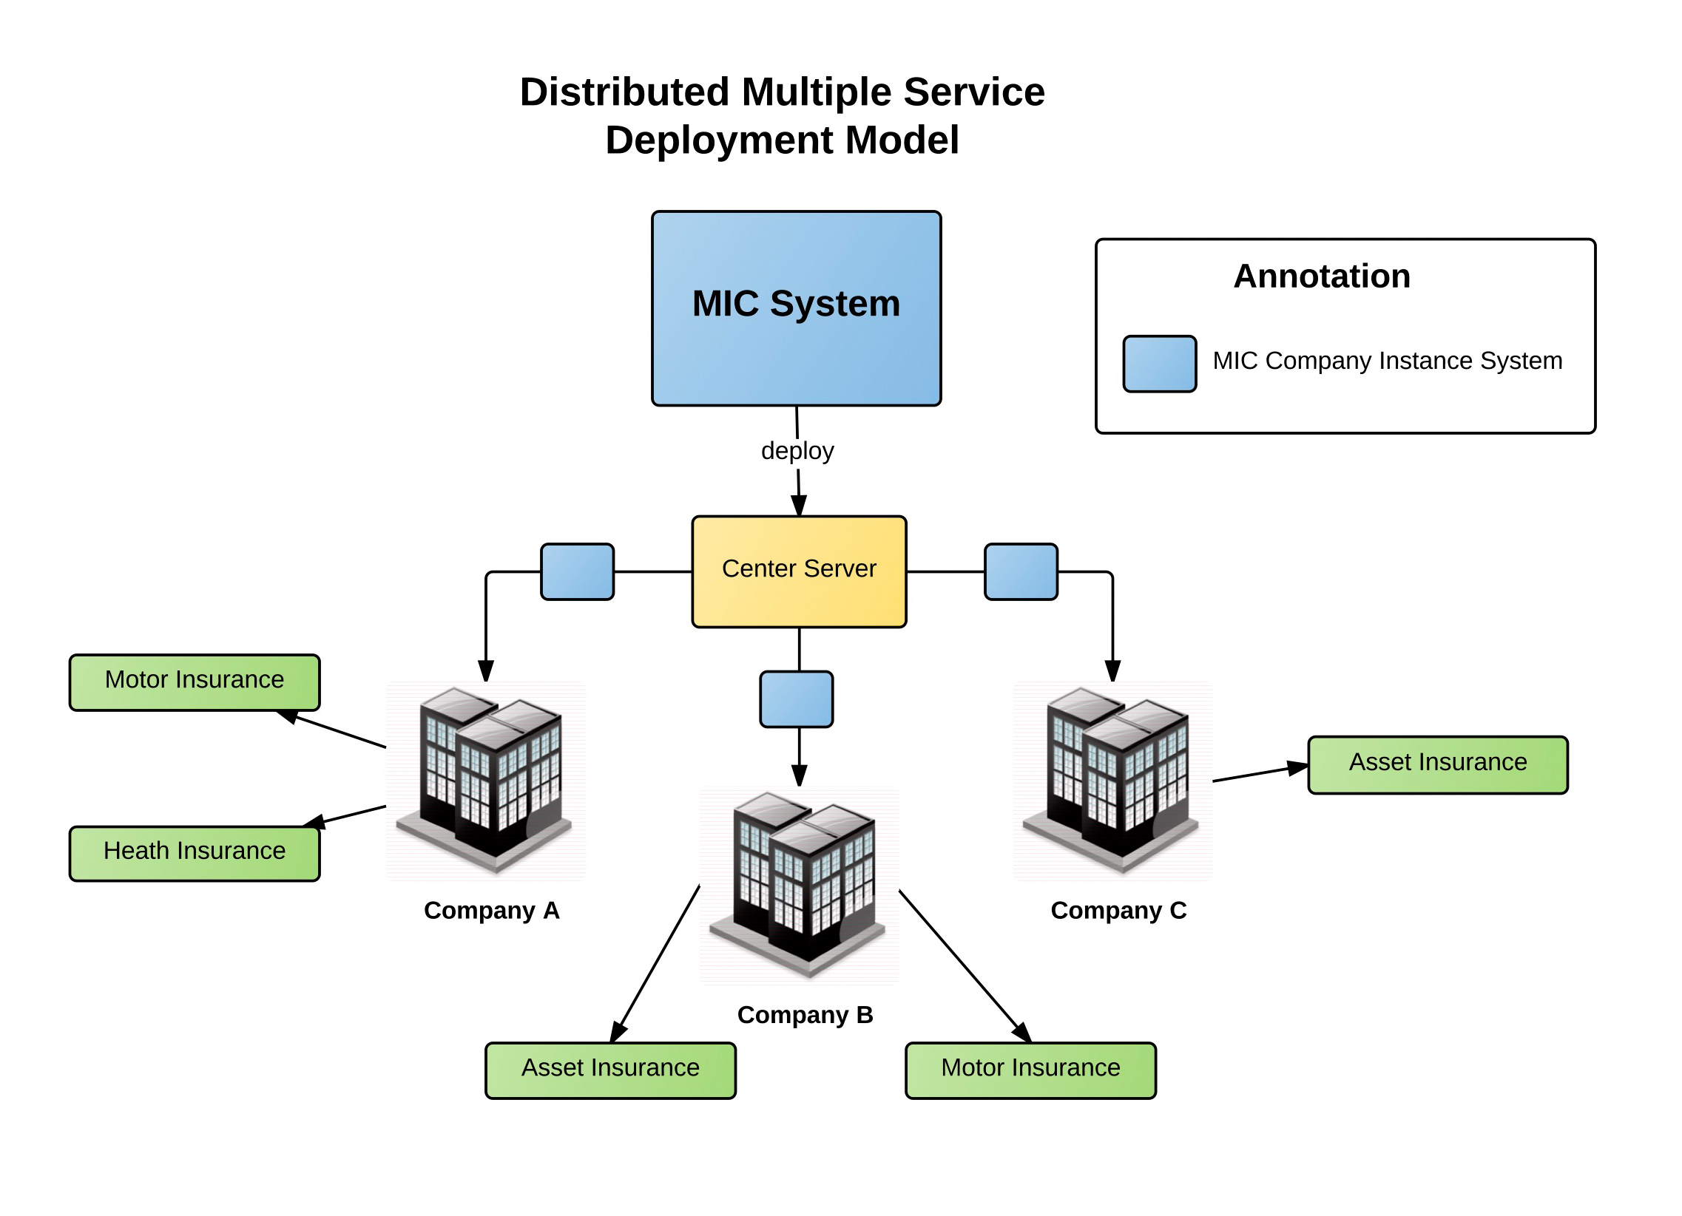

Figure Distributed Multiple Service Deployment Model

This is the final model of MIC system from our vision. In this model, we deploy MIC System in a Center Server which operates multiple insurance company, each company can provide different types of contract (motor insurance, health insurance, asset insurance…). All the company use a unify card system and customer information. By this model, a customer can have multiple contracts from different companies using only one NFC card to use for all the services.

This is the expected deployment component we estimated:

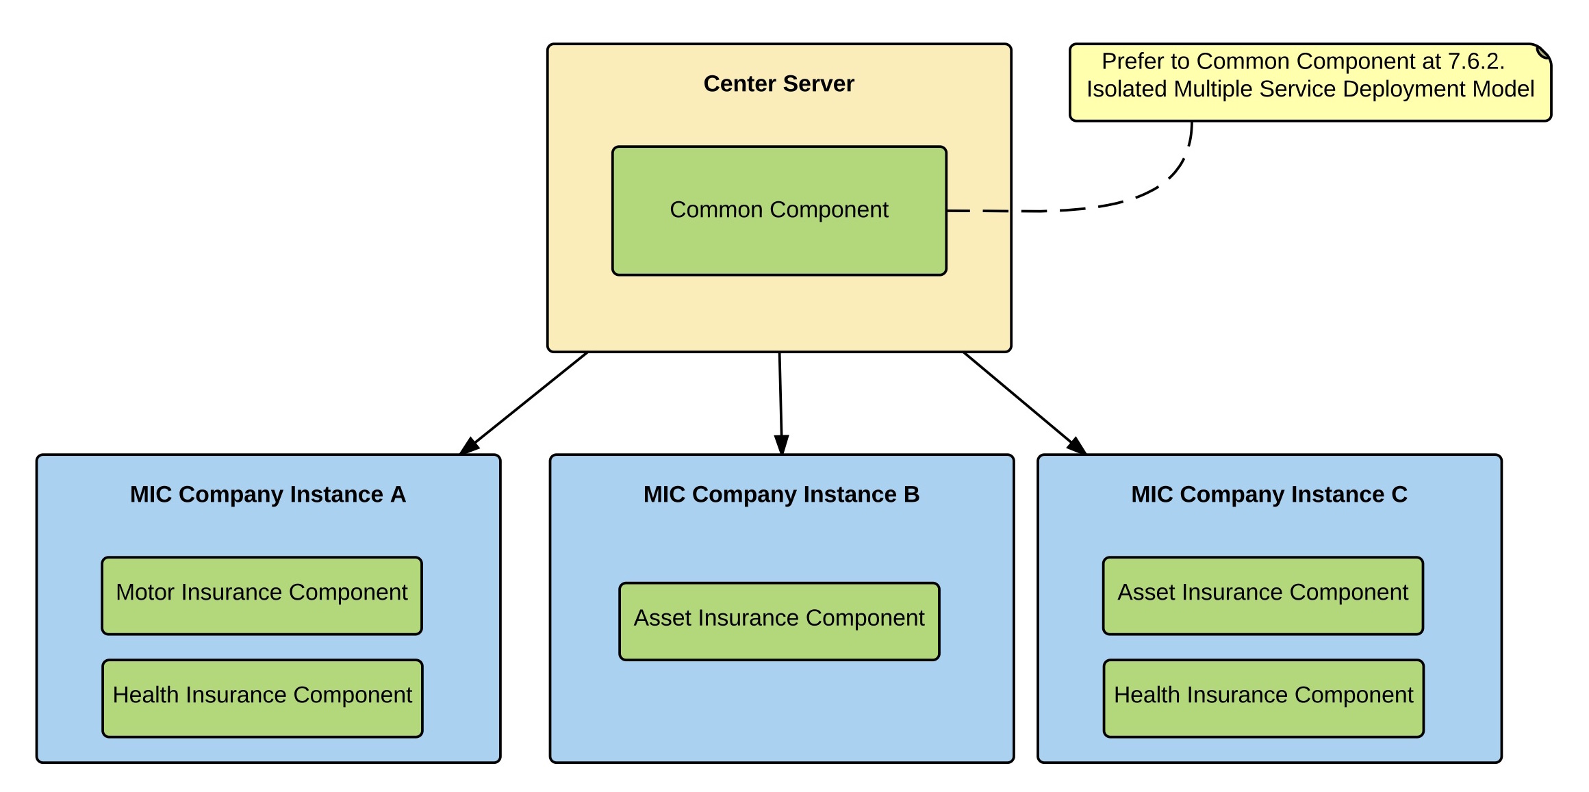

Figure Components group by container (Distributed Multiple Service)

The Distributed Multiple Service plan is still need to be investigate a lot to clarify the components and relationships between entities as well as the architecture design to maintain the best performance and less impact to the current system, we also need to identify the arise problems when switching from isolated model to distributed model.

# System Implementation & Test

## Introduction

### Overview

This section describes the approach and methodologies used by group to plan, organize and manage the testing of MIC system. It provides in the detail all necessary information about the implementation and testing procedure of the system included test plans, test cases, test result, test environments, pass/fail criteria and risks estimations as well as a checklist to cover all possible cases.

### Test Approach

* Goal: Test all features in the whole MIC system based on the core flow.
* Method: black-box testing
* Technique: check list

The testing for this project will consists of Integration System test level. Testing the program which was integrated and as a complete system to ensure that the software requirements have been met.

* Integration testing would be performed by all member of team and approved by team leader.
* System testing is focused on assessing the system’s reliability. This process is concerned with finding errors that result from unanticipated interactions between components and component interface problems.

## Database Relationship Diagram

### Physical Diagram

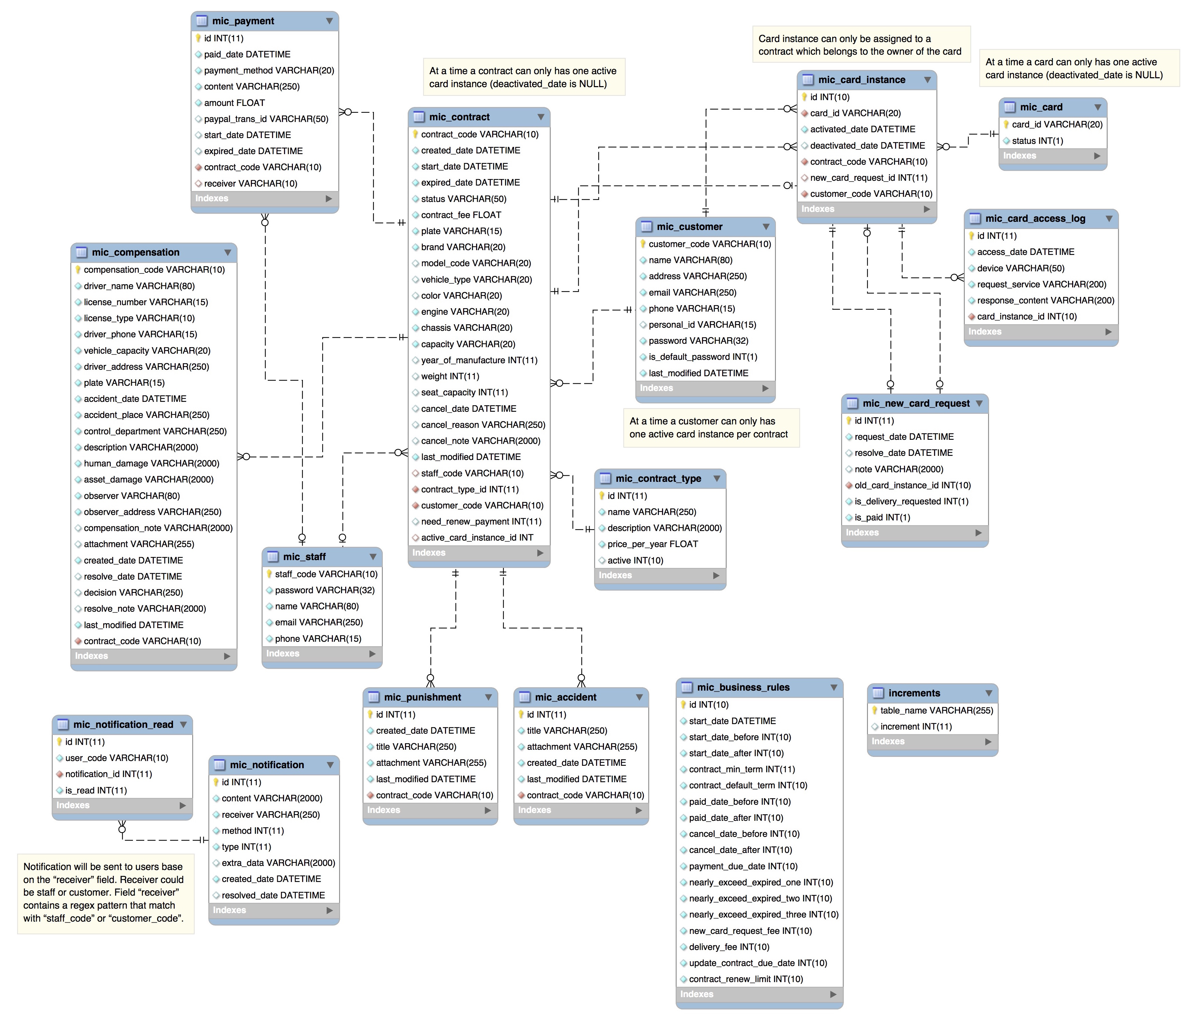

Figure Physical diagram

### Data Dictionary

|  |  |  |
| --- | --- | --- |
| Data dictionary: describe content of all tables | | |
| Table Name | **Mapping with Conceptual diagram** | **Description** |
| increments | N/A | Not exist in conceptual diagram. Needed in physical diagram to generate codes with prefixes sequentially. |
| mic_business_rules | N/A | Not exist in conceptual diagram. Needed in physical diagram to describe all configuration based on company’s business rules. |
| mic_contract_type | ContractType | Describe all contract type in the system. |
| mic_contract | Contract | Describe all contract detail information in the system. |
| mic_accident | Accident | Describe all accident information belongs to contract in the system. |
| mic_compensation | Compensation | Describe all compensation detailed information belongs to contract in the system. |
| mic_punishment | Punishment | Describe all punishment information belongs to contract in the system. |
| mic_card | Card | Describe all card, which has been issued in the system. |
| mic_card_instance | CardInstance | Describe all card instance. |
| mic_card_access_log | N/A | Not exist in conceptual diagram. Needed in physical diagram to describe all history access to card. |
| mic_new_card_request | NewCardRequest | Describe all new card request in the system. |
| mic_customer | Customer | Describe all customer profile available in the system. |
| mic_notification | N/A | Not exist in conceptual diagram. Needed in physical diagram to describe all notification detail in the system. |
| mic_notification_read | N/A | Not exist in conceptual diagram. Needed in physical diagram to support manage all notification in the system. |
| mic_payment | Payment | Describe all payment information in the system. |
| mic_staff | Staff | Describe all staff profile available in the system. |

Table Data table dictionary

|  |  |  |  |  |
| --- | --- | --- | --- | --- |
| Table Name | Attributes | Description | Domain | Null |
| increments | table_name {PK} | Unique identifier of increments | varchar(255) | No |
| increment |  |  | Yes |
| mic_business_rules | id {PK} | Unique identifier of business rules | int(10) | No |
| start_date_before | Duration contract start before current date | int(10) | No |
| start_date_after | Duration contract start after current date | int(10) | No |
| contract_min_term | Minimum contract term | int(11) | No |
| contract_default_term | Default contract term | int(10) | No |
| paid_date_before | Duration pay for contract before current date | int(10) | No |
| paid_date_after | Duration pay for contract after current date | int(10) | No |
| cancel_date_before | Duration cancel contract before current date | int(10) | No |
| cancel_date_after | Duration cancel contract after current date | int(10) | No |
| payment_due_date | Duration pay for contract from create date | int(10) | No |
| nearly_exceed_expired_one | Duration first time notify contract is going to expired | int(10) | No |
| nearly_exceed_expired_two | Duration second time notify contract is going to expired | int(10) | No |
| nearly_exceed_expired_three | Duration third time notify contract is going to expired | int(10) | No |
| new_card_request_fee | The amount has to paid for new card | int(10) | No |
| delivery_fee | The amount has to paid for delivery new card | int(10) | No |
| mic_contract_type | id {PK} | Unique identifier of contract type, auto increment. | int(11) | No |
| name | Contract type name. | varchar(250) | No |
| description | Contract type description. | varchar(2000) | No |
| price_per_year | Contract type price per year. | float | No |
| mic_contract | contract_code {PK} | Unique identifier of contract. | varchar(10) | No |
| created_date | Contract created date | datetime | No |
| start_date | Contract start date | datetime | No |
| expired_date | Contract expired date | datetime | No |
| status | Contract status | varchar(50) | No |
| contract_fee | Contract fee | float | No |
| plate | Vehicle plate | varchar(15) | No |
| brand | Vehicle brand | varchar(20) | No |
| model_code | Vehicle model code | varchar(20) | Yes |
| vehicle_type | Vehicle type | varchar(20) | Yes |
| color | Vehicle color | varchar(20) | Yes |
| engine | Vehicle engine number | varchar(20) | No |
| chassis | Vehicle chassis nuber | varchar(20) | No |
| capacity | Vehicle capacity | varchar(20) | No |
| year_of_manufacture | Vehicle year of manufacture | int(11) | Yes |
| weight | Vehicle empty weight | int(11) | Yes |
| seat_capacity | Vehicle seat capacity | int(11) | Yes |
| cancel_date | Contract cancel date | datetime | Yes |
| cancel_reason | Contract cancel reason | varchar(250) | Yes |
| cancel_note | Contract cancel note | varchar(2000) | Yes |
| last_modified | Contract last modified | datetime | No |
| staff_code | Code of the staff who created this contract | varchar(10) |  |
| contract_type_id | Contract type id | int(11) | No |
| customer_code | Code of the customer who own this contract | varchar(10) | No |
| active_card_instance_id | Active card instance of the contract | int(11) | Yes |
| mic_accident | id {PK} | Unique identifier of accident, auto increment. | int(11) | No |
| title | Accident title | varchar(250) | No |
| attachment | Accident attachment | varchar(255) | No |
| created_date | Accident created date | datetime | No |
| last_modified | Accident last modified | datetime | No |
| contract_code | Code of the contract has this accident | varchar(10) | No |
| mic_compensation | compensation_code {PK} | Unique identifier of compensation | varchar(10)PK | No |
| driver_name | Compensation driver name | varchar(80) | Yes |
| license_number | Compensation driver license number | varchar(15) | Yes |
| license_type | Compensation driver license type | varchar(10) | Yes |
| driver_phone | Compensation driver phone | varchar(15) | Yes |
| vehicle_capacity | Compensation driver vehicle capacity | varchar(20) | Yes |
| driver_address | Compensation driver address | varchar(250) | Yes |
| plate | Compensation driver vehicle plate | varchar(15) | Yes |
| accident_date | Compensation accident date | datetime | Yes |
| accident_place | Compensation accident place | varchar(250) | Yes |
| control_department | Department which control this accident | varchar(250) | Yes |
| description | Compensation description | varchar(2000) | Yes |
| human_damage | Accident human damage | varchar(2000) | Yes |
| asset_damage | Accident asset damage | varchar(2000) | Yes |
| observer | Observer name | varchar(80) | Yes |
| observer_address | Observer address | varchar(250) | Yes |
| compensation_note | Compensation note | varchar(2000) | Yes |
| attachment | Compensation attachment | varchar(255) | Yes |
| created_date | Compensation created date | datetime | No |
| resolve_date | Compensation resolve date | datetime | Yes |
| decision | Compensation decision | varchar(250) | Yes |
| resolve_note | Compensation resolve note | varchar(2000) | Yes |
| last_modified | Compensation last modified time | datetime | No |
| contract_code | Code of the contract has this compensation | varchar(10) | No |
| mic_punishment | id {PK} | Unique identifier of punishment, auto increment. | int(11) | No |
| title | Punishment title | varchar(250) | No |
| attachment | Punishment attachment | varchar(255) | No |
| created_date | Punishment created date | datetime | No |
| last_modified | Punishment last modified | datetime | No |
| contract_code | Code of the contract has this punishment | varchar(10) | No |
| mic_card | card_id | Unique identifier of card | varchar(20) | No |
| status | Status of the card | int(1) | No |
| mic_card_instance | Id {PK} | Unique identifier of card instance. | int(11) | No |
| card_id | Card ID of the instance | varchar(20) | No |
| activated_date | Card activated date | datetime | No |
| deactivated_date | Card deactivated date | datetime | Yes |
| contract_code | Code of contract has this card | varchar(10) | No |
| new_card_request_id | New card request id | int(11) | Yes |
| customer_code | Customer code, owner of the card | varchar(10) | No |
| mic_card_access_log | id {PK} | Unique identifier of card access log, auto increment. | int(11) | No |
| access_date | Access card date | datetime | No |
| device | Access card device | varchar(50) | No |
| request_service | Service requested | varchar(200) | No |
| response_content | Content responsed | varchar(200) | No |
| card_id | Card ID | varchar(20) | No |
| mic_new_card_request | id {PK} | Unique identifier of new card request, auto increment. | int(11) | No |
| request_date | Send request date | datetime | No |
| resolve_date | Resolve request date | datetime | Yes |
| note | Resolve request note | varchar(2000) | Yes |
| old_card_id | ID of old card | varchar(20) | No |
| mic_customer | customer_code{PK} | Unique identifier of customer | varchar(10) | No |
| name | Customer name | varchar(80) | No |
| address | Customer address | varchar(250) | No |
| email | Customer email | varchar(250) | No |
| phone | Customer phone | varchar(15) | No |
| personal_id | Customer personal ID | varchar(15) | Yes |
| password | Customer password | varchar(32) | No |
| is_default_password | Value to check customer password is default or not. | int(1) | No |
| last_modified | Customer last modified time | datetime | No |
| mic_notification | id {PK} | Unique identifier of notification, auto increment. | int(11) | No |
| content | Notification content | varchar(2000) | No |
| receiver | Notification receiver | varchar(250) | No |
| method | Notification method | int(11) | No |
| type | Notification type | int(11) | No |
| extra_data | Notification extra data | varchar(2000) | Yes |
| created_date | Notification created date | datetime | No |
| resolved_date | Notification resolved date | datetime | Yes |
|
| mic_notification_read | id {PK} | Unique identifier of notification read, auto increment. | int(11) | No |
| user_code | Code of user read this notification | varchar(10) | No |
| notification_id | Notification ID | int(11) | No |
| is_read | Value to check notification is read or not yet. | int(11) | No |
| mic_payment | id {PK} | Unique identifier of payment, auto increment. | int(11) | No |
| paid_date | The date the payment is paid | datetime | No |
| payment_method | Payment method | varchar(20) | No |
| content | Payment content | varchar(250) | No |
| amount | Payment amount | float | No |
| paypal_trans_id | PayPal transaction ID | varchar(50) | Yes |
| start_date | Contract start date while payment content is renew | datetime | Yes |
| expired_date | Contract expired date while payment content is renew | datetime | Yes |
| contract_code | Code of contract has this payment | varchar(10) | No |
| receiver | Payment receiver | varchar(10) | Yes |
| mic_staff | staff_code {PK} | Unique identifier of staff | varchar(10) | No |
| password | Staff password | varchar(32) | No |
| name | Staff name | varchar(80) | No |
| email | Staff email | varchar(250) | No |
| phone | Staff phone | varchar(15) | No |

Table Data attribute dictionary

## Performance Measures

### Web application page load speed

#### Definition

This section tests the general page load speed from all the page of the web application.

#### Test environment

**Server:**

* **Operating system:** Ubuntu 14.04 Server 32 bit
* **RAM:** 512 MB
* **Storage:** 40 GB
* **Processor:** 2.6 GHz Intel Core i5
* **Network:** 1 Mbps

#### Test cases

Using browser from client side and go to each page of the web application. Record the page load time using Chrome Dev Tools at client side.

**Test pages:**

|  |  |
| --- | --- |
| Public | **home** |
| register |
| checkout |
| login |
| Staff | dashboard |
| contract:   * list contract * detail contract * create contract |
| compensation:   * list all compensation * list compensation by contract * detail compensation * create compensation * edit compensation |
| punishment   * list punishment by contract * create punishment * edit punishment |
| accident   * list accident by contract * create accident * edit accident |
| card   * list card * detail card * list new card request |
| customer   * list customer * customer detail * create customer * edit customer information |
| Customer | dashboard |
| contract   * list contract * detail contract * create new contract |
| compensation:   * list compensation by contract * detail compensation * create compensation |
| punishment   * list punishment by contract * create punishment |
| accident   * list accident by contract * create accident |
| card   * list card * detail card * list new card request |
| profile information |

#### Test result

The test is run 10 times, each time we go through all the pages listed above and log down the average page load time.



Figure Web application page load speed test result

|  |  |  |
| --- | --- | --- |
| Test No. | Average page load time (second) | Execute date |
| 1 | 1.67 | 6 July 2015 |
| 2 | 1.35 | 6 July 2015 |
| 3 | 0.94 | 6 July 2015 |
| 4 | 1.44 | 6 July 2015 |
| 5 | 2.01 | 6 July 2015 |
| 6 | 1.35 | 6 July 2015 |
| 7 | 1.59 | 6 July 2015 |
| 8 | 2.12 | 6 July 2015 |
| 9 | 1.11 | 6 July 2015 |
| 10 | 1.29 | 6 July 2015 |
|  | **Average: 1.49 (seconds)** |  |

Table Web application page load speed test result

### Mobile application API load speed

#### Definition

This section tests the load speed of mobile apps when connection to server through API.

#### Test environment

**Server:**

* **Operating system:** Ubuntu 14.04 Server 32 bit
* **RAM:** 512 MB
* **Storage:** 40 GB
* **Processor:** 2.6 GHz Intel Core i5
* **Network:** 1 Mbps

**Client:**

|  |  |  |
| --- | --- | --- |
| Hardware Requirements | Minimum | Recommended |
| Internet Connection | 512Kbps | Wi-Fi Connection 12MB |
| Operating System | Android 4.0 | Android 4.0 |
| Hardware | NFC supported | NFC supported |
| Memory | 128MB of RAM | 1GB of RAM or more |

Table Mobile app API load speed client specification

#### Test cases

Using mobile application to send the entire API request to web server.

List of APIs:

|  |  |  |
| --- | --- | --- |
| No. | API | Description |
| 1 | getCheckConnection | Check server status |
| 2 | getContracts | Get contract information |
| 3 | getUpdateCardID | Update Card ID for contract |
| 4 | getCheckCard | Check card validation |
| 5 | getUpdatePunishment | Update punishment information for contract |

Table Mobile app API load speed test cases

#### Test result

The test is run 10 times, each time we run all the test cases listed above and log down the average API response time.



Figure Mobile application API load speed test result

|  |  |  |
| --- | --- | --- |
| Test No. | Average page load time (second) | Execute date |
| 1 | 2.13 | 6 July 2015 |
| 2 | 2.89 | 6 July 2015 |
| 3 | 2.21 | 6 July 2015 |
| 4 | 2.5 | 6 July 2015 |
| 5 | 2.87 | 6 July 2015 |
| 6 | 1.73 | 6 July 2015 |
| 7 | 2.17 | 6 July 2015 |
| 8 | 1.58 | 6 July 2015 |
| 9 | 1.62 | 6 July 2015 |
| 10 | 1.31 | 6 July 2015 |
|  | **Average: 2.10 (seconds)** |  |

Table Mobile application API load speed test result

## Test Plan

The overall purpose of testing is to ensure MIC system meets its entire technical, functional and business requirement. The purpose of this document is to describe the overall test plan and strategy for testing the MIC system. The approach described in this document provides the framework for all testing related to this application. Individual test cases will be written for each version of the application that is released. This document will also be updated as required for each release.

### Features to be tested

* Staff: view contract information, view compensation information, resolve new card request, resolve compensation request, create new contract, renew contract, cancel contract.
* Customer: view contract information, view compensation information, renew contract, cancel contract, request compensation, new card request, change password.
* Guest: Create new contract request
* System: notify schedule
* Mobile application: verify card, add punishment, print card

### Features not to be tested

* Admin: add staff, remove staff
* Login, logout, change profile
* View information: card, punishment, accident, customer, staff, payment.

## System Testing Test Case

#### <Guest> Register new contract

|  |  |  |  |  |  |  |
| --- | --- | --- | --- | --- | --- | --- |
| ID | Test Case Description | Test case procedure | Expected output | Inter-test case dependence | Result | Test Date |
| RNC1 | Test guest register new contract with valid information | 1. Go to the home page  2. Enter personal information:  - Họ tên: Nguyễn Văn A  - Email: baohiem@yahoo.com  - Số điện thoại:0909099099  - Số CMND/Hộ chiếu: 272185738  - Địa chỉ: 123 Chợ Lớn, Bến Thành, HCM.  - Ngày bắt đầu: 13/7/2015  - Hình thức bảo hiểm: Xe trên 50cc có BH cho người trên xe  3. Click "Tiếp theo" button.  4. Click tab "2.Thông tin xe".  5. Enter vehicle information:  - Biển số đăng ký:60-Y6 6666  - Nhãn hiệu: Honda  - Số khung: 1001001  - Số máy: 1001001  - Dung tích: 110cc  - Số loại: Air blade  - Loại xe: Hai bánh  - Màu sơn: Đỏ  - Năm sản xuất: 2000  - Tự trọng: 100  - Số người: 2  6. Click "TIẾP THEO" button.  7. Click "TẠO HỢP ĐỒNG VÀ THANH TOÁN" button. | Create contract successful, send an email contains customer code and password to customer. Request payment |  | Pass | 7/13/15 |
| RNC2 | Test guest register contract with an exist plate number | 1. Register new contract with information like test case "RNC1". And excute payment process like test case "RNCP2".  2. Register another contract with information :  - Họ tên: Nguyễn Văn B  - Email: baohiem1@yahoo.com  - Số điện thoại:0909888888  - Số CMND/Hộ chiếu: 123485738  - Địa chỉ: 123 Chợ Nhỏ, Bến Thành, HCM.  - Ngày bắt đầu: 13/7/2015  - Hình thức bảo hiểm: Xe trên 50cc có BH cho người trên xe  - Biển số đăng ký:60-Y6 6666  - Nhãn hiệu: Honda  - Số khung: 1231231  - Số máy: 1231231  - Dung tích: 110cc  - Số loại: Air blade  - Loại xe: Hai bánh  - Màu sơn: Đỏ  - Năm sản xuất: 2000  - Tự trọng: 100  - Số người: 2 | Show error message:"Đang có hợp đồng hiệu lực với xe có biển số này" | RNC1,RNCP2. | Pass | 7/13/15 |
| RNC3 | Test guest register contract with an exist email | 1. Register new contract with information like test case "RNC1".  2. Go to the home page  3. Enter personal information:  - Họ tên: Nguyễn Văn B  - Email: baohiem@yahoo.com  - Số điện thoại:0909123123  - Số CMND/Hộ chiếu: 123456789  - Địa chỉ: 123 Chợ Bà Chiểu,Bình Thạnh, HCM.  - Ngày bắt đầu: 13/7/2015  - Hình thức bảo hiểm: Xe trên 50cc có BH cho người trên xe  4. Click "Tiếp theo" button. | Show error message: "Email đã được đăng ký bởi người dùng khác" | RNC1 | Pass | 7/13/15 |

Table Test case - <Guest> Register new contract

#### <Guest> Register new contract payment

|  |  |  |  |  |  |  |
| --- | --- | --- | --- | --- | --- | --- |
| ID | Test Case Description | Test case procedure | Expected output | Inter-test case dependence | Result | Test Date |
| RNCP1 | Test guest choose direct payment for register new contract | 1. Guest registered contract succeed like test case "RNC1".  2. Guest choose direct payment. | Show company address map | RNC1 | Pass | 7/13/15 |
| RNCP2 | Test Paypal payment successful for register new contract. | 1. Guest registered contract succeed like test case "RNC1".  2. Guest choose PayPal payment.  3. Guest log in and pay with PayPal web page. | Show success message:"Thanh toán thành công" | RNC1 | Pass | 7/13/15 |
| RNCP3 | Test guest cancel transaction while excute Paypal payment for register new contract. | 1. Guest registered contract succeed like test case "RNC1".  2. Guest choose PayPal payment.  3. Guest cancel transaction | Show message to notify that guest has canceled the transaction:"Bạn đã hủy thanh toán. Xin vui lòng Đăng nhập để thanh toán lại hoặc đến thanh toán trực tiếp" | RNC1 | Pass | 7/13/15 |

Table Test case - <Guest> Register new contract payment

#### <Staff> View Contracts

|  |  |  |  |  |  |  |
| --- | --- | --- | --- | --- | --- | --- |
| ID | Test case description | Test case procedure | Expected output | Inter-test case dependence | Result | Test date |
| WC1 | View contract detail | 1. Create a contract with code HD0001  2. Click contract code in the grid to view its detail | Display contract detailed information page | CC1 - Create Contract | Pass | 7/13/15 |
| WC2 | Search contract with customer name | 1. Create 3 customer with names "Dang Van Ngu", "Duong Tu Ky" and "Nguyen Dinh Bao" alternatively  2. Create 2 contract HD0001 and HD0002 belongs to "Dang Van Ngu" and "Nguyen Dinh Bao" in turn  3. Input "Nguyen Dinh Bao" to search box  4. Click "Tìm kiếm" button | Display contract HD0002 in the grid view | Create Customer  CC1 - Create Contract | Pass | 7/13/15 |
| WC3 | Search contract with no keyword | 1. Create 3 customer with names "Dang Van Ngu", "Duong Tu Ky" and "Nguyen Dinh Bao" alternatively  2. Create 2 contract HD0001 and HD0002 belongs to "Dang Van Ngu" and "Nguyen Dinh Bao" in turn  3. Click "Tìm kiếm" button | A message notify there are no value for this search | Create Customer  CC1 - Create Contract | Pass | 7/13/15 |

Table Test case - <Staff> View contract

#### <Staff> Create Contract

|  |  |  |  |  |  |  |
| --- | --- | --- | --- | --- | --- | --- |
| ID | Test case description | Test case procedure | Expected output | Inter-test case dependence | Result | Test date |
| CC1 | Create contract success | 1. Create customer "Nguyen Van A" has customer code is KH0001  2. Click create new contract, input form is displayed  3. Input all default value according to "Default_value_for_forms.xlsx" file  4. Set customer code is KH0001, contract start date to 12 July 2015  5. Click "Tạo hợp đồng" button | A contract with status is "No card" created successfully | Create Customer | Pass | 7/13/15 |
| CC2 | Create contract success but not start yet | 1. Create customer "Nguyen Van A" has customer code is KH0001  2. Click create new contract, input form is displayed  3. Input all default value according to "Default_value_for_forms.xlsx" file  4. Set customer code is KH0001, contract start date to 21 July 2015  5. Click "Tạo hợp đồng" button | A contract with status is "Pending" created successfully | Create Customer | Pass | 7/13/15 |
| CC3 | Create contract fail because of existed vehicle plate number | 1. Create customer "Nguyen Van A" has customer code is KH0001, customer "Duong Thien Hoa" has customer code is KH0002  2. Create new contract with start date is 12 July 2015, contract status is Ready, vehicle plate number is 59Y9-38482  3. Click create new contract, input form is displayed  4. Input all default value according to "Default_value_for_forms.xlsx" file  5. Set vehicle plate number is 59Y9-38482  6. Click "Tạo hợp đồng" button | A message notify this vehicle plate number is existed in the system | Create Customer  CC1 - Create Contract | Pass | 7/13/15 |
| CC4 | Create contract fail because of there are no customer | 1. Create customer "Nguyen Van A" has customer code is KH0001  2. Click create new contract, input form is displayed  3. Input all default value according to "Default_value_for_forms.xlsx" file, customer code is KH0002  4. Set contract start date to 12 July 2015  5. Click "Tạo hợp đồng" button | A message notify this customer is not exist in the system | Create Customer | Pass | 7/13/15 |

Table Test case - <Staff> Create contract

#### <Staff> Renew Contract

|  |  |  |  |  |  |  |
| --- | --- | --- | --- | --- | --- | --- |
| ID | Test case description | Test case procedure | Expected output | Inter-test case dependence | Result | Test date |
| RC1 | Renew contract success | 1. Create new contract has start date is 10 July 2015, expired date is 1 September 2015. Contract status is "No card"  2. Click view this contract detail  3. Click "Gia hạn" button, renew contract form displayed  4. Fill out the form:  - Gia hạn đến: 01/09/2016  - Ngày nộp phí:  13/07/2015  5. Click "Gia hạn hợp đồng" button | Renew contract successfully, contract status is "No card"  A new payment is created with start date is 01/09/2015, expired date is 01/09/2016 | CC1 - Create Contract  WC1 - View Contracts | Pass | 7/13/15 |
| RC2 | Renew contract success with request for new card and delivery it | 1. Create new contract has start date is 9 July 2015, expired date is 13 August 2015. Contract status is "No card"  2. Print a card with code "12-34-56-78-91" for this contract. Contract new status is "Ready"  3. Click view this contract detail  4. Click "Gia hạn" button, renew contract form displayed button  5. Fill out the form:  - Gia hạn đến: 13/08/2016  - Ngày nộp phí:  13/07/2015  6. Check "Cấp thẻ mới", "Vận chuyển thẻ" boxes  7. Click "Gia hạn hợp đồng" button | Renew contract successfully, its status is "No card".  A new payment is created with start date is 13/08/2015, expired date is 13/08/2016  The card with code "12-34-56-78-91" is deactivated | CC1 - Create Contract  Print Card  WC1 - View Contracts | Pass | 7/13/15 |
| RC3 | Renew contract success | 1. Create new contract has start date is 6 July 2015, expired date is 12 July 2015. Contract status is "Expired"  2. Click view this contract detail  3. Click "Gia hạn" button, renew contract form displayed  4. Fill out the form:  - Gia hạn đến: 13/08/2016  - Ngày nộp phí:  13/07/2015  5. Click submit button | Renew contract successfully, contract status is "No card"  A new payment is created with start date is 13/07/2015, expired date is 13/07/2016 | CC1 - Create Contract  WC1 - View Contracts | Pass | 7/13/15 |
| RC4 | Renew contract fail because of contract term is out of bound | 1. Create new contract has start date is 6 July 2015, expired date is 12 August 2015. Contract status is "No card"  2. Click view this contract detail  3. Click "Gia hạn" button, renew contract form displayed  4. Fill out the form:  - Gia hạn đến: 13/12/2016  - Ngày nộp phí:  13/07/2015  5. Click "Gia hạn hợp đồng" button | A message notify contract term can not exceed the limit | CC1 - Create Contract  WC1 - View Contracts | Pass | 7/13/15 |
| RC5 | Renew contract success with request for new card fail because this contract have no card | 1. Create new contract has start date is 6 July 2015, expired date is 12 July 2015. Contract status is "Expired"  2. Click view this contract detail  3. Click "Gia hạn" button, renew contract form displayed  4. Fill out the form:  - Gia hạn đến: 13/08/2016  - Ngày nộp phí:  13/07/2015  5. Check "Cấp thẻ mới" box  6. Click "Gia hạn hợp đồng" button | A message notify this contract have no card | CC1 - Create Contract | Pass | 7/13/15 |

Table Test case - <Staff> Renew contract

#### <Staff> Cancel Contract

|  |  |  |  |  |  |  |
| --- | --- | --- | --- | --- | --- | --- |
| ID | Test case description | Test case procedure | Expected output | Inter-test case dependence | Result | Test date |
| CC1 | Cancel contract having "Ready" status | 1. Create new contract has start date is 11 July 2015, expired date is 11 July 2016. Contract status is "No card"  2. Print a card with code "12-34-56-78-AZ" for this contract. Contract new status is "Ready"  3. Click view this contract detail  4. Click "Hủy hợp đồng" button, cancel contract form displayed  5. Fill out the form:  - Ngày hủy hợp đồng: 13/07/2015  - Lý do hủy hợp đồng: Mất xe  6. Click "Đồng ý hủy" button | Cancel contract successfully, its status is "Cancelled".  The card with code "12-34-56-78-AZ" is deactivated | CC1 - Create Contract  PC1 - Print Card  WC1 - View Contracts | Pass | 7/13/15 |
| CC2 | Cancel contract having "Request cancel" status | 1. Create new contract has start date is 11 July 2015, expired date is 11 July 2016. Contract status is "Request cancel"  2. Click view this contract detail  3. Click handle cancel contract request button, cancel contract form displayed  4. Quyết định của công ty: Hủy hợp đồng này  5. Click "Xác nhận" button | Cancel contract successfully, its status is "Cancelled". | CC1 - Create Contract  WC1 - View Contracts | Pass | 7/13/15 |
| CC3 | Cancel contract fail because of cancel reason is empty | 1. Create new contract has start date is 11 July 2015, expired date is 11 July 2016. Contract status is "No card"  2. Click view this contract detail  3. Click "Hủy hợp đồng" button, cancel contract form displayed  4. Click "Đồng ý hủy" button | A message notify cancel reason is can not empty, request Staff to fill it out | CC1 - Create Contract  WC1 - View Contracts | Pass | 7/13/15 |

Table Test case - <Staff> Cancel contract

#### <Staff> View Compensation List

|  |  |  |  |  |  |  |
| --- | --- | --- | --- | --- | --- | --- |
| ID | Test case description | Test case procedure | Expected output | Inter-test case dependence | Result | Test date |
| WCL1 | View compensation list | 1. Create new contract with code is "HD0001"  2. Create new compensation for "HD0001" contract  3. Click view list of compensation | A grid view display list of compensation | CC1 - Create Contract  Create Compensation | Pass | 7/11/15 |
| WCL2 | Search compensation with contract code | 1. Create 2 new contract with code is "HD0001", "HD0002"  2. Create 4 new compensation, 2 for each contract  3. Input "HD0001" to search box  4. Click "Tìm kiếm" button | A grid view display 2 compensation belongs to the contract has code "HD0001" | CC1 - Create Contract  Create Compensation | Pass | 7/12/15 |
| WCL3 | Search contract with no keyword | 1. Create 2 new contract with code is "HD0001", "HD0002"  2. Create 4 new compensation, 2 for each contract  3. Click "Tìm kiếm" button | A message notify there are no value for this search | CC1 - Create Contract  Create Compensation | Pass | 7/13/15 |

Table Test case - <Staff> View compensation list

#### <Staff> Compensation Detail

|  |  |  |  |  |  |  |
| --- | --- | --- | --- | --- | --- | --- |
| ID | Test case description | Test case procedure | Expected output | Inter-test case dependence | Result | Test date |
| CD1 | View an unsolved compensation detail | 1. Create new contract  2. Create new compensation for this contract  3. Click compensation code in list of compensation | Display compensation detail page with an alert about resolve this compensation | CC1 - Create Contract  Create Compensation | Pass | 7/13/15 |
| CD2 | View an solved compensation detail | 1. Create new contract  2. Create new compensation for this contract  3. Resolve this compensation  4. Click compensation code to view its detail | Display compensation detail page with solved compensation information | CC1 - Create Contract  Create Compensation  RC1 - Resolve Compensation | Pass | 7/13/15 |

Table Test case - <Staff> View compensation detail

#### <Staff> Resolve Compensation

|  |  |  |  |  |  |  |
| --- | --- | --- | --- | --- | --- | --- |
| ID | Test case description | Test case procedure | Expected output | Inter-test case dependence | Result | Test date |
| RC1 | Resolve compensation success | 1. Create new contract  2. Create new compensation for this contract  3. Click compensation code in list of compensation  4. Click "Giải quyết yêu cầu" button, solve form is displayed  5. Fill out the form:  - Ngày giải quyết yêu cầu: 13/07/2015  - Quyết định của công ty: "Từ chối bồi thường"  6. Click "Quyết định" button | Display compensation detail page with solved compensation information | CC1- Create Contract  Create Compensation | Pass | 7/13/15 |

Table Test case - <Staff> Resolve compensation

#### <Staff> View new card requests

|  |  |  |  |  |  |  |
| --- | --- | --- | --- | --- | --- | --- |
| ID | Test Case Description | Test case procedure | Expected output | Inter-test case dependence | Result | Test Date |
| VNCR1 | Test list new card request in ascending order of request date. | 1. Create 5 new card request with 5 different request date.  2. Click "Yêu cầu thẻ mới" bar. | Display the list new card requests in ascending order of request date. | SNCR1 | Pass | 7/13/15 |
| VNCR2 | Test unresolved request will be on top. | 1. Crete 5 new card request with the same request date. But 2 of them is resolved.  2. Click "Yêu cầu thẻ mới" bar. | Display 3 unresolved new card requests on top and 2 resolved new card request on bottom. | SNCR1 | Pass | 7/13/15 |

Table Test case - <Staff> View new card requests

#### <Staff> Resolve new card request

|  |  |  |  |  |  |  |
| --- | --- | --- | --- | --- | --- | --- |
| ID | Test Case Description | Test case procedure | Expected output | Inter-test case dependence | Result | Test Date |
| RNCR1 | Test resolve new card request, print a new card | 1. Contract HD0001 is Ready and having an actived card.  2. Create new card request for contract HD001 like test case SNCR1.  3. Print card for Ready contract "HD0001" like test case PC2. | Printer app show message "Write success", contract card change to new card ID, old card is deactivated | SNCR1,PC2. | Pass | 7/13/15 |

Table Test case - <Staff> Resolve new card request

#### <Customer> Create New Contract

|  |  |  |  |  |  |  |
| --- | --- | --- | --- | --- | --- | --- |
| ID | Test Case Description | Test case procedure | Expected output | Inter-test case dependence | Result | Test Date |
| CNC1 | Create new contract success | 1. Click "Hợp đồng mới" button.  2. Input all default value according to Default form value.xlsx file" (Create new contract form)  3. Click "Thêm hợp đồng"  4. Click "Xác nhận"  5. Click "Thanh toán ngay bây giờ"  6. Login to paypla an pay fee | Customer can see their new contract with status "No card" and some information about compensation, punishment, accident and card | Default form value.xlsx file | Pass | 7/13/15 |
| CNC2 | Create new contract fail | 1. Click "Hợp đồng mới" button.  2. Click "Thêm hợp đồng" | Sytem show message error and required input value | Default form value.xlsx file | Pass | 7/13/15 |
| CNC3 | Create new contract success | 1. Click "Hợp đồng mới" button.  2. Input all default value according to Default form value.xlsx file" (Create new contract form)  3. Click "Thêm hợp đồng"  4. Click "Xác nhận"  5. Click "Thanh toán ngay bây giờ"  6. Click "Trực tiếp" | System shows map with detail address of company where customer can pay direct for their contract.  Customer can see their new contract with status "Pending" and some information about compensation, punishment, accident and card | Default form value.xlsx file | Pass | 7/13/15 |
| CNC4 | Create new contract fail | 1. Click "Hợp đồng mới" button.  2. Input all default value according to Default form value.xlsx file" (Create new contract form)  3. Thời điểm có hiệu lực input "07/04/2015"  3. Click "Thêm hợp đồng" | Sytem show message error "Thời điểm có hiệu lực phải sau ngày hiện tại" | Default form value.xlsx file | Pass | 7/13/15 |

Table Test case - <Customer> Create contract

#### <Customer> Renew Contract

|  |  |  |  |  |  |  |
| --- | --- | --- | --- | --- | --- | --- |
| ID | Test Case Description | Test case procedure | Expected output | Inter-test case dependence | Result | Test Date |
| RC1 | Renew contract success | 1. Create new contract with contract code "HD0001"  2. Prepare a contract with startdate: 7/25/2014 and expireddate: 7/25/2015 and status is "Ready"  3. Click "Gia hạn" button  4. Click "Gia hạn hợp đồng"  5. Choose "Paypal" and login paypal to pay fee  6. Click "Trở về trang chi tiết hợp đồng" | System show page with message "Gia hạn thành công" and expired is updated "7/26/2016" | Create new contract | Pass | 7/13/15 |
| RC2 | Renew contract success | 1. Create new contract with contract code "HD0001"  2. Prepare a contract with startdate: 7/11/2014 and expireddate: 7/11/2015 and status is "Expired"  3. Click "Gia hạn" button  4. Click "Gia hạn hợp đồng"  5. Choose "Paypal" and login paypal to pay fee  6. Click "Trở về trang chi tiết hợp đồng" | System show page with message "Gia hạn thành công" and expired is updated "7/13/2016" and status change to "Ready" | Create new contract | Pass | 7/13/15 |
| RC3 | Renew contract fail | 1. Login with role customer  1. Create new contract with contract code "HD0001" with  2. Prepare a contract with status Expired  3. Open new browser and login with role Staff and goes into contract-detail at contract code "HD0001"  4. Click "Gia hạn hợp đồng" at browser staff  5. Do action like RC2  6 Click "Gia hạn hợp đồng" at browser customer | System will show error message "Thông tin hợp đồng đã bị sửa đổi trước đó bởi một người khác, vui lòng thực hiện lại thao tác" | Create new contract | Pass | 7/13/15 |

Table Test case - <Customer> Renew contract

#### <Customer> Cancel Contract

|  |  |  |  |  |  |  |
| --- | --- | --- | --- | --- | --- | --- |
| ID | Test Case Description | Test case procedure | Expected output | Inter-test case dependence | Result | Test Date |
| CC1 | Cancel contract success | 1. Create new contract with contract code "HD0001"  2. Prepare a contract with status "Ready" check resson cancel  3. Click "Hủy hợp đồng" button  4. Click " Xe cơ giới bị mất được cơ quan công an xác nhận"  5. Click "Xác nhận" button | System will reload page and change status into "Request cancel" and show detail of request cancel, show "Hủy yêu cầu button" | Create new contract | Pass | 7/13/15 |
| CC2 | Cancel contract fail | 1. Login with role customer  1. Create new contract with contract code "HD0001" with  2. Prepare a contract with status Ready  3. Open new browser and login with role Staff and goes into contract-detail at contract code "HD0001"  4. Click "Hủy hợp đồng" at browser staff  5. Do action like CC1  6. Click "Hủy hợp đồng" at browser customer | System will show error message "Thông tin hợp đồng đã bị sửa đổi trước đó bởi một người khác, vui lòng thực hiện lại thao tác" | Create new contract | Pass | 7/13/15 |
| CC3 | Cancel contract contract fail | 1. Create new contract with contract code "HD0001"  2. Prepare a contract with status "Ready"  3. Click "Hủy hợp đồng" button  4. Click "Xác nhận" button | System will show error message "Vui lòng chọn lí do hủy hợp đồng trước khi xác nhận. Cảm ơn!" | Create new contract | Pass | 7/13/15 |
| CC4 | Cancel contract contract fail | 1. Create new contract with contract code "HD0001"  2. Prepare a contract with status "Ready"  3. Click "Lý do khác" radio check  4. Click "Xác nhận" button | System will show error message "Vui lòng chọn lí do hủy hợp đồng trước khi xác nhận. Cảm ơn!" | Create new contract | Pass | 7/13/15 |
| CC5 | Cancel contract contract fail | 1. Create new contract with contract code "HD0001"  2. Prepare a contract with status "Ready"  3. Click "Lý do khác" radio check  4. Input blank value into texterea  4. Click "Xác nhận" button | System will show error message "Vui lòng chọn lí do hủy hợp đồng trước khi xác nhận. Cảm ơn!" | Create new contract | Pass | 7/13/15 |

Table Test case - <Customer> Cancel contract

#### <Customer> Send Compensation Request

|  |  |  |  |  |  |  |
| --- | --- | --- | --- | --- | --- | --- |
| ID | Test Case Description | Test case procedure | Expected output | Inter-test case dependence | Result | Test Date |
| SCR1 | Send compensation success | 1. Create contract with contract code "HD0001"  2. Click on "Hợp đồng" menu  3. Search Contract with code "HD0001"  4 Click link "HD0001"  5. Click tab "Lịch sữ bồi thường"  6. Click "Yêu cầu bồi thương"  7. Input all default value according to Default form value.xlsx file" (Create new compensation)  8. Click "Gởi yêu cầu"  9. Click "Trở về trang chi tiết hợp đồng" | System show compensation detaiil about request compensation they just send | Create new  contract  Default form value.xlsx file | Pass | 7/13/15 |
| SCR2 | Send compensation fail | 1. Create contract with contract code "HD0001"  2. Click on "Hợp đồng" menu  3. Search Contract with code "HD0001"  4 Click link "HD0001"  5. Click tab "Lịch sữ bồi thường"  6. Click "Yêu cầu bồi thương"  7. Input all default value according to Default form value.xlsx file" (Create new compensation)  8. Ngày xảy ra tai nạn input "09/13/2015"  8. Click "Gởi yêu cầu" | System show error message "Ngày xảy ra tai nạn phải trước ngày hiện tại" | Create new  contract  Default form value.xlsx file | Pass | 7/13/15 |
| SCR3 | Send compensation fail | 1. Create contract with contract code "HD0001"  2. Click on "Hợp đồng" menu  3. Search Contract with code "HD0001"  4 Click link "HD0001"  5. Click tab "Lịch sữ bồi thường"  6. Click "Yêu cầu bồi thương"  8. Click "Gởi yêu cầu" | System show error message "Vui lòng nhập giá trị" and required input into some field have "*" symbol | Create new  contract  Default form value.xlsx file | Pass | 7/13/15 |

Table Test case - <Customer> Send compensation request

#### <Customer> Send new card request

|  |  |  |  |  |  |  |
| --- | --- | --- | --- | --- | --- | --- |
| ID | Test Case Description | Test case procedure | Expected output | Inter-test case dependence | Result | Test Date |
| SNCR1 | Test send new card request with direct payment. | 1. Contract HD0001 having an actived card. No new card request before.  2. In "Yêu Cầu Thẻ Mới" page for contract HD0001, input fields:  - Mật khẩu: correct password  - Ghi chú: "Làm lại thẻ".  - Choose: "Thanh toán trực tiếp(tại công ty)"  - Uncheck "Hủy bỏ thẻ cũ"  3. Click "Xác nhận" button. | Show success message:"Yêu cầu thẻ mới thành công. Vui lòng đến trực tiếp để thanh toán". Create new card request record. |  | Pass | 7/13/15 |
| SNCR2 | Test send new card and deactivate old card request with direct payment. | 1. Contract HD0001 having an actived card. No new card request before.  2. In "Yêu Cầu Thẻ Mới" page for contract HD0001, input fields:  - Mật khẩu: correct password  - Ghi chú: "Làm lại thẻ".  - Choose: "Thanh toán trực tiếp(tại công ty)"  - Check "Hủy bỏ thẻ cũ"  3. Click "Xác nhận" button. | Show success message:"Yêu cầu thẻ mới thành công. Vui lòng đến trực tiếp để thanh toán". Create new card request record and the old card been deactivated. |  | Pass | 7/13/15 |
| SNCR3 | Test send new card request with PayPal payment. | 1. Contract HD0001 having an actived card. No new card request before.  2. In "Yêu Cầu Thẻ Mới" page for contract HD0001, input fields:  - Mật khẩu: correct password  - Ghi chú: "Làm lại thẻ".  - Choose: "Thanh toán qua PayPal"  - Uncheck "Hủy bỏ thẻ cũ"  - Check "Nhận thẻ tại công ty"  3. Click "Xác nhận" button.  4. User log in and pay with PayPal web page. | Show success message:"Thanh toán thành công".Create new card request record. |  | Pass | 7/13/15 |
| SNCR4 | Test send new card and deactivate old card request with PayPal payment. | 1. Contract HD0001 having an actived card. No new card request before.  2. In "Yêu Cầu Thẻ Mới" page for contract HD0001, input fields:  - Mật khẩu: correct password  - Ghi chú: "Làm lại thẻ".  - Choose: "Thanh toán qua PayPal"  - Check "Hủy bỏ thẻ cũ"  - Check "Nhận thẻ tại công ty"  3. Click "Xác nhận" button.  4. User log in and pay with PayPal web page. | Show success message:"Thanh toán thành công".Create new card request record and the old card been deactivated. |  | Pass | 7/13/15 |
| SNCR5 | Test send new card and delivery request with PayPal payment | 1. Contract HD0001 having an actived card. No new card request before.  2. In "Yêu Cầu Thẻ Mới" page for contract HD0001, input fields:  - Mật khẩu: correct password  - Ghi chú: "Làm lại thẻ".  - Choose: "Thanh toán qua PayPal"  - Uncheck "Hủy bỏ thẻ cũ"  - Uncheck "Nhận thẻ tại công ty"  3. Click "Xác nhận" button.  4. User log in and pay with PayPal web page. | Show success message:"Thanh toán thành công". Create new card request record with delivery requested. |  | Pass | 7/13/15 |
| SNCR6 | Test send new card, deactivate old card and delivery request with PayPal payment | 1. Contract HD0001 having an actived card. No new card request before.  2. In "Yêu Cầu Thẻ Mới" page for contract HD0001, input fields:  - Mật khẩu: correct password  - Ghi chú: "Làm lại thẻ".  - Choose: "Thanh toán qua PayPal"  - Check "Hủy bỏ thẻ cũ"  - Uncheck "Nhận thẻ tại công ty"  3. Click "Xác nhận" button.  4. User log in and pay with PayPal web page. | Show success message:"Thanh toán thành công".Create new card request record with delivery requested and the old card been deactivated. |  | Pass | 7/13/15 |
| SNCR7 | Test send new card request with PayPal payment but user cancel payment process | 1. Contract HD0001 having an actived card. No new card request before.  2. In "Yêu Cầu Thẻ Mới" page for contract HD0001, input fields:  - Mật khẩu: correct password  - Ghi chú: "Làm lại thẻ".  - Choose: "Thanh toán qua PayPal"  - Uncheck "Hủy bỏ thẻ cũ"  - Check "Nhận thẻ tại công ty"  3. Click "Xác nhận" button.  4. User cancel PayPal payment process. | Show error message:"Bạn đã hủy thanh toán. Xin vui lòng thực hiện lại hoặc đến thanh toán trực tiếp" |  | Pass | 7/13/15 |
| SNCR8 | Test send new card request for a card already had another new card request before. | 1. Contract HD0001 having an actived card with a new card request before.  2. Send new card request for contract HD0001 like test case SNCR1. | Show error message:"Bạn đã yêu cầu thẻ mới trước đó. Vui lòng chờ xử lý" | SNCR1 | Pass | 7/13/15 |
| SNCR9 | Test send new card request for a contract have no card. | 1. Contract HD0001 not having a card.  2. Send new card request for contract HD0001 like test case SNCR1. | Show error message:"Hợp đồng chưa có thẻ bảo hiểm. Xin vui lòng đợi phát hành" | SNCR1 | Pass | 7/13/15 |

Table Test case - <Customer> Send new card request

# Software User’s Manual

## Installation Guide

### Setting up environment at server side

Bellows are requirements for hardware and software environment to run MIC system in 10 years. The specifications are based on the dependencies requirements and performance test result from previous section of this document.

#### Hardware requirements

|  |  |
| --- | --- |
| Hardware | Specification |
| Internet Connection | 8 Mbps |
| Computer Processor | Intel® Core(TM) i5 CPU , M 460 @ 2.53GHz |
| Computer Memory | 3GB of RAM or more |
| Hard Disk Drive | 40GB or more |

Table Hardware requirements

#### Software requirements

|  |  |
| --- | --- |
| Software | Application name / version |
| Operating System | Ubuntu Server 14.04.2 LTS |
| Java | 1.7.0_79 |
| Web Server | Apache Tomcat 7.0.52 |
| Database | MySQL 5.6 |

Table Software requirements

### Web Application Deployment Process

#### Check environment

Check Ubuntu version: 14.04.2 LTS

|  |
| --- |
| root@MIC:~# **lsb_release -a**  No LSB modules are available.  Distributor ID: Ubuntu  Description: Ubuntu 14.04.2 LTS  Release: 14.04  Codename: trusty |

Check Java version: 1.7.0_79

|  |
| --- |
| root@MIC:~# **java -version**  java version "1.7.0_79"  OpenJDK Runtime Environment (IcedTea 2.5.6) (7u79-2.5.6-0ubuntu1.14.04.1)  OpenJDK 64-Bit Server VM (build 24.79-b02, mixed mode) |

Check MySQL version: 5.6

|  |
| --- |
| root@MIC:~# **mysql --version**  mysql Ver 14.14 Distrib 5.6.19, for debian-linux-gnu (x86_64) using EditLine wrapper |

Check Apache Tomcat version: 7.0.52

|  |
| --- |
| root@MIC:~# **/usr/share/tomcat7/bin/version.sh**  Using CATALINA_BASE: /usr/share/tomcat7  Using CATALINA_HOME: /usr/share/tomcat7  Using CATALINA_TMPDIR: /usr/share/tomcat7/temp  Using JRE_HOME: /usr/lib/jvm/java-7-openjdk-amd64  Using CLASSPATH: /usr/share/tomcat7/bin/bootstrap.jar:/usr/share/tomcat7/bin/tomcat-juli.jar  Server version: Apache Tomcat/7.0.52 (Ubuntu)  Server built: Jun 19 2015 08:54:46  Server number: 7.0.52.0  OS Name: Linux  OS Version: 3.13.0-57-generic  Architecture: amd64  JVM Version: 1.7.0_79-b14  JVM Vendor: Oracle Corporation |

#### Import database

Using file **database.sql** located under **Deployment** directory from this document.

|  |
| --- |
| root@MIC:~# **mysql -u root -p mic_data < database.sql** |

#### Build war artifact

Under **Source code/MICWeb** directory, edit file **pom.xml** and set correct MySQL username and password at <**profiles>** tag:

|  |
| --- |
| <profiles>  <profile>  <id>production</id>  <properties>  <db.username>**mysql username here**</db.username>  <db.password>**mysql password here**</db.password>  </properties>  </profile> </profiles> |

Under **Source code/MICWeb** directory, run bellow command to build war artifact:

|  |
| --- |
| **mvn clean install –pProduction** |

A **war** artifact file will be created under **Source code/MICWeb/target** directory, we will use this file for deployment.

#### Deploy war artifact

Using file **war** built from previous step.

|  |
| --- |
| root@MIC:~# **mv MIC.war /var/lib/tomcat7/webapps/ROOT.war** |

Web application is now available at **http://server-ip-address**.

### Mobile Application Deployment Process

At mobile device, go to Setting/Security, uncheck check box **Unknown sources**.

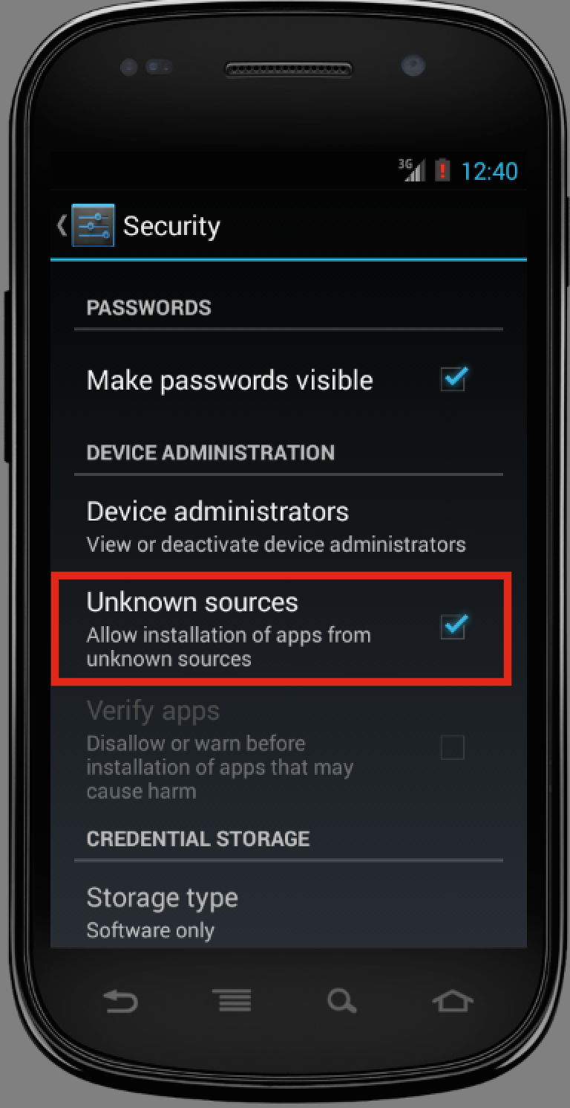

Using apk files from **Deployment** directory under this document. Click to install application.

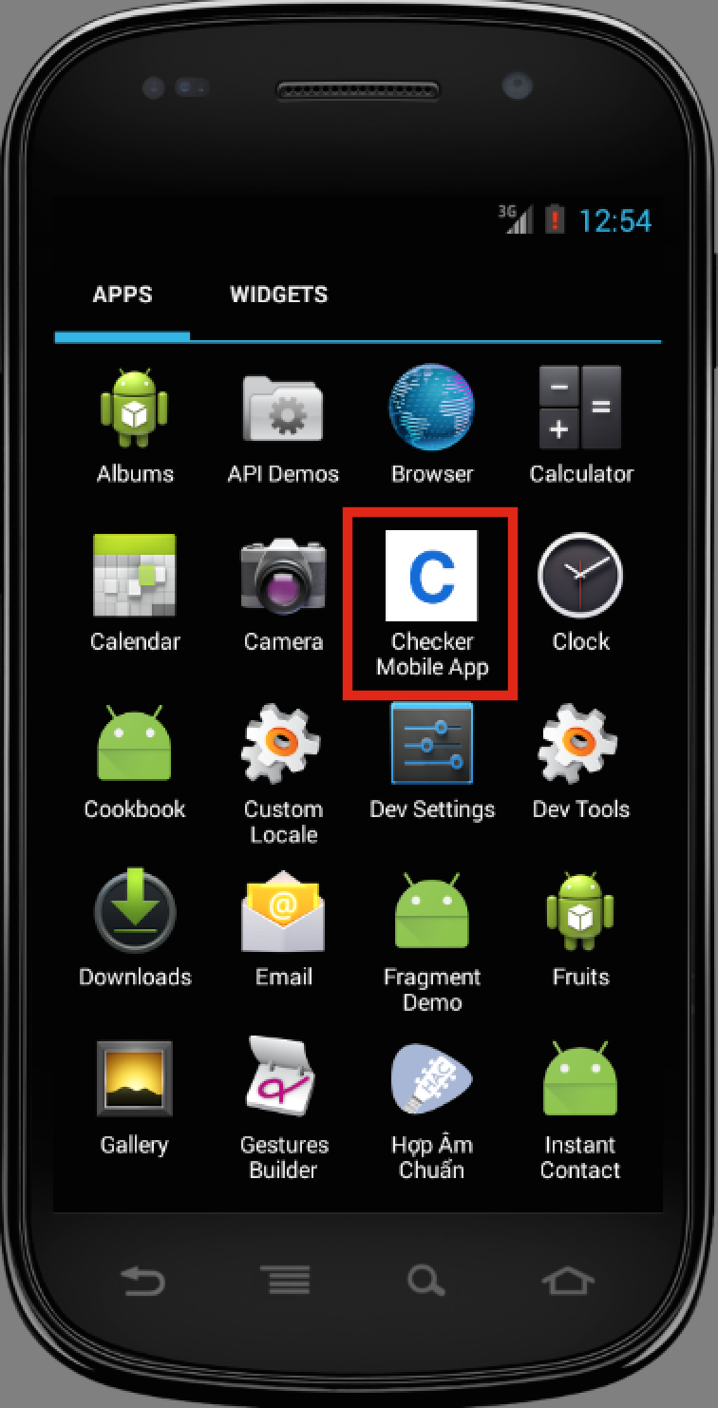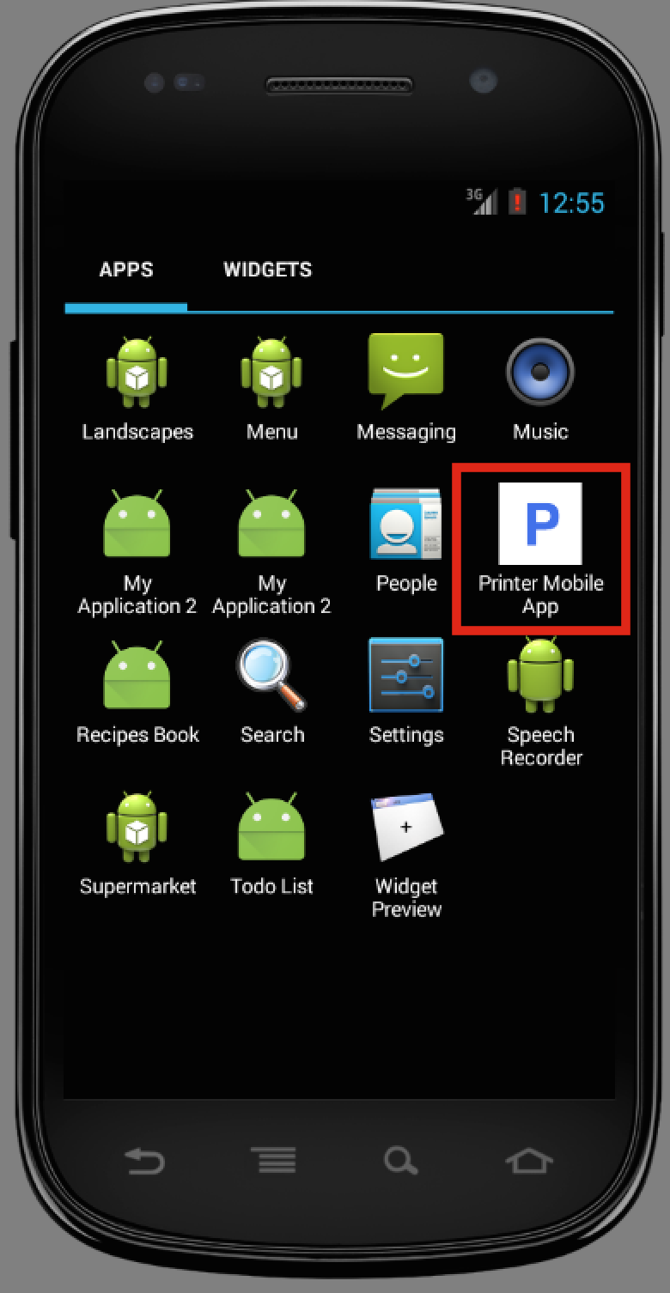

## User Guide

### Web Application

### Checker Application

#### Validate card

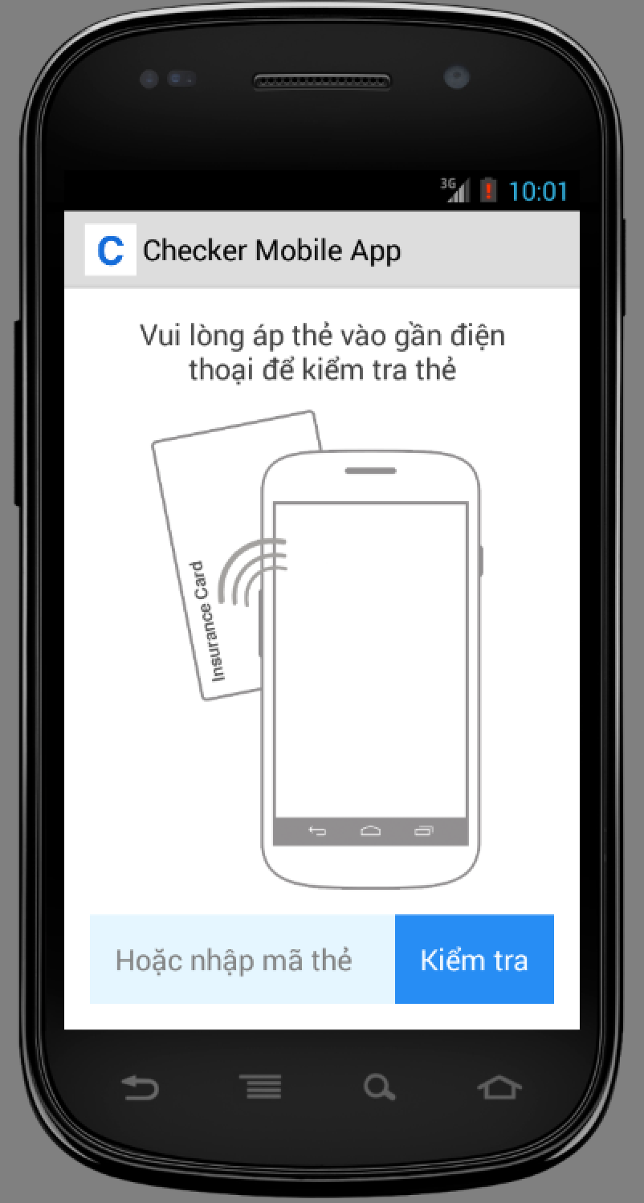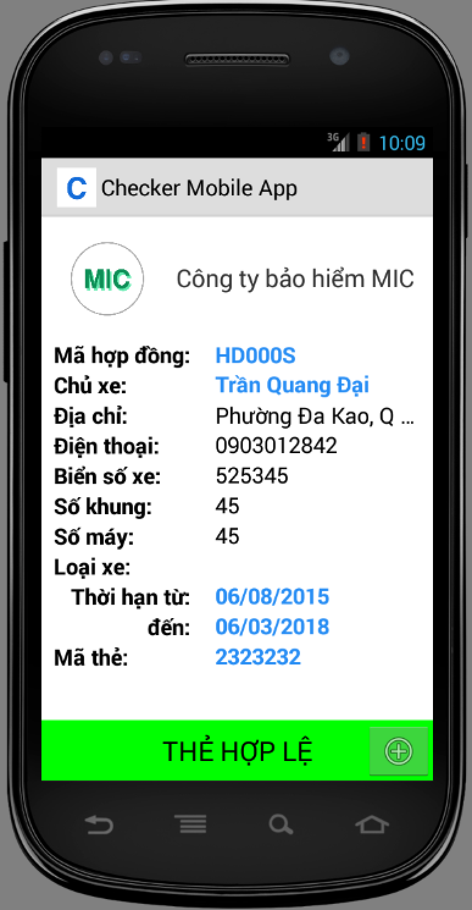

|  |  |
| --- | --- |
| Step | Description |
| 1 | Put Card close to the phone |
| 2 | Check information from the output screen |

#### Add punishment information

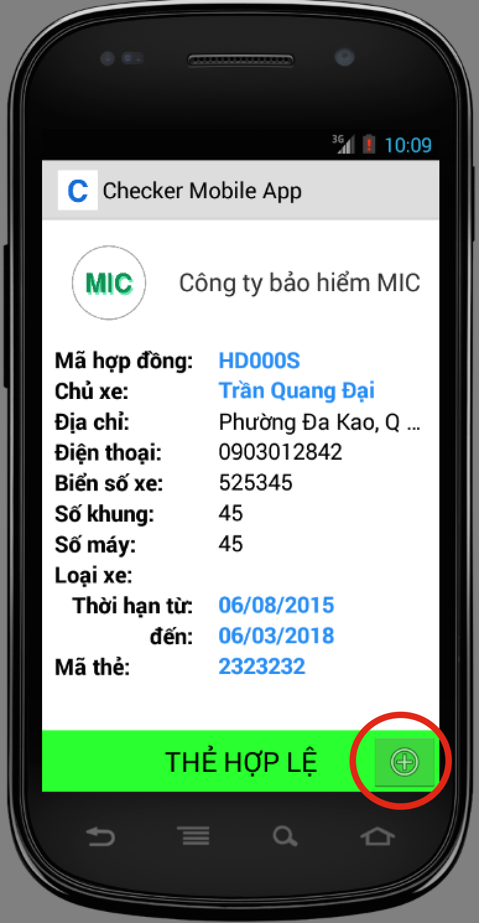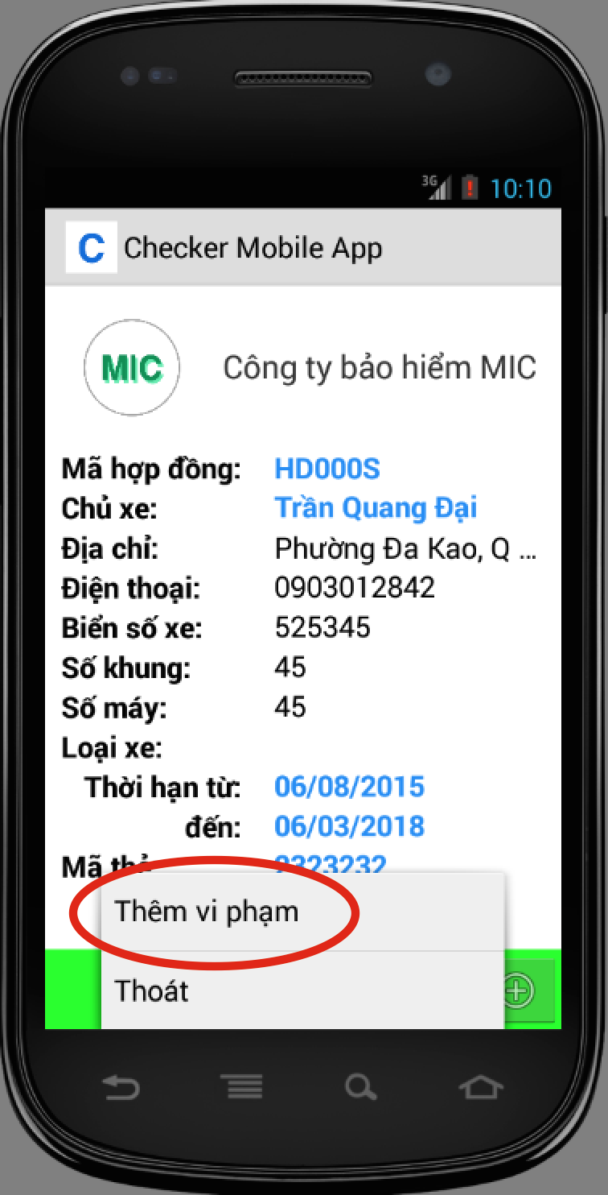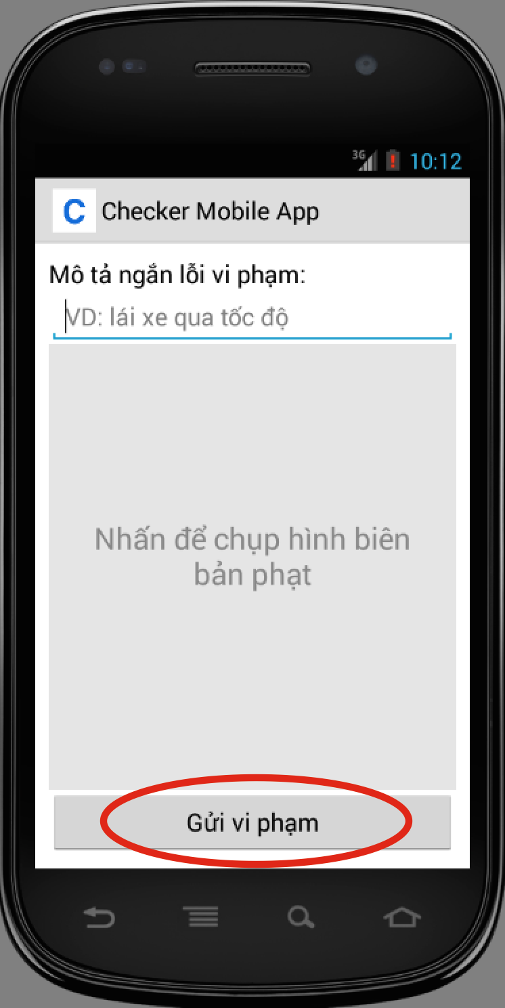

|  |  |
| --- | --- |
| Step | Description |
| 1 | At output screen, tap the plus button at bottom right corner. |
| 2 | Tap “Thêm vi phạm” button, application open new screen to enter punishment information |
| 3 | Press “Gửi vi phạm” to send punishment information |

### Printer Application

#### Print card

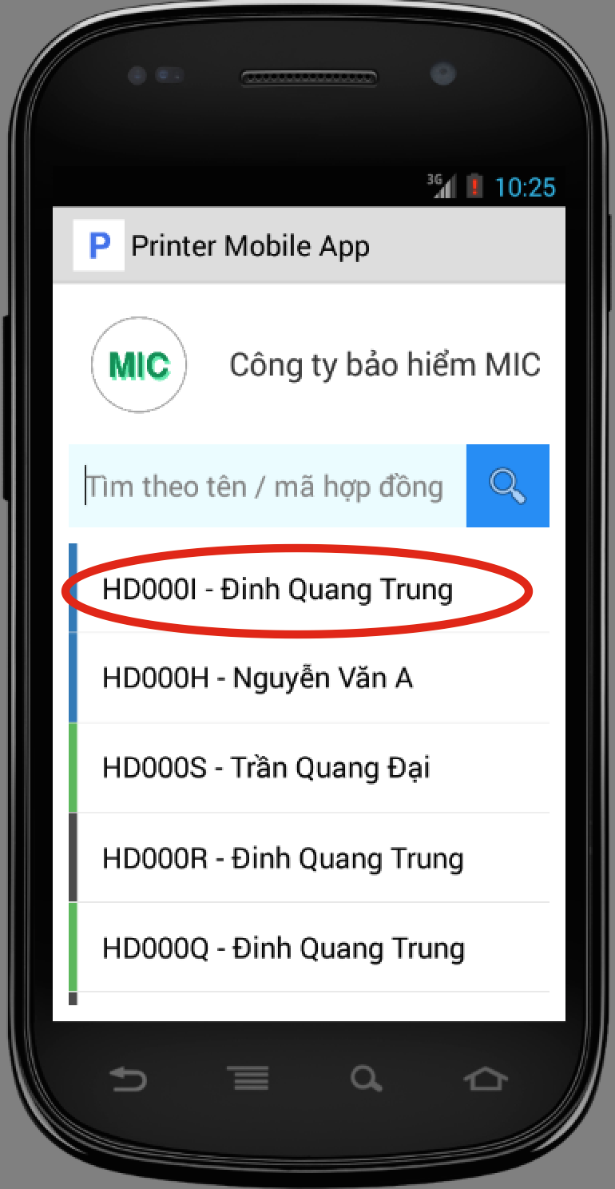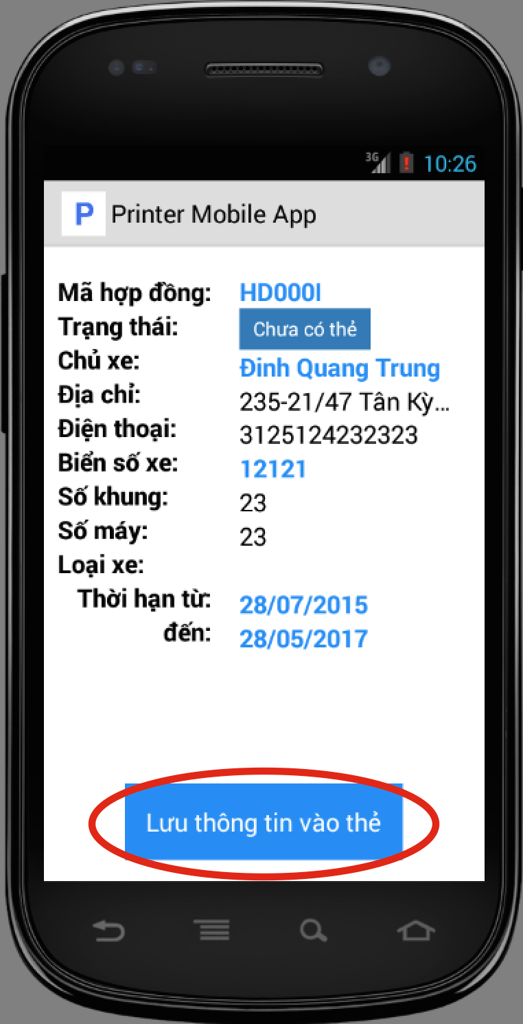

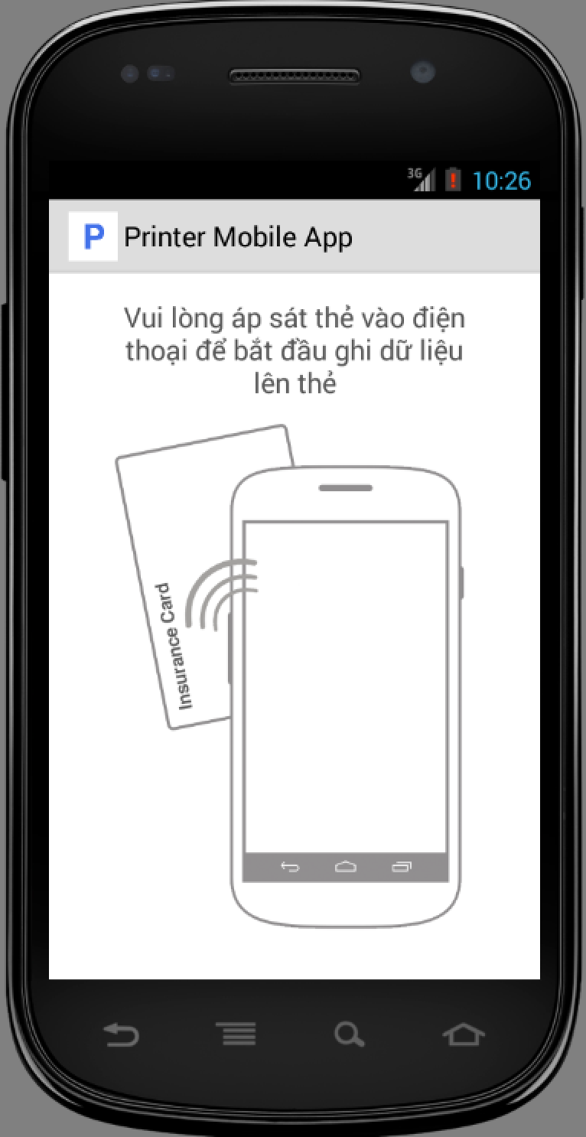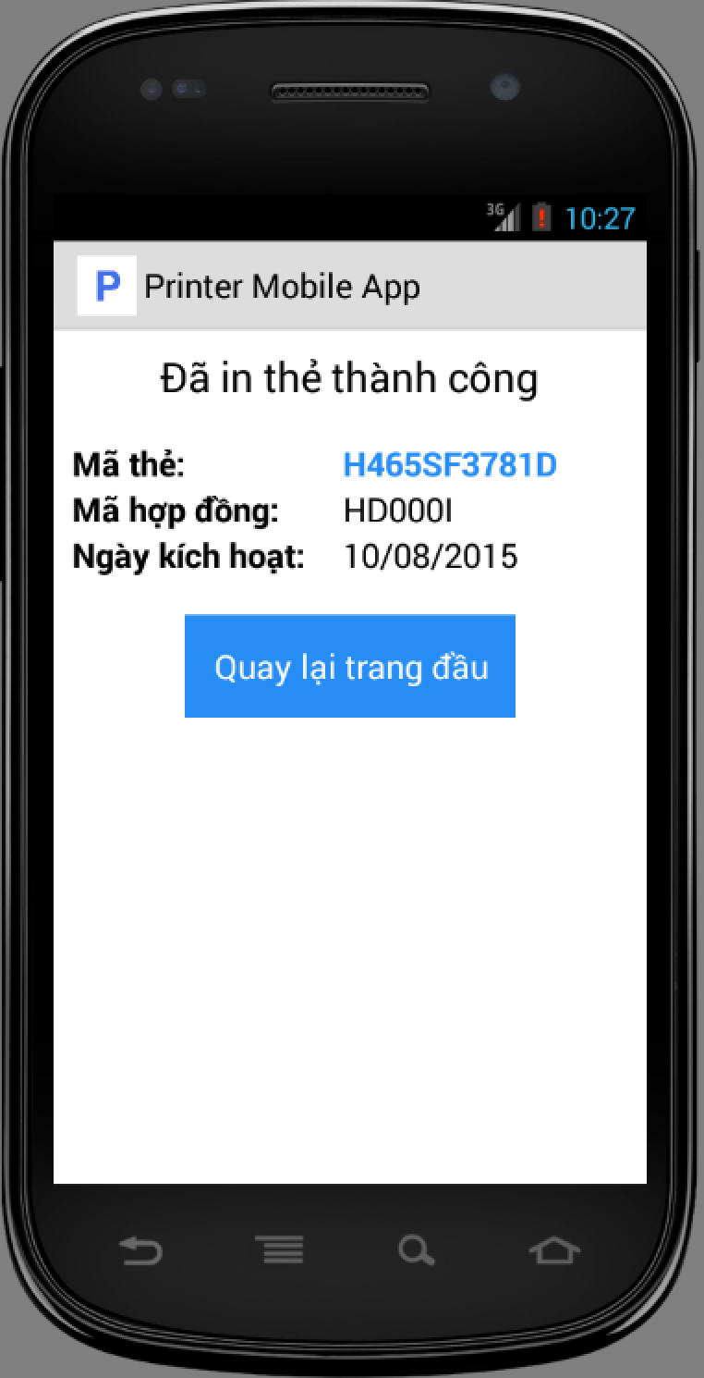

|  |  |
| --- | --- |
| Step | Description |
| 1 | At home screen, select a contract from list. |
| 2 | Tap “Lưu thông tin vào thẻ” button |
| 3 | Put NFC card close to phone, application show print result |

# Appendix

* 1. SOFTWARE ENGINEERING 9th Edition, by Ian Sommerville.
  2. Code Conventions for the Java TM Programming Language, by Sun Microsystems, rev April 20, 1999.
  3. Android Developer Guide - Application Fundamentals

<http://developer.android.com/guide/components/fundamentals.html>

* 1. NFC ForumTM Type 3 Tag Operation Specification 1.1, 2011-06-28.
  2. Circular No. 126/2008/TT-BTC: On rules, terms, table of premium rates and levels of liability of compulsory insurance for civil liability of motor vehicle owners - The Ministry of Finance - Hanoi, December 22, 2008.

<http://thuvienphapluat.vn/van-ban/Bao-hiem/Thong-tu-126-2008-TT-BTC-quy-tac-dieu-khoan-bieu-phi-muc-trach-nhiem-bao-hiem-bat-buoc-dan-su-chu-xe-co-gioi-83284.aspx>